Particle Habit Imaging and Polar Scattering (PHIPS) probe

David Delene, Emma Järvinen, Martin Schnaiter, Greg McFarquhar, and Wei Wu

A White Paper Submitted to the

**ARM Aerial Instrumentation Workshop White Paper Call**

# 1. Short Description

The Particle Habit Imaging and Polar Scattering (PHIPS) probe is a newly developed aircraft probe designed to measure single atmospheric cloud particles. Cloud particles are simultaneously observed using a high-resolution stereo-microscopic imager and a polar nephelometer. The imagers obtain high resolution images at 120 degrees to each other and the polar nephelometer simultaneously measures light scattering of the same particle using parabola mirrors placed at 20 equally spaced angles from 18 to 170 degrees.

# 2. Science Drivers

The PHIPS probe measures the angular light scattering function of individual cloud particles while obtaining stereo-graphic images which enables crystal habit identification. The angular scattering function segmented by cloud particle habit is needed to understand remote sensing and radiation measurements and to determine the uncertainty of retrieval algorithms. The PHIPS probe complements existing ARM cloud probes, such as the two-dimensional stereo (2D-S) probe and High Volume Precipitation Spectrometer version 3 (HVPS3) probe, which provide the particles size distribution, by delivering optical properties of cloud particles (~20-700 µm) classified by habit. In addition to enabling particle habit classification, the stereo-microscopic images provide information about the detailed microstructure of ice particles (riming, internal structure, and aggregate structure) that is useful for understanding cloud processes, which leads to improved cloud microphysical modelling. The angular light scattering of single particles enables unequivocally phase (water or ice) identification of small (diameter < 100 µm) cloud particles, which is not possible from any other existing cloud probe and is critical for understanding precipitation processes.

To summarize, the scientific motivations for the PHIPS probe are:

* To measure the angular light scattering function of individual cloud particles that are identifiable as belonging to a particular habit, which enables the understanding of cloud remote sensing observations.
* To obtain high resolution stereo-graphic images of cloud particles with sufficient detail to improve the understanding of microphysical processes (e.g. riming, aggregation) which enables improved cloud microphysical modelling.
* To provide reliable information on the phase of intermediate and small cloud particles which enables improved understanding of precipitation formation.

# 3. Full Description

## 3.1. Instrument/Measurement Description

The PHIPS probe is a combination of a stereo-microscopic imager and single-particle polar nephelometer. The imager part of the instrument consists of two camera telescope assemblies and a 690 nm nanosecond pulsed illumination laser. The magnification of the zoom lenses can be manually set in the range from 1.4 x to 9 x, which corresponds to a field of view dimensions ranging from 6.27 x 4.72 to 0.98 x 0.73 mm2 and optical resolution limit ranging from 7.2 to 2.35 µm, respectively. The maximum image acquisition rate of the cameras is currently 15 Hz.

The single-particle polar nephelometer consists of a 532 nm continuous wave laser and 20 scattering detectors that are equally spaced to cover the angular range from 18 to 170 degrees (Figure 1). The polar nephelometer has a maximum data acquisition rate of 13 kHz, which means that it can detect all cloud particles that penetrate the sensitive area of the instrument under typical operation conditions. The stereo-microscopic imager and the polar nephelometer are combined by a trigger detector positioned at a polar angle of 90° with respect to the scattering plane of the polar nephelometer, but opposite to its detector ring (Figure 1). The trigger is azimuthally tilted by 32° out of the scattering plane with a radial distance of the front lens to the laser beam of 24.5 mm. The trigger detector defines a sensitive area of 0.0018 cm2 that is similar to other single particle light scattering probes (e.g. Cloud Droplet Probe (CDP), Cloud and Aerosol Spectrometer (CAS)) but significantly smaller than the sensitive area of optical array probes (e.g. Cloud Particle Imager (CPI), Cloud Imaging Probe (CIP), Fast Two-dimensional Stereo probe (F2DS), Fast Two-dimensional Cloud Probe (F2DC)).

When a particle is entering the laser beam at the position of the sensing area, part of the scattered light is collected by the trigger detector optics and is guided to the first channel of the photomultiplier array, where the signal is processed and analyzed. If the trigger event is classified to be a real particle event (i.e. if it is longer than a predefined glitch period and higher than a predefined intensity threshold), the data acquisition is eventually initiated. The electronics then analyzes and digitizes the pulse height of the nephelometer detector channels, which takes a period of about 10 µs in total. Simultaneously, if the imaging system is ready to take a stereo-image (i.e. if it is not processing the last image), the electronics sends triggers to the cameras and the flash laser of the imager. If the imager has been triggered, the electronics flags the corresponding light scattering data set acquired by the nephelometer, which is important for the subsequent stereo-image to scattering function assignment.

The PHIPS probe has a robust mechanical structure consisting of a 12 mm thick aluminum base plate that carries all the optical components of the stereo imager and two 12 mm thick aluminum rings that form the basis of the nephelometer (Figure 2). The probe optics are aligned with a specifically designed aid that slides into the inlet of the mounted instrument. The aid carriers is a tungsten needle whose 60 µm wide tip can be precisely positioned into the sensitive area via micrometer screws. The focal planes of the two zoom lens systems are then adjusted to the tip position, which usually becomes necessary after the zoom settings have been changed (e.g. to get a larger field of view or a higher optical resolution in one or both imagers).

Figure 1: A schematic diagram of the two main components of the PHIPS probe. Please note that the forward PMT array is not implemented in the current instrument version. Adapted from Schnaiter et al., 2018.



Both the imagers and the polar nephelometer are calibrated with glass beads of known diameter and refractive index. The angular scattering function is converted to a (partial) scattering phase function by using Mie theory to calculate the differential scattering cross section of the glass beads or cloud droplets that have been imaged.

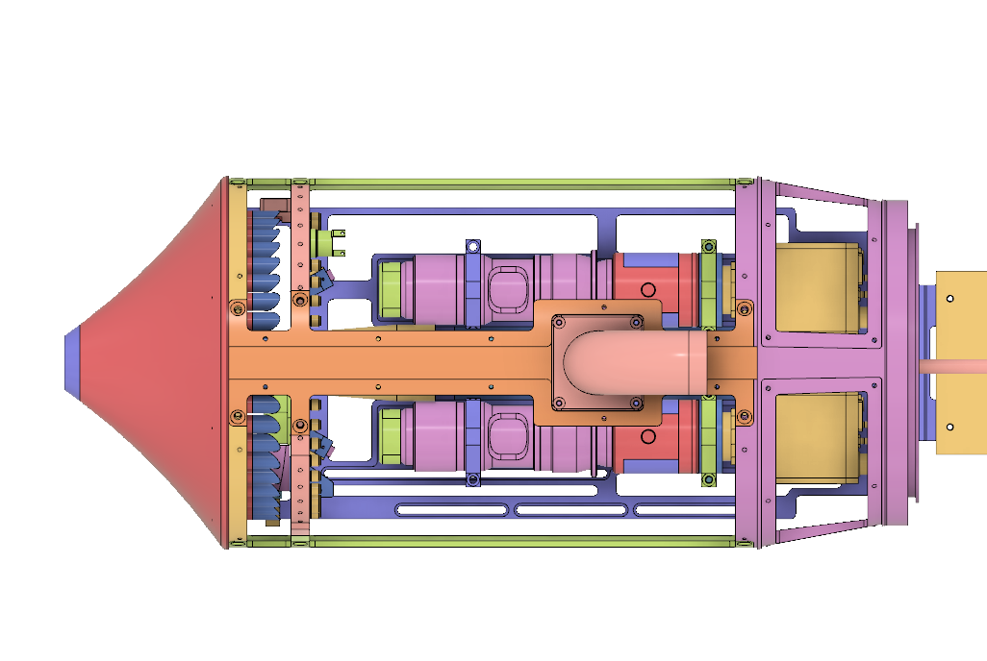

Figure 2: Top view of the instrument head showing the two zoom lens camera assemblies mounted on the base plate and the two mounting rings of the nephelometer that carrier the off axis parabola mirrors and the individual channels of the fiber assembly (not shown).

The PHIPS probe is unique because:

* The probe is the only currently existing airborne single-particle polar nephelometer.
* Stereo-imaging on the same particle as the scattering measurement provides information on the detailed microstructure as well as the orientation of particles.
* The probe uses incoherent, but monochromatic, illumination that is free of diffraction blurring.

## 3.2. Data Analyses

The PHIPS probe data processing delivers the following data products:

* Size and form parameters from stereo-microscopic images (e.g. Figure 3) including maximum dimension, area-equivalent diameter, aspect ratio, and roundness (Schön et al., 2011).
* Single-particle angular light scattering information (Figure 4) and single particle phase (polar nephelometer) (Stegmann et al., 2016; Schnaiter et al., 2018).
* Size distributions for spherical and aspherical particles for the size ranges of 60-700 µm and 20-700 µm, respectively (Waitz et al., *in preparation*).
* Crystal habit classification is performed by manually reviewing images.



Figure 4: Averaged angular scattering functions from different campaigns, which was used to validate the MODIS C6 ice optical model (Järvinen et al., 2018).

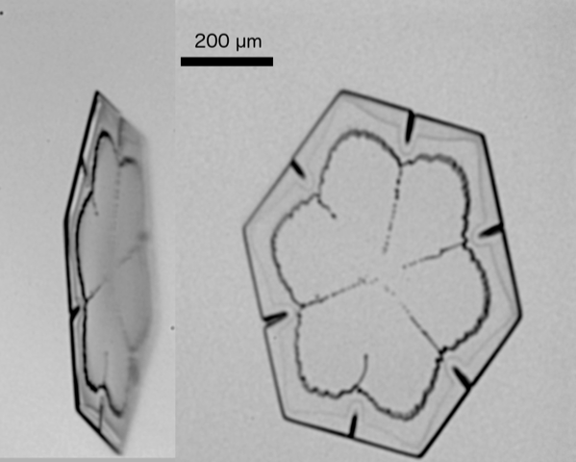

Figure 3: Example of stereo-microscopic image of an ice plate imaged by the PHIPS probe when sampling in a convective outflow anvil during the CapeEx19 campaign. The CapeEx19 field project sampled Florida thunderstorm anvils between 30,000 and 40,000 ft during July and August 2019 concurrent with the Navy’s Mid-course Radar (Schmidt et al., 2019).

As with all cloud probes, the PHIPS probe is prone to shattering of ice crystals on the probe structures under certain operation conditions. Particle shattering can cause biases when determining number concentrations; however, there are several possibility to correct for shattering: inter-arrival analysis, exclusion of time periods when large (>1 mm) crystal are present in large numbers or inspection of the raw image frames. All the algorithms for data analysis are published, or will be published soon. The data processing source code is openly accessible. All tools, except habit identification, are automated, and all algorithms can be performed on a personal computer.

## 3.3. Operational Requirement and Experience

The PHIPS probe has operated on several airborne platforms including the NCAR HIAPER and C-130, NASA P-3, North Dakota Citation Research Aircraft (Delene et al., 2019), DLR HALO and AWI Polar and has participated in many airborne campaigns, including ACRIDICON-CHUVA, ACLOUD, ML-CIRRUS, SOCRATES, ARISTO 16/17, CapeEx19, and IMPACTS. Examples of the use of PHIPS data can be found in the following publications: Stegmann et al., 2016; Wendisch et al., 2016; Järvinen et al., 2018; Schnaiter et al., 2018; Finlon et al., 2020; Wang et al., 2020).

The PHIPS probe is an underwing mounted instrument that is housed in a PMS (standard format originated by Particle Measuring Systems) canister (Figure 5). The instrument requires 110 VAC power that is split to system (max. 1 A) and heating (max. 5 A) lines. The instrument has a weight of 28.2 lbs. The PHIPS probe operates autonomously, and the probe contains its own data acquisition computer and storage. If required, the probe can be controlled and data monitored using an Ethernet interface.

## 3.4. Potential Difficulties and Justification

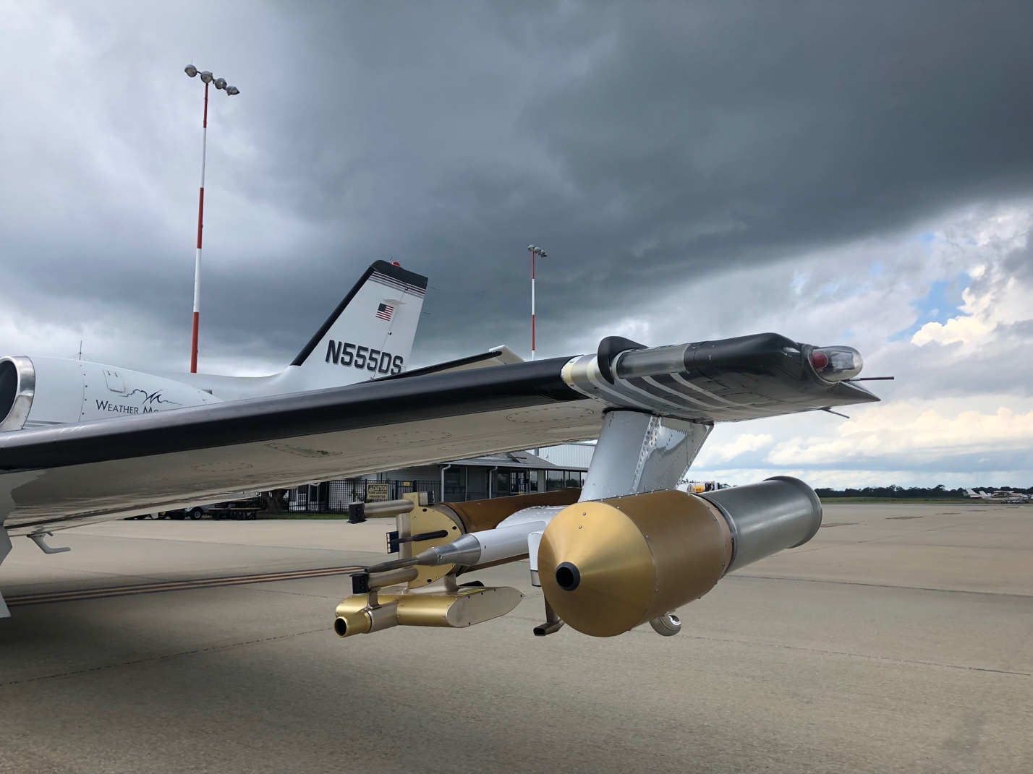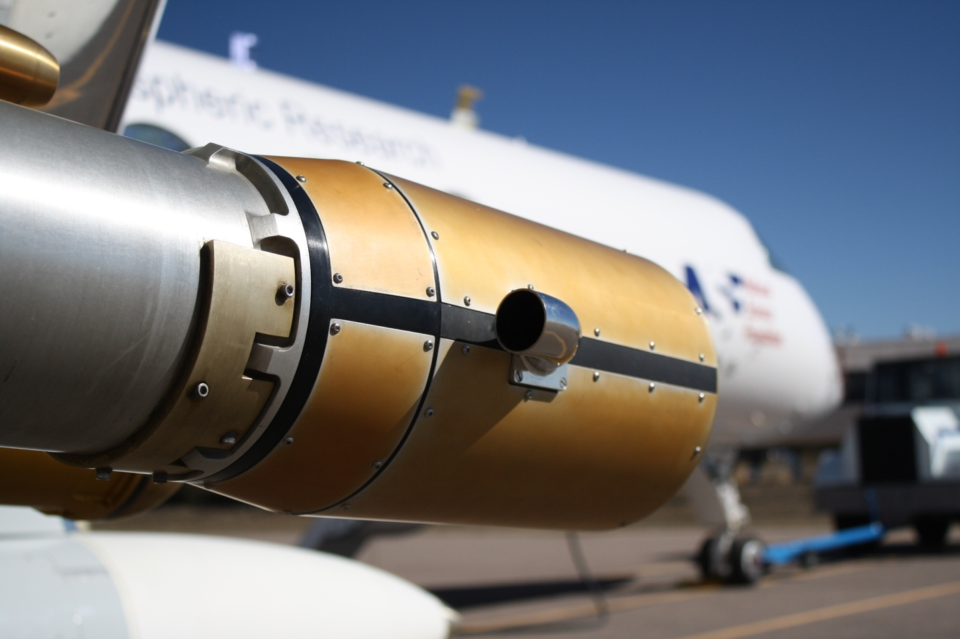

Figure 5: The PHIPS probe installed on the North Dakota Citation Research Aircraft during CapeEx2019 (top) and on the NSF/NCAR G-V (HIAPER) during SOCRATES (bottom).

The PHIPS instrument is able to operate unattended; however, like many cloud probes issues can arise so a trained operator should monitor the instrument in flight. Currently, there is only one PHIPS probe available, which makes supporting a particular ARM field project problematic. Hence, an ARM facility PHIPS probe would ensure availability for field deployment. Flight testing should be conducted to ensure the PHIPS is providing high quality data on the ARM aircraft.

# 4. References

Delene, D., Hibert, K. Poellot, M., and Brackin N., The North Dakota Citation Research Aircraft Measurement Platform, SAE Technical Paper 2019-01-1990, 2019, doi: 10.4271/2019-01-1990.

Finlon, J. A., Rauber, R. M., Wu, W., Zaremba, T. J., McFarquhar, G. M., Nesbitt, S. W., Schnaiter, M., Järvinen, E., Waitz, F. Structure of an Atmospheric River over Australia and the Southern Ocean. Part II: Microphysical Evolution of the Seeder-Feeder Process, J Geophys Res Atmos., *submitted.*

Järvinen, E., Jourdan, O., Neubauer, D., Yao, B., Liu, C., Andreae, M. O., Lohmann, U., Wendisch, M., McFarquhar, G. M., Leisner, T., and Schnaiter, M.: Additional global climate cooling by clouds due to ice crystal complexity, Atmos. Chem. Phys., 18, 15767–15781, https://doi.org/10.5194/acp-18-15767-2018, 2018.

Schmidt, Jerome M., Piotr J. Flatau, Paul R. Harasti, Robert D. Yates, David J. Delene, Nicholas J. Gapp, William J. Kohri, Jerome R. Vetter, Jason E. Nachamkin, Joshua D. Hoover, Mark J. Anderson; Seth Green, and James E. Bennett, Radar Detection of Individual Raindrops, Bulletin of the American Meteorological Society, 2019.

Schnaiter, M., Järvinen, E., Abdelmonem, A., and Leisner, T.: PHIPS-HALO: the airborne particle habit imaging and polar scattering probe – Part 2: Characterization and first results, Atmos. Meas. Tech., 11, 341–357, https://doi.org/10.5194/amt-11-341-2018, 2018.

Schön, R., Schnaiter, M., Ulanowski, Z., Schmitt, C., Benz, S., Möhler, O., Vogt, S., Wagner, R., and Schurath, U.: Particle habit imaging using incoherent light: a first step towards a novel in- strument for cloud microphysics, J. Atmos. Oceanic Technol., 28, 439–512, doi:10.1175/2010jtecha1445.1, 2011.

Stegmann, P. G., Tropea, C., Järvinen, E., & Schnaiter, M.: Comparison of measured and computed phase functions of individual tropospheric ice crystals. Journal of Quantitative Spectroscopy and Radiative Transfer, 178, 379-389, 2016.

Waitz, F., Schnaiter, M., Leisner, T., Järvinen, E.: PHIPS-HALO: the airborne particle habit imaging and polar scattering probe - Part 3: Single Particle Phase Discrimination and Particle Size Distribution based on Angular Scattering Function, Atmos. Meas. Tech., *in preparation*.

Wang, Y., McFarquhar, G. M., Rauber R. M., Zhao, C. , Wu, W., Stechman, D. M., Finlon, J. A., Stith, J., Schnaiter, M., Järvinen, E., Jensen, J., Vivekanandan, J., and Dixon, M. Microphysical Properties of Generating Cells over the Southern Ocean: Results from SOCRATES, J Geophys Res Atmos., *submitted.*

Wendisch, M., Pöschl, U., Andreae, M. O., Machado, L. A., Albrecht, R., Schlager, H., ... & Araùjo, A. C.: ACRIDICON–CHUVA campaign: studying tropical deep convective clouds and precipitation over amazonia using the New German research aircraft HALO. Bulletin of the American Meteorological Society, 97(10), 1885-1908, 2016.