**The Relationship of West African Rainfall and North Atlantic Tropical Cyclone Activity**

Lance Wilson

**Abstract**

Seasonal forecasts of tropical cyclone activity can benefit the preparing to respond to landfalls, but the accuracy of these forecasts depends on the ability to understand the influences on the formation of tropical cyclones. One suggested influence, the early season rainfall in the Western Sahel, is investigated to determine whether rainfall anomalies in this region can be correlated with anomalies in tropical cyclone activity in the North Atlantic Basin. Linear regressions of the data show that there is a weak to moderate correlation between wetter rainfall anomalies over the Western Sahel region and the number of tropical storm-strength tropical cyclones over the Atlantic, but no correlation exists been rainfall and the more intense storms of hurricane strength.

1. **Introduction**

Predictions of tropical cyclone activity in the North Atlantic Ocean are an important baseline for preparing for the annual hurricane season. Predictions of the total number and number of intense tropical cyclones are a useful guide to help both government officials and the public prepare for potential landfalls during the season. However, like all long-term forecasts, the ability to make accurate predictions is limited and predictions of the quantity of tropical cyclones relies on an understanding of the factors that contribute to the development of tropical cyclones. These factors are not always well understood, whether due to lack of study or lack of available data. As a result, knowing which factors are important is difficult. Furthermore, when those factors disagree with each other, the prediction can suffer (Klotzbach 2007).

Previously, pre-season rainfall in western Africa has been correlated to the activity of tropical cyclones in the Atlantic, with the best correlation being with the number of major, or intense, hurricanes (those rated category 3 or higher on the Saffir-Simpson scale) and the number of major hurricane days (Landsea and Gray 1992). Above average rainfall for the Gulf of Guinea region in August to November of the previous year and in the western Sahel region (roughly the region in Africa between 11 and 20 degrees North) in June and July of the current year showed a strong correlation with a greater than average number of intense hurricanes from August to the end of the season (Gray and Landsea 1992). Although June and July are after the start of the official start of hurricane season, predictions from August to the end of the season are useful because only ten percent of tropical cyclone activity and five percent of intense tropical cyclone activity in the Atlantic occur before August (Klotzbach 2007). However, although it was expected that the activity of the 1990’s and 2000’s would be greater after the drought in west Africa ended (Gray and Landsea 1992), the correlation between west African rainfall and tropical cyclone activity became less significant in the 1990’s and early 2000’s (Klotzbach 2007). Previous suggestions for the cause have included multidecadal variation in upper level divergence over the west African region and variable station measurement quality (Klotzbach 2007). This observed decreased correlation between west African rainfall and north Atlantic tropical cyclone activity is now ten years old. Furthermore, it has been twenty-five years since the initial correlation between above average west African rainfall and increased tropical cyclone activity has been the focus of a scientific study, so an updated analysis is warranted. It is also worth investigating whether this correlation is, or was ever, a side effect of teleconnections with the El Niño-Southern Oscillation (ENSO) or Atlantic Multidecadal Oscillation (AMO), or if it acts as an independent modifier on Atlantic tropical cyclone activity. ENSO refers to anomalies in sea surface temperatures in the equatorial Pacific Ocean, and its effects on global weather have been frequently studied and are now often used to assist in extended range outlooks for regional weather (Larkin 2005). Many definitions have been proposed over the years for the occurrence of El Niño, but one definition that has attained some level of acceptance is the National Oceanic and Atmospheric Administration’s definition, which defines El Niño or La Niña conditions as an anomaly of 0.5 °C or more from the long-term mean sea surface temperature in the Niño-3.4 region, which extends from 5° S to 5° N latitude and 120° to 170° W, averaged over three consecutive months (Kug 2009). The AMO refers to a similar phenomenon in the North Atlantic Ocean and is measured by looking at the anomalies in sea surface temperatures over the Atlantic Ocean from 0° to 80° N latitude, with above average temperatures indicating the warm phase and the cold phase being indicated by below average temperatures (Trenberth et al. 2017). The sea surface temperature data are typically detrended from climate change-related effects by subtracting the mean anomaly for global sea surface temperatures from the north Atlantic anomaly (Trenberth et al. 2017). In the past, the warm phase of the AMO has been shown to correlate with above average precipitation in the Sahel region (Knudsen et al. 2011). The primary goals of this experiment are to reaffirm or refute this relationship with the AMO, establish, if it exists, a similar relationship with ENSO, and determine whether there is a correlation between these effects and tropical cyclone activity in the North Atlantic Ocean basin.

1. **Methodology**

This study looks at the correlation between rainfall in the western Sahel in June and July and the subsequent activity of intense tropical cyclones in the North Atlantic Basin, which encompasses all tropical cyclones that form in the Atlantic Ocean north of the equator. Where possible, data are from the same sites used by Landsea and Gray, 1992. A few additional sites were obtained with similar periods of record to the collected data. Sites used for this study are shown in **Error! Reference source not found.**, and their locations are shown in Figure 1. The aforementioned variable measurement quality issue has become evident here, as the data generally only has a period of record going back to the 1970’s, and the data that do it exist are often sparse.

Precipitation data for western Africa are from the National Centers for Environmental Information (formerly the National Climatic Data Center) (NCEI/NCDC 2017). Data are collected for each station and are saved in plain text files, one for each station. A python program is used to load the data for each station, find the dates within June and July, and calculated the total rainfall for each month. The number of data points for each month is also noted and are used to calculate an average amount of rainfall per day, which is then used to create an adjusted monthly total that was the extrapolated amount of rainfall received if all data was available.

Data for the ENSO and AMO phases were collected from NOAA’s Earth System Research Laboratory, Physical Sciences Division. Both datasets are formatted in plain text files, with each line containing the year and the monthly data. The AMO data contains both the raw data sea surface temperature anomalies, as well as the temperature anomalies detrended for climate change (ESRL 2017). The ENSO data has separate files containing the raw mean sea surface temperatures for each month and the deviation from the normal values averaged over a three-month period (ESRL 2015).

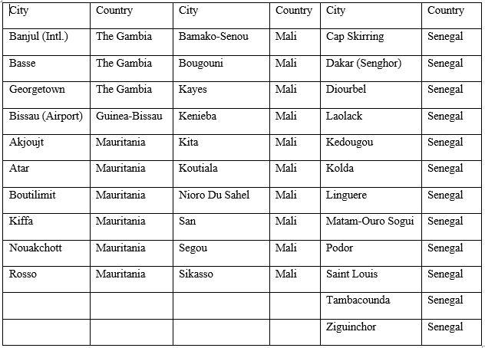

Table 1: The stations from which precipitation data were collected for this study. A map of their locations can be found in Figure 1.

Data for seasonal tropical cyclone activity were obtained from NOAA’s Atlantic Ocean and Meteorological Laboratory, Hurricane Research Division. The Hurricane Database 2nd Generation (HURDAT2) database was utilized, with data collected containing the seasonal numbers of tropical cyclones, including the numbers achieving hurricane and major hurricane strength (AOML 2016). The comprehensive data containing individual advisories (including those obtained by re-analysis) for each tropical cyclone from 1851 to 2016 were also obtained. This data contained information related to the number of tropical cyclones in each year, as well as the peak strength of each storm in both wind speed (in knots) and minimum pressure (in millibars) (AOML 2016).

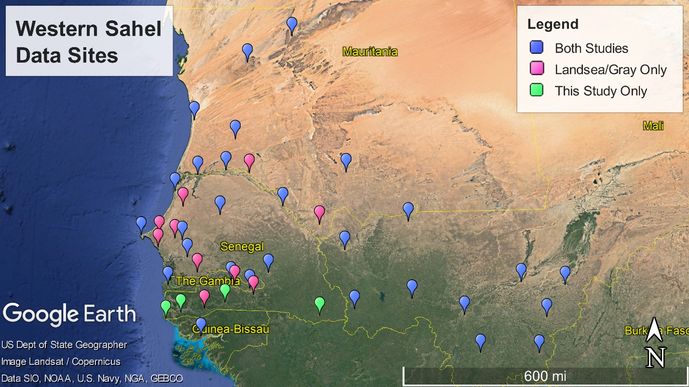

Figure 1: Locations of sites utilized in Landsea and Gray, 1992 (pink), this study (green), and both (blue).

For processing the data, computer programs are well-suited to the task of performing calculations on datasets that would be unwieldy to handle manually. To this end a program was written called INTRAMWARE (the **In**fluence on the Atlantic **Tr**opical Cyclone Season of the **AM**O, **W**est **A**frican **R**ainfall, and **E**NSO). INTRAMWARE first loops through the set of files that contain the raw precipitation for each of the selected stations from the western Sahel. The total precipitation for the station in June and July is accumulated, and then the adjustment to account for incomplete data is made. The normalized precipitation index for each year for each station was then calculated by dividing the difference of the perturbation and the station’s mean precipitation total by the standard deviation (Landsea and Gray 1992). The regionally averaged rainfall index, a measure of the normalized deviation from the mean over the entire region, is then calculated using the Kraus method (Landsea and Gray 1992). The phase of the AMO and ENSO are then calculated for the period centered on June and July (the early season) and for the full June through November hurricane season. An extra month is added to the beginning and end of each period when calculating the average phase to get a better idea of the trend during that time period. After the number of named tropical cyclones, hurricanes, and intense hurricanes is read into the program, the years that are common to all datasets are calculated. A function is then used to plot the correlation between two of the many potential variables (for example, the correlation between ENSO phase and the number of tropical cyclones). The resulting correlation was plotted for the years in which data was common to all data sets, which corresponded to 1957 through 1967, and 1973 through 2017 (except in the data for the number of storm days, for which data is only available to 2016). The plot produces a linear regression of the input variables, and highlights the upper and lower quartiles of the compared variable (the variable plotted on the y-axis), as some comparisons of data appeared to show a wider spread of data with warmer phases of the AMO and ENSO.

1. **Results and Discussion**
2. *Relationship of the Atlantic Multidecadal Oscillation and Western Sahel Rainfall*

The first correlation noted is the effect of the phase of the AMO on the early season West African rainfall. A warmer AMO phase indicates warmer ocean temperatures in the North Atlantic Basin, which should lead to more favorable conditions for the production of tropical cyclones, so there should be a correlation between AMO phase and tropical cyclone activity. This means that the correlation coefficient between AMO phase and tropical cyclone frequency can be used as a baseline comparison for the influence of the AMO on Western Sahel rainfall. The linear regression of the data resulted in the observation that warmer phases of the AMO are weakly correlated with the number of named storms in the North Atlantic basin, with a correlation coefficient of only 0.55, as shown in Figure 2. Notable, however, is that the upper quartile of named storm frequency all corresponded with a warm phase of the AMO. The correlation coefficient between the full season AMO phase and number of named storm days is also 0.55. Although these correlations are not particularly strong, they are still much larger than the correlation between the phase of the AMO and West African rainfall. The correlation coefficient for the regression of the early season AMO phase with the early season regionally averaged normalized rainfall is only 0.20, as shown in Figure 3. The correlation between the full season AMO phase and early season rainfall is even closer to zero. That the correlation coefficient is significantly lower than the correlation coefficient for the effect of the AMO on frequency of named tropical cyclones would indicate that the quantity of rainfall received in West Africa is not immediately tied to the phase of the AMO. Therefore, it would be expected that if any relationship exists between Western Sahel rainfall and the tropical cyclone frequency, it would be unlikely to be a side-effect of the AMO.

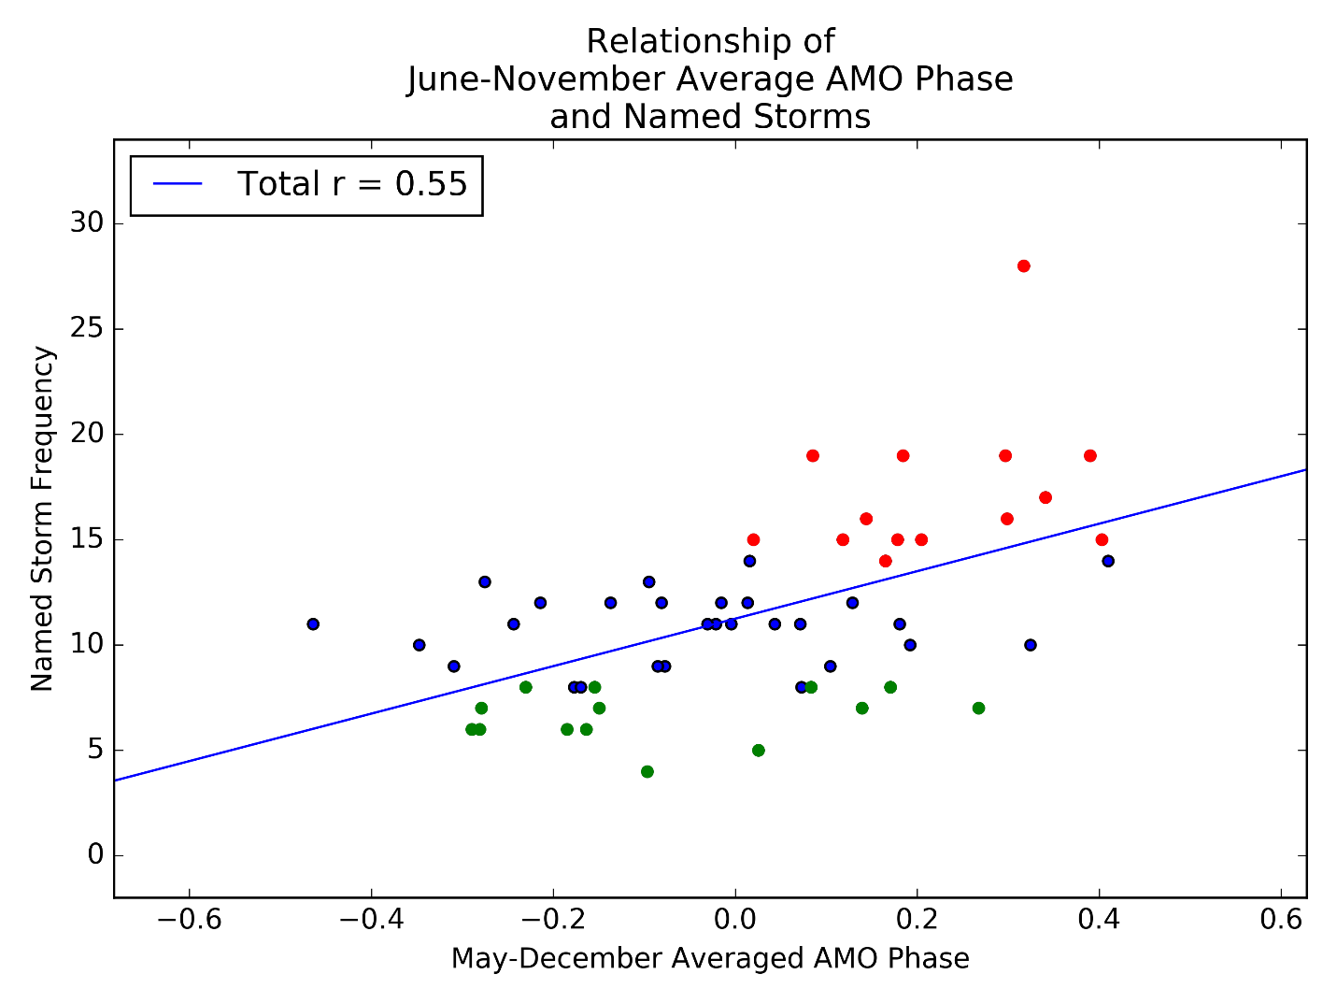

Figure 2: Correlation between the average anomaly of the AMO over the course of the entire hurricane season and the frequency of tropical cyclones attaining a strength of 18 m s-1 (38 MPH) for seasons from 1957-1967 and 1973-2017. The correlation coefficient of the linear regression is 0.55, which indicates a weak to moderate correlation.

1. *Relationship of the El Niño-Southern Oscillation and Western Sahel Rainfall*

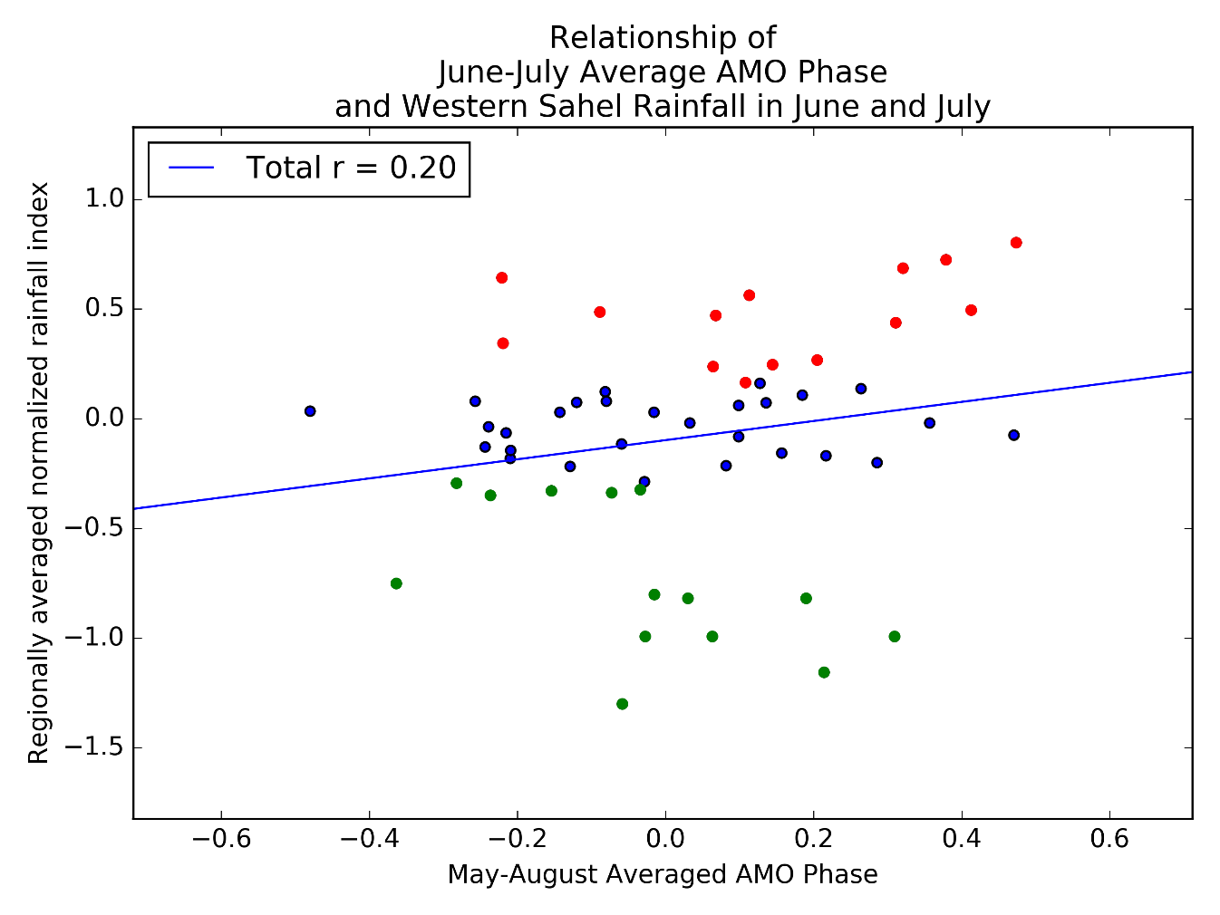

Figure 3: Correlation between the average anomaly of the AMO over the early stage of the Atlantic Hurricane Season (June and July) and the regionally averaged normalized rainfall over the Western Sahel region, over the same time range as in Figure 2. The correlation coefficient of the linear regression is 0.20, which indicates a very weak correlation.

The next set of correlations to be noted is how ENSO correlates with the early season West African rainfall. Warmer phases of ENSO have been noted to inhibit tropical cyclone activity, so the correlation between ENSO and tropical cyclone frequency can be used as a baseline for comparison to the effect of ENSO on Western Sahel rainfall. The linear regression of the data resulted in the observation that the correlation coefficient between ENSO and the number of named storms in a given year is -0.40, as shown in Figure 4. The correlation coefficient between ENSO and the number of named storm days is -0.37. These are somewhat less than the correlation coefficients observed for the same correlations with the AMO, but given the closer geographic proximity of the AMO this is not altogether surprising. This correlation may also be less significant because the average ENSO phase for the season was calculated based on summer data, whereas ENSO effects are considered to be most significant in winter. Notable in this figure is that all but two of the ten least active years occurred in a warm ENSO phase, and all but four of the thirteen most active years occurred in a cool ENSO phase. In comparison, the correlation coefficient between the early season ENSO phase and early season regional averaged normalized rainfall is -0.12, as shown in Figure 5. The comparison with the full season ENSO phase is slightly closer to zero. As with the AMO, the correlation of ENSO with the Western Sahel rainfall is much closer to zero than the correlation with tropical cyclone frequency, and thus it seems unlikely that ENSO is the primary factor resulting in Western Sahel rainfall, and any correlation between west African rainfall and tropical cyclone frequency would be independent of this effect.

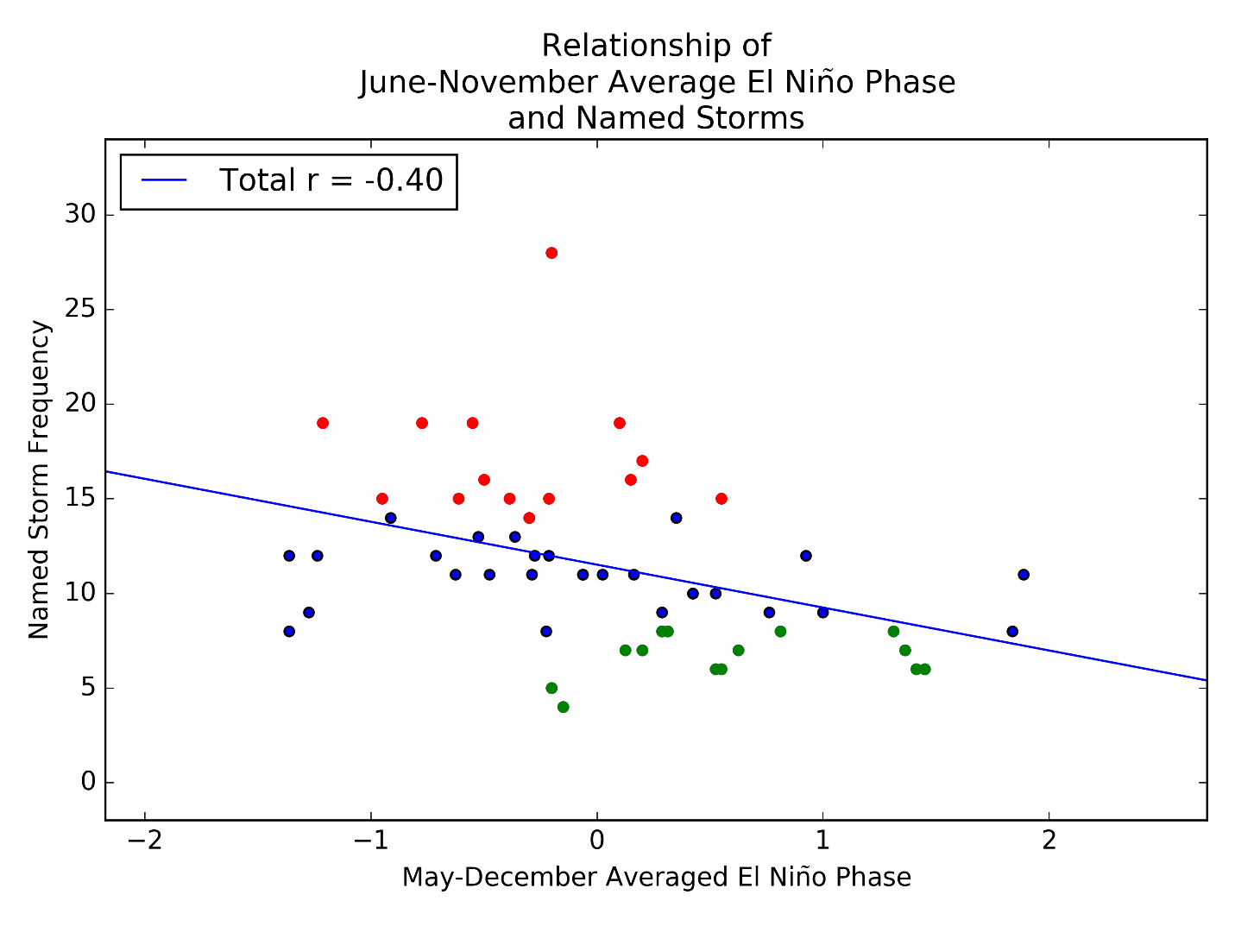

Figure 4: Correlation between the average anomaly of ENSO over the full Atlantic Hurricane Season and the frequency of tropical cyclones of tropical storm strength, over the same time range as in Figure 2. The correlation coefficient of the linear regression is -0.40, which indicates a weak correlation.

1. *Relationship of Early-Season Western Sahel Rainfall and Tropical Cyclone Activity*

The previous two correlations with the western Sahel rainfall and the AMO and ENSO indicate that if there is a correlation between west African rainfall and tropical cyclone activity, then it will either be a unique, significant effect worth noting in forecasts of late-season tropical cyclone activity, or that it will be a function of another teleconnection not researched in this study. The correlation coefficient of the linear regression of the Western Sahel regionally averaged rainfall index and frequency of named tropical cyclones was 0.43, as shown in Figure 6. Although fairly low, this value is comparable in magnitude to the correlation coefficient between ENSO and named storm frequency. Eleven of the thirteen years with the greatest number of named tropical cyclones occurred in years when the rainfall index was greater than zero (i.e. when the rainfall across the Western Sahel region was above average). Also noteworthy is that with increasing rainfall there is also an increasing variance in the number of storms in a given year. Since this correlation coefficient is comparable with the similar correlation with ENSO, it is reasonable to say that there is at least a weak correlation between Western Sahel rainfall and named tropical cyclones that is independent of the influences of the AMO and ENSO.

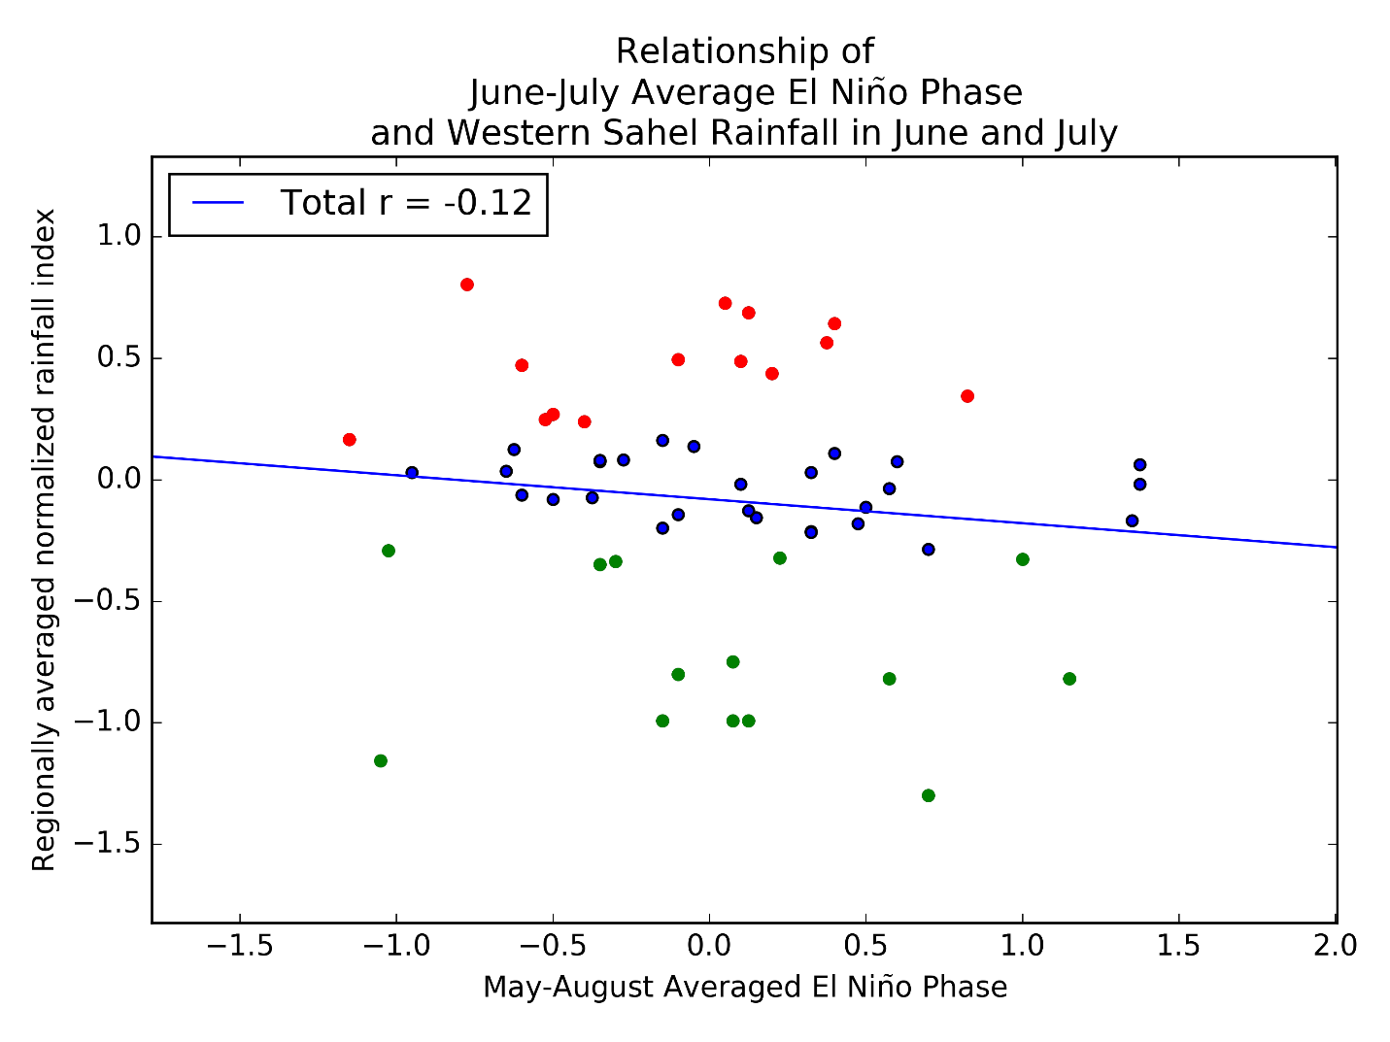

Figure 5: Correlation between the average anomaly of ENSO over the early portion of the Atlantic Hurricane Season (June and July) and the regionally averaged normalized rainfall over the Western Sahel region, over the same time range as in Figure 2. The correlation coefficient of the linear regression is -0.12, which indicates almost no correlation.

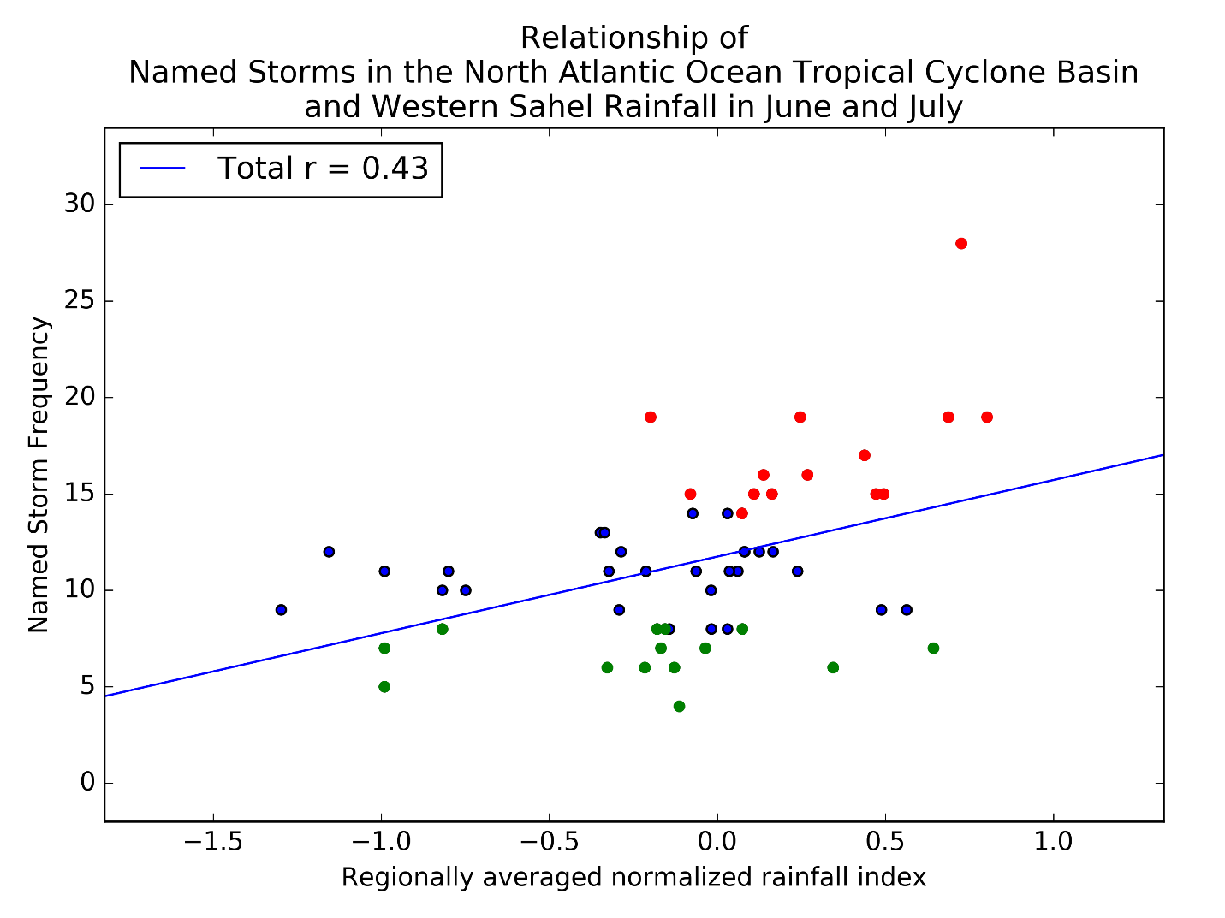

Figure 6: Correlation between the regionally averaged normalized rainfall over the Western Sahel region in June and July and the frequency of tropical cyclones of tropical storm strength, over the same time range as in Figure 2. The correlation coefficient of the linear regression is 0.43, which indicates a weak correlation, comparable to the correlation between ENSO and the number of tropical storm strength tropical cyclones.

The correlation between Western Sahel rainfall and the number of named storm days is lower, with a correlation coefficient of 0.22, as shown in Figure 7. This is low in comparison with the correlations of the AMO and ENSO and both the frequency of named storms and the number of storm days, which suggests that early season Western Sahel rainfall is not a significant factor in the number of storm days during the season.

The correlation coefficient between the linear regression between the Western Sahel regionally averaged rainfall index and frequency of hurricane-strength tropical cyclones is 0.20, as shown in Figure 8. As with the correlation with named storm frequency, the variance in hurricane frequency increases with wetter rainfall indices. However, the correlation coefficient is low in comparison with the correlations with ENSO, the AMO, and named tropical cyclone frequency, so it is unlikely that early season rainfall in the Western Sahel is a significant factor influencing the number of tropical cyclones that reach hurricane strength during the remainder of the season.

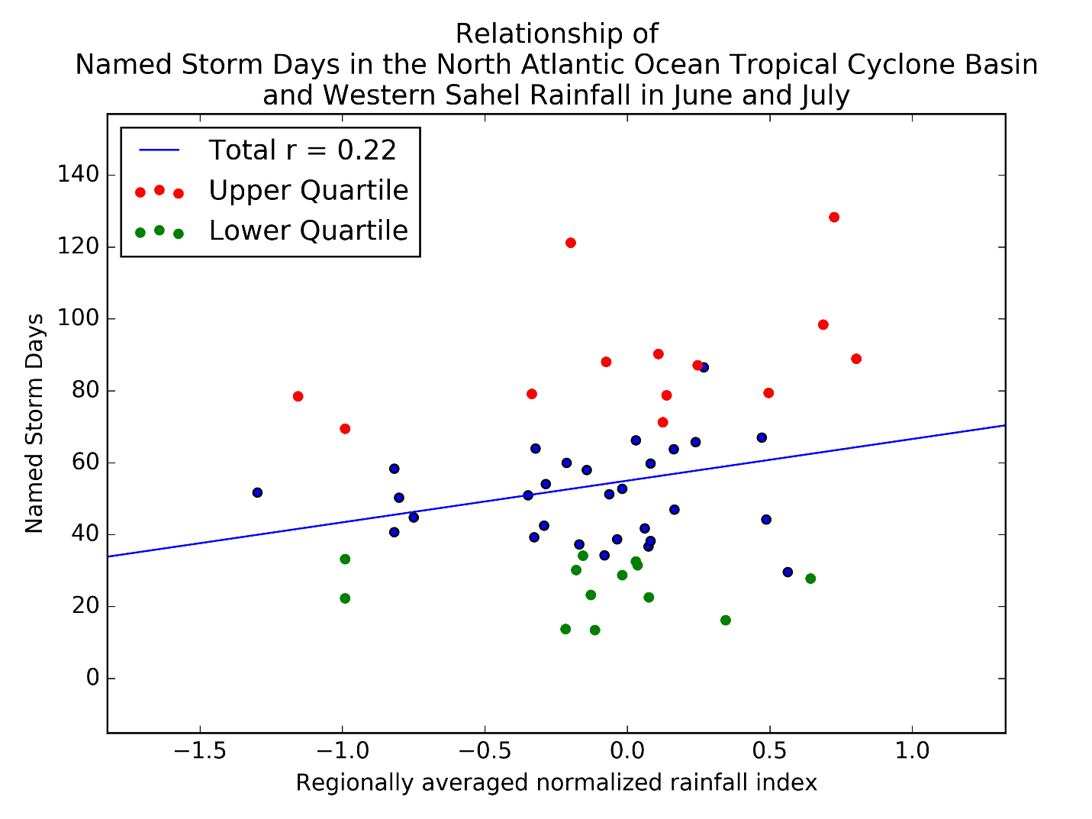

Figure 7: Correlation between the regionally averaged normalized rainfall over the Western Sahel region in June and July and the number of days of tropical cyclones of tropical storm strength, over the same time range as in Figure 2, except that 2017 is not included in this dataset. The correlation coefficient of the linear regression is 0.22, which indicates a weak correlation.

The correlation between Western Sahel rainfall and the number of days of hurricane strength tropical cyclones has a correlation coefficient of -0.05, as shown in Figure 9. This is very low in comparison with the correlations of the AMO and ENSO and both the frequency of named storms and the number of storm days, and indicates almost no correlation between the two variables. This suggests that early season Western Sahel rainfall is not a significant factor in the number of hurricane-strength storm days during the season.

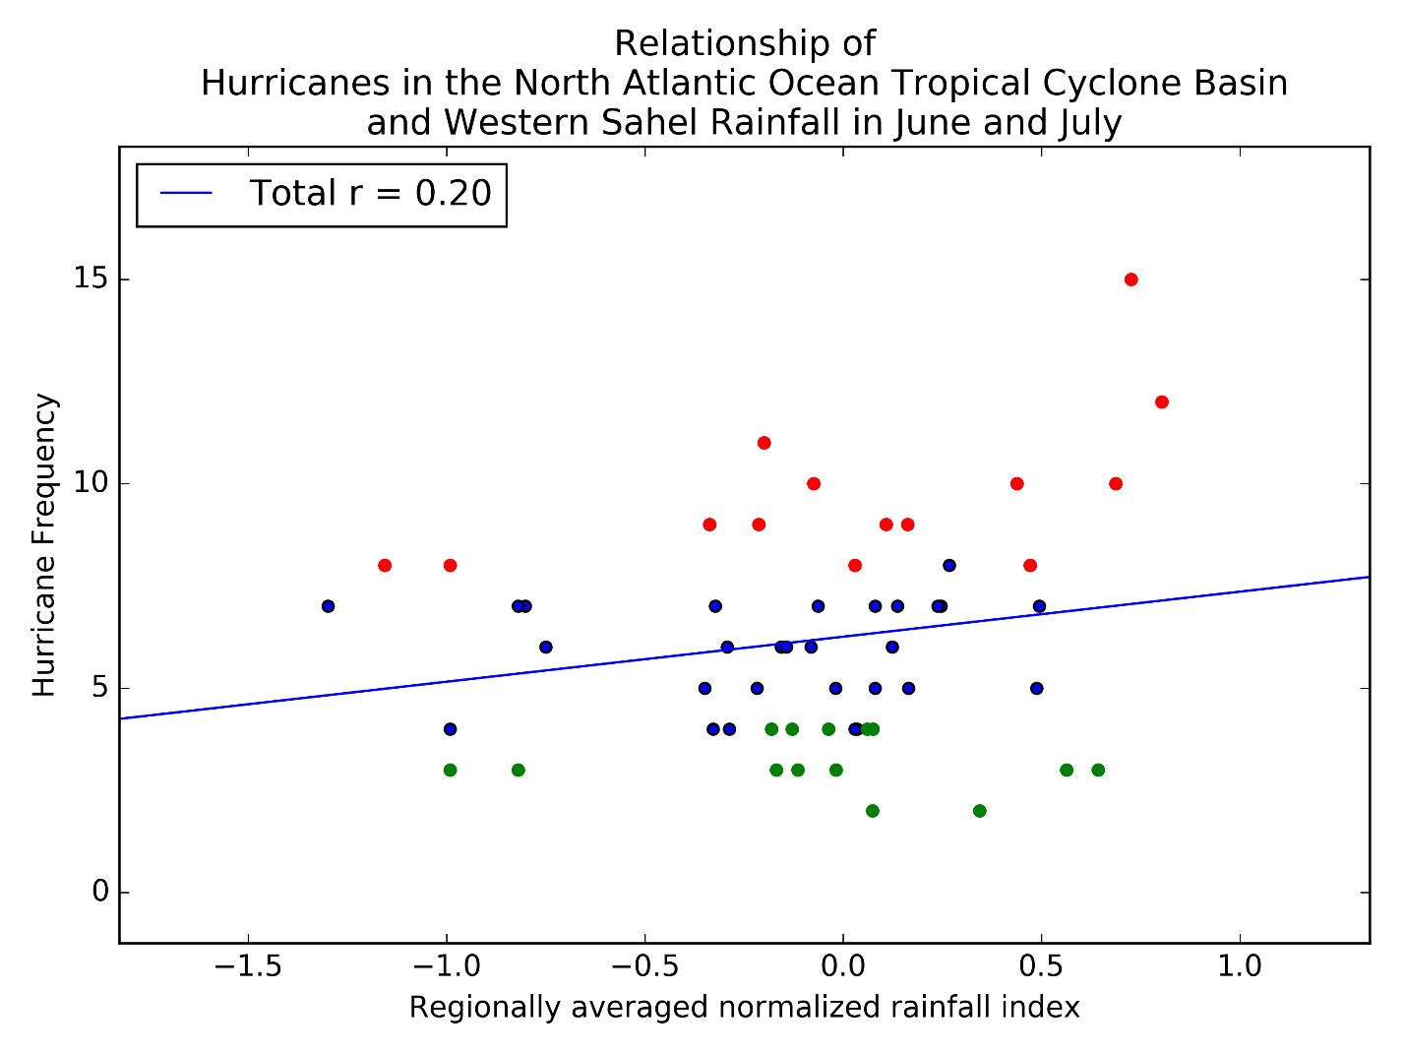

Figure 8: Correlation between the regionally averaged normalized rainfall over the Western Sahel region in June and July and the frequency of tropical cyclones of hurricane strength, over the same time range as in Figure 2. The correlation coefficient of the linear regression is 0.20, which indicates a very weak correlation.

The correlation coefficient between the linear regression between the Western Sahel regionally averaged rainfall index and frequency of intense hurricane-strength (Saffir-Simpson scale categories three and higher) tropical cyclones is 0.06, as shown in Figure 10. No discernable trend is evident from the scatter plot, so this gives strong evidence that there is no correlation between the rainfall index and the frequency of intense hurricanes. Thus, it is very unlikely that early season rainfall over the Western Sahel is a significant factor influencing the number of tropical cyclones that reach intense hurricane strength during the remainder of the season.

The correlation between Western Sahel rainfall and the number of days of intense hurricanes has a correlation coefficient of -0.05, as shown in Figure 11. This is very low in comparison with the correlations of the AMO and ENSO and both the frequency of named storms and the number of storm days, and indicates almost no correlation between the two variables. This suggests that early season Western Sahel rainfall is not a significant factor in the number of intense hurricane-strength storm days during the season.

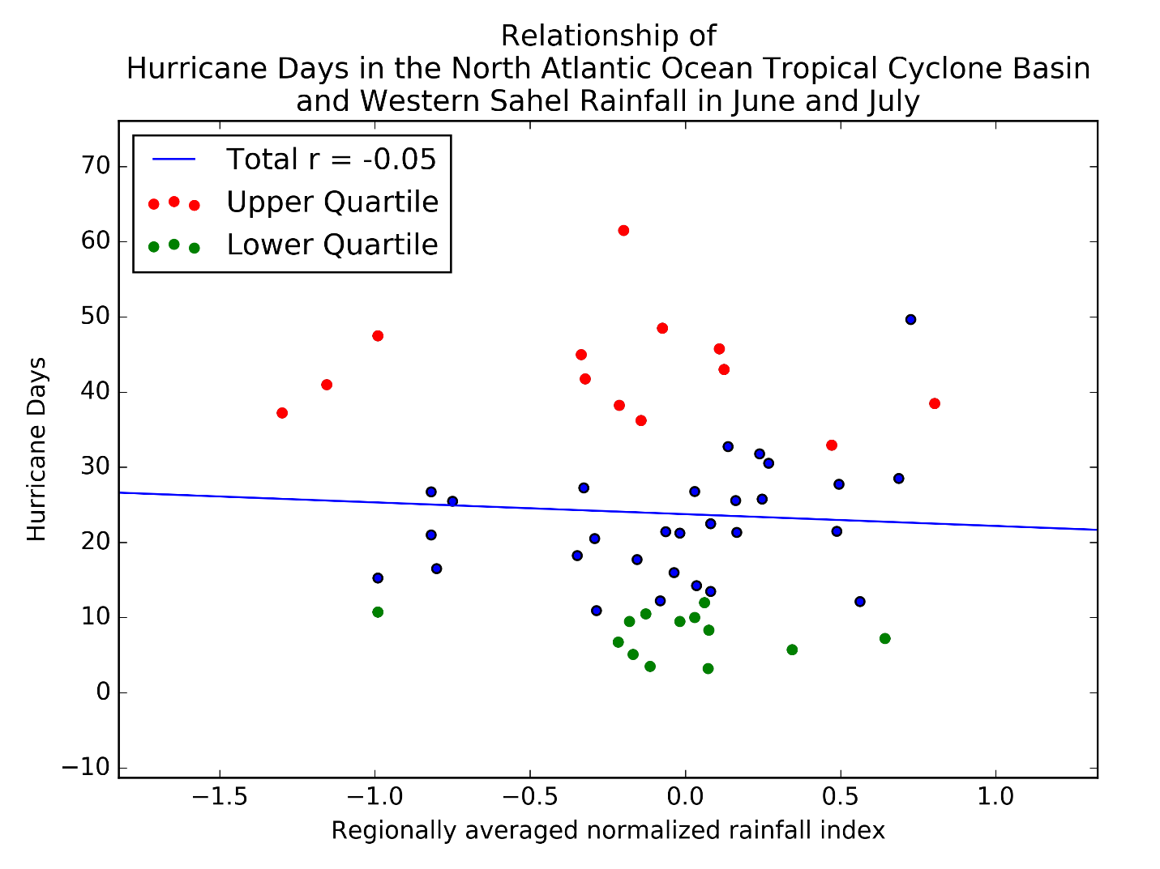

Figure 9: Correlation between the regionally averaged normalized rainfall over the Western Sahel region in June and July and the number of days of tropical cyclones of hurricane strength, over the same time range as in Figure 7. The correlation coefficient of the linear regression is -0.05, which indicates almost no correlation.

1. *Sources of Error*

Given the large amount of data involved in the production of these results, it is unsurprising that are several sources of error that may contribute to their inaccuracy. Most notable is that the station data that were used to calculate early season rainfall contained a large quantity of missing data, forcing the calculations to be extrapolated. It is also important to note that the phase of ENSO and the AMO were calculated for the time period during the time period under study for rainfall. However, the effects of ENSO are generally most pronounced in the winter months, so a change in the phase between winter and summer may indicate a different effect than what occurred in some years. In addition, no trends have been removed from the rainfall data to adjust for climate change. However, Landsea and Gray found no difference in their results based on whether the data was detrended, so this effect may be smaller, and may only alter the strength of the results rather than the results obtained (1992).

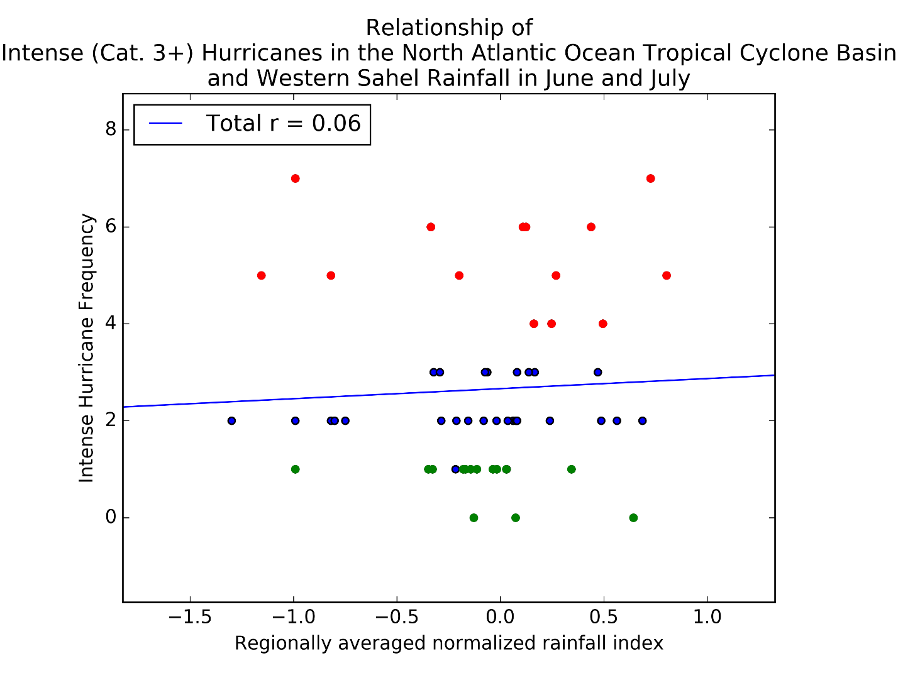

Figure 10: Correlation between the regionally averaged normalized rainfall over the Western Sahel region in June and July and the frequency of tropical cyclones of intense hurricane strength (Category Three and higher on the Saffir-Simpson Scale), over the same time range as in Figure 2. The correlation coefficient of the linear regression is 0.06, which indicates almost no correlation.

1. **Conclusion**

The correlation coefficient for the linear regression of Western Sahel rainfall and tropical cyclone frequency in the North Atlantic Ocean is 0.43, comparable with the correlation between ENSO and tropical cyclone frequency. The correlations between Western Sahel rainfall and hurricanes of any strength were weaker. The lack of a correlation between either ENSO or the AMO and the rainfall in the Western Sahel suggests that the rainfall’s effect on tropical cyclone activity is independent of these two oceanic oscillations. Therefore, rainfall in June and July may be considered as a factor in refining the forecast of the number of tropical cyclones that occur in the remainder of the season, but not the strength of these storms. This limits the usage in determining whether the remainder of the season will be particularly destructive, but still provides a useful baseline for producing more accurate forecasts regarding overall activity for the rest of the season. Care must be taken however, as Western Sahel rainfall may be influenced by other oscillations not noted here, and many other factors influence tropical cyclone activity, so it should not be taken as the sole ingredient to a seasonal activity forecast.

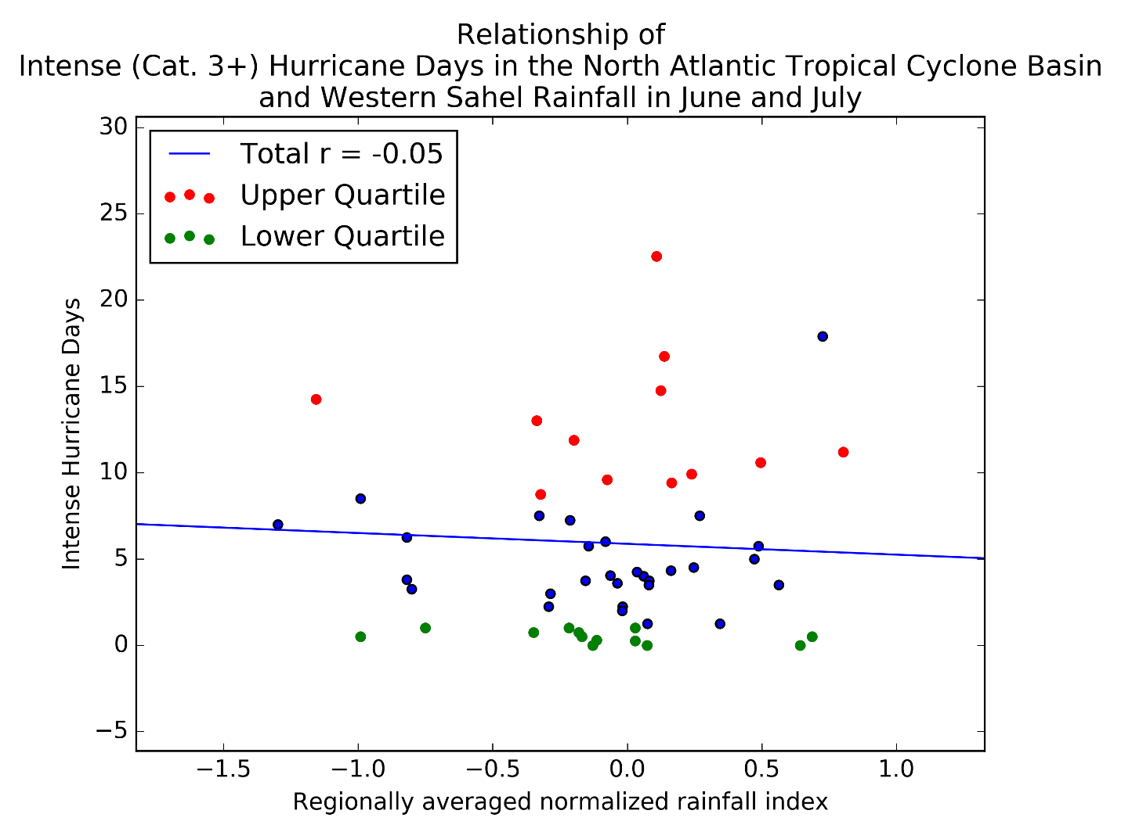

Figure 11: Correlation between the regionally averaged normalized rainfall over the Western Sahel region in June and July and the number of days of tropical cyclones of intense hurricane strength, over the same time range as in Figure 7. The correlation coefficient of the linear regression is -0.05, which indicates almost no correlation.

Future work that may beneficially extend this study would incorporate other sets of seasonal oscillations that are not considered in this study, such as the Quasi-Biennial Oscillation, the North Atlantic Oscillation, or the Pacific Decadal Oscillation. Correlations with these phenomena would help further isolate the independence (or potential lack thereof) of the effect of Western Sahel rainfall. It may also be useful to look at correlations between ENSO when the phase is calculated from the previous winter’s state.

1. **References**

Atlantic Ocean and Meteorological Laboratory Hurricane Research Division, 2016: Re-Analysis Project. National Oceanic and Atmospheric Administration, http://www.aoml.noaa.gov/hrd/hurdat/Data_Storm.html

Earth System Research Laboratory Physical Sciences Division, 2015: Niño 3.4 SST Index. National Oceanic and Atmospheric Administration, https://www.esrl.noaa.gov/psd/gcos_wgsp/Timeseries/Nino34/

Earth System Research Laboratory Physical Sciences Division, 2017: Climate Timeseries AMO (Atlantic Multidecadal Oscillation) Index. National Oceanic and Atmospheric Administration, https://www.esrl.noaa.gov/psd/data/timeseries/AMO/

Gray, W.M. and C.W. Landsea, 1992: [African Rainfall as a Precursor of Hurricane-Related Destruction on the U.S. East Coast.](http://journals.ametsoc.org/doi/abs/10.1175/1520-0477(1992)073%3c1352%3AARAAPO%3e2.0.CO%3B2) *Bull. Amer. Meteor. Soc.,* **73**, 1352–1364, [https://doi.org/10.1175/1520-0477(1992)073<1352:ARAAPO>2.0.CO;2](https://doi.org/10.1175/1520-0477(1992)073%3c1352:ARAAPO%3e2.0.CO;2)

Klotzbach, P.J., 2007: Revised Prediction of Seasonal Atlantic Basin Tropical Cyclone Activity from 1 August. Wea. Forecasting, 22, 937–949, <https://doi.org/10.1175/WAF1045.1>

Knudsen, M. F. *et al*, 2011: Tracking the Atlantic Multidecadal Oscillation through the last 8,000 years. *Nat. Commun.*2:178 doi: 10.1038/ncomms1186.

Kug, J., F. Jin, and S. An, 2009: Two Types of El Niño Events: Cold Tongue El Niño and Warm Pool El Niño. *J. Climate,* **22**, 1499–1515, https://doi.org/10.1175/2008JCLI2624.1

Landsea, C.W. and W.M. Gray, 1992: [The Strong Association between Western Sahelian Monsoon Rainfall and Intense Atlantic Hurricanes.](http://journals.ametsoc.org/doi/abs/10.1175/1520-0442(1992)005%3c0435%3ATSABWS%3e2.0.CO%3B2) *J. Climate,* **5**, 435–453, [https://doi.org/10.1175/1520-0442(1992)005<0435:TSABWS>2.0.CO;2](https://doi.org/10.1175/1520-0442(1992)005%3c0435:TSABWS%3e2.0.CO;2)

Larkin, N. K., and D. E. Harrison, 2005: On the definition of El Niño and associated seasonal average U.S. weather anomalies. *Geophys. Res. Lett.*, **32,** L13705. doi:10.1029/2005GL022738.

NCEI/NCDC, 2017: NNDC Climate Data Online, Production Version (updated daily). National Climatic Data Center, https://www7.ncdc.noaa.gov/CDO/cdoselect.cmd.

Trenberth, Kevin, Zhang, Rong & National Center for Atmospheric Research Staff (Eds), 2017: The Climate Data Guide: Atlantic Multi-decadal Oscillation (AMO). University Corporation for Atmospheric Research, National Center for Atmospheric Research, https://climatedataguide.ucar.edu/climate-data/atlantic-multi-decadal-oscillation-amo.