Investigation of the Existence of Vertically Oriented Ice CRYSTALs in Winter Storms
by
Kendra Ranae Sand
Bachelor of Science, Embry-Riddle Aeronautical University, 2009
A Thesis
Submitted to the Graduate Faculty
of the
University of North Dakota
in partial fulfilment of the requirements
for the degree of
Master of Science
Grand Forks, North Dakota
December
2024

© 2024 Kendra Ranae Sand

(Reserved for approval page)

PERMISSION
Title Investigation of the Existence of Vertically Oriented Ice Crystals in Winter Storms
Department Atmospheric Science
Degree Master of Science
In presenting this thesis in partial fulfillment of the requirements for a graduate degree from the University of North Dakota, I agree that the library of this University shall make it freely available for inspection. I further agree that permission for extensive copying for scholarly purposes may be granted by the professor who supervised my thesis work, or in his absence, by the Chairperson of the department or the dean of the School of Graduate Studies. It is understood that any copying or publication or other use of this thesis or part thereof for financial gain shall not be allowed without my written permission. It is also understood that due recognition shall be given to me and to the University of North Dakota in any scholarly use which may be made of any material in my thesis.
Kendra R. Sand
11 December 2024

Table of Contents
LIST OF FIGURES vi
LIST OF TABLES xiv
ACKNOWLEDGEMENTS xvi
ABSTRACT xviii
CHAPTER I INTRODUCTION 1
CHAPTER II INSTRUMENTATION 5
CHAPTER III DATA PROCESSING 9
3.1 Quality Assurance 19
CHAPTER IV DATA SET 22
4.1 Observational Platforms 22
4.2 Additional Observations 25
CHAPTER V METHODOLOGY 33
5.1 Case Selection 33
5.2 Analysis Approach 38
CHAPTER VI DATA 40
CHAPTER VII RESULTS 56
CHAPTER VIII DISCUSSION 70
CHAPTER IX CONCLUSIONS 72
REFERENCES 77
DATA AND SOFTWARE AVAILABILITY 79
APPENDIX A 80
APPENDIX B 85
list of figures
FIGURE 1 6
Simplified Two-Dimensional Stereo Optical Array Probe (2D-S) with the vertical channel (2D-SV) laser path in red and the horizontal channel (2D-SH) in green as it originates at the transmitting (T) arms and is sent through the receiving arms (R). The dashed lines show the path each channel takes inside the 2D-S as it is bent 90 degrees twice and is detected by an array of 128 photodiodes, represented by the dotted lines (blue) for each channel. The aircraft-relative reference frame is given, where the x-axis points forward along the direction of flight (aircraft nose), the y-axis points to the right (starboard) wingtip, and the z-axis points down.
FIGURE 2 8
Artistic rendering of how a variety of vertically oriented columnar and planar ice crystals would appear in the two-dimensional shadow image data of the Two-Dimensional Stereo Optical Array Probe (2D-S) if captured by both the horizontal (green) and vertical (red) channels. The ice crystal and laser beam depictions are not to scale. Each 3-D model of an ice crystal in this figure was given a 90 degree rotation to provide an accurate representation of orthogonal shadow image sampling. Note that the images appear on the 2D-S image strip in succession from left to right as the ice crystals pass through the sampling volume sequentially, which appears to be a mirrored image due to the viewing angle of the figure. The x, y, z labels in the diagram indicate the aircraft-relative coordinate system, whereas the X and Y labeled in blue on the image strip are relative to the 2D-S array axis. The array of 2D-S photodiodes are labeled as 1 to 128 in both the diagram and the image strips in the columnar example. The relative position of the transmitting (T) and receiving (R) arms of the 2D-S are labeled in the planar example for both the horizontal (H) and vertical (V) laser beams.
FIGURE 3 11
Diagram showing how an in situ idealized hexagonal plate crystal encountering the sampling volume of the Two-Dimensional Stereo Optical Array Probe (2D-S) is recorded in the image data and parameterized by the System for Optical Array Probe (OAP) Data Analysis (SODA-2) processing software using the Fast Circle Method, which generates a smallest enclosing circle for each particle. The measured particle diameter is equal to the diameter of the smallest enclosing circle. The major axis of the particle is identified based on the maximum dimension and is equal to the particle diameter, and the minor axis is orthogonal to the major axis. The Orientation Angle parameter is the angle between the major axis and the 2D-S array axis, with clockwise rotations (towards the direction of flight) being positive angles and counterclockwise rotations being negative angles.
FIGURE 4 13
Depicts how particles sampled by the Two-Dimensional Stereo Optical Array Probe (2D-S) and parameterized by System for OAP Data Analysis (SODA-2) define the Orientation Angle parameter of each non-circular particle based on the angle between the major axis of the particle and the array of diodes that receives the laser beam across the sampling volume. A sampled particle that has a major axis parallel with the diode array will result in an Orientation Angle of zero degrees. A clockwise rotation away from the diode array axis is measured as a positive Orientation Angle, and a counterclockwise rotation away from the diode array is a negative Orientation Angle. The range of possible values includes -90 to +90 degree angles. The Orientation Angle is measured by both orthogonally-positioned channels of the 2D-S, with a depiction of the horizontal channel shown in (a) and the vertical channel shown in (b).
FIGURE 5 14
Randomly selected Two-Dimensional Stereo Optical Array Probe (2D-S) image data that corresponds with the attribute data shown in Table 1.
FIGURE 6 16
The possible shaded pixel configurations of single (a), dual (b) and (c), and up to three (d) pixel particles, as would be depicted in Two-Dimensional Stereo Optical Array Probe (2D-S) image data and the default orientation angles for each possible pixel configuration.
FIGURE 7 17
Orientation angle histograms for particles with diameters of 10 µm sampled during the 07 February, 2020 Investigation of Microphysics and Precipitation for Atlantic Coast-Threatening Snowstorms (IMPACTS) flight for the Two-Dimensional Stereo Optical Array Probe (2D-S) horizontal (left) and vertical (right) channels.
FIGURE 8 17
Similarly, the orientation angle histogram for particles up to 20 µm diameter sampled during the 07 February, 2020 Investigation of Microphysics and Precipitation for Atlantic Coast-Threatening Snowstorms (IMPACTS) flight for the Two-Dimensional Stereo (2D-S) Optical Array Probe (OAP) horizontal (left) and vertical (right) channels.
FIGURE 9 18
Finally, the orientation angle histogram for particles greater than 20 µm but less than or equal to 30 µm in diameter sampled during the 07 February, 2020 Investigation of Microphysics and Precipitation for Atlantic Coast-Threatening Snowstorms (IMPACTS) flight for the Two-Dimensional Stereo Optical Array Probe (2D-S) horizontal (left) and vertical (right) channels.
FIGURE 10 20
Buffer of Two-Dimensional Stereo Optical Array Probe (2D-S) images from the 07 February, 2020 Investigation of Microphysics and Precipitation for Atlantic Coast-Threatening Snowstorms (IMPACTS) flight at 17:09:35 UTC for the vertical channel. The subsequent buffer is positioned to the right of the preceding buffer to demonstrate a case where an ice crystal was sampled near the end of a data buffer and continued in the next buffer. The black triangle along the bottom of the strip denotes the transition point between buffers, and the timestamp in [HHMMSS.ss UTC] format is labeled along the top of each image strip.
FIGURE 11 20
An additional example showing the buffer of Two-Dimensional Stereo Optical Array Probe (2D-S) images from the 07 February, 2020 Investigation of Microphysics and Precipitation for Atlantic Coast-Threatening Snowstorms (IMPACTS) flight at 17:10:11 UTC for the vertical channel. The subsequent buffer is positioned to the right of the preceding buffer to demonstrate a case where an ice crystal was sampled near the end of a data buffer and continued in the next buffer. The black triangle along the bottom of the strip denotes the transition point between buffers, and the timestamp in [HHMMSS.ss UTC] format is labeled along the top of each image strip.
FIGURE 12 25
Simplified rendering of a top-view of the NASA P-3 Orion research aircraft and its local frame of reference coordinate system, where the x-axis points out the nose of the aircraft along the direction of flight, the y-axis is aligned with the right wing (starboard side) of the aircraft, and the z-axis points down towards the ground when in level flight. The instrument labels shown in blue mark the mounting locations of each probe assembly when configured for the Investigation of Microphysics and Precipitation for Atlantic Coast-Threatening Snowstorms (IMPACTS) campaign.
FIGURE 13 26
Photo of the mounting location of the Particle Habit Imaging and Polar Scattering (PHIPS) Probe and Two-Dimensional Stereo Optical Array Probe (2D-S) on the outer pylon of the starboard wing of the NASA P-3 aircraft during the Investigation of Microphysics and Precipitation for Atlantic Coast-Threatening Snowstorms (IMPACTS) 2020 field campaign.
FIGURE 14 28
A photo taken during ground testing of the NASA P-3 during the Investigation of Microphysics and Precipitation for Atlantic Coast-Threatening Snowstorms (IMPACTS) campaign in 2020 shows a wide angle view of Rosemount Icing Detector (RICE) mounting location on the right (starboard) side of the fuselage.
FIGURE 15 30
Photo depicting the left (port) wing probes on the NASA P-3 during the preflight inspection of the 18 January, 2020 Investigation of Microphysics and Precipitation for Atlantic Coast-Threatening Snowstorms (IMPACTS) flight. The instruments mounted here include the two adjacent, orthogonally mounted High Volume Precipitation Spectrometers (HVPS-3) on the inboard pylon and the Cloud Droplet Probe (CDP), King Liquid Water Content 100 (LWC-100), and Nevzorov Probe on the outboard pylon hot wire boom. Note the inboard mounting location of the CDP on the hot wire boom.
FIGURE 16 31
Later in the campaign, a photo taken on 01 February, 2020 during ground testing of the NASA P-3 wing-mounted probes during the Investigation of Microphysics and Precipitation for Atlantic Coast-Threatening Snowstorms (IMPACTS) campaign shows the modified mounting position of the Cloud Droplet Probe (CDP) on the outboard side of the hot wire boom.
FIGURE 17 32
Captured during the preflight inspection of the 18 January, 2020 Investigation of Microphysics and Precipitation for Atlantic Coast-Threatening Snowstorms (IMPACTS) flight, this photo displays the right (starboard) wing probes on the NASA P-3, including the Particle Habit Imaging and Polar Scattering (PHIPS) on the outboard side of the outboard pylon, the standalone Two-Dimensional Stereo Optical Array Probe (2D-S) on the inboard side of the outboard pylon, and the Hawkeye on the inboard pylon, which contained the Cloud Particle Imager (CPI).
FIGURE 18 35
Four pairs of time series plots from the Two-Dimensional Stereo Optical Array Probe (2D-S) horizontal and vertical channels of the orientation angles of all particles sampled during the 07 February, 2020 Investigation of Microphysics and Precipitation for Atlantic Coast-Threatening Snowstorms (IMPACTS) flight that met the following subset criteria: (a) particles with aspect ratios up to 0.6; (b) all-in particles with aspect ratios up to 0.6; (c) all-in particles greater than 100 µm in diameter with aspect ratios up to 0.6; (d) all-in particles greater than 200 µm in diameter with aspect ratios up to 0.6. Particles are assigned a color based upon the aspect ratio of the particle. The apparent lapse in the data around the 17:24:57 UTC mark is due to a momentary cloud-free segment.
FIGURE 19 37
The same two time series plots from the Two-Dimensional Stereo Optical Array Probe (2D-S) horizontal and vertical channels are shown along the top and bottom of each quadrant of this figure. The data shown is a plot of the orientation angles of all particles sampled during the 07 February, 2020 Investigation of Microphysics and Precipitation for Atlantic Coast-Threatening Snowstorms (IMPACTS) flight that met the following subset criteria: all-in particles greater than 100 µm in diameter with aspect ratios up to 0.6. Interesting periods are outlined in red and categorized by similar patterns into four types: A, B, C, and D, which will be used as the basis for further investigation and possible identification of particle orientation cases.
FIGURE 20 38
A final look at two time series plots from the Two-Dimensional Stereo Optical Array Probe (2D-S) horizontal and vertical channels of the orientation angles of all particles sampled during the 07 February, 2020 Investigation of Microphysics and Precipitation for Atlantic Coast-Threatening Snowstorms (IMPACTS) flight that met the following refined subset criteria: all-in particles greater than 100 µm in diameter with aspect ratios up to 0.6 and area ratios greater than 0.1.
FIGURE 21 44
Maps showing the NASA P-3 starting and ending point locations and flight track (red) of each selected case during the 07 February, 2020 Investigation of Microphysics and Precipitation for Atlantic Coast-Threatening Snowstorms (IMPACTS) flight with the NEXRAD Reflectivity Mosaic displayed. The GPS Altitude (m) of the NASA P-3 is given for each starting and ending point, and the Total Air Temperature (C) is also given for the starting and ending times (UTC) of each case.
FIGURE 22 47
Plots detailing the NASA P-3 True Heading (dark green), Pitch Angle (gray), Roll Angle (medium green), GPS Altitude (light blue), Total Air Temperature (dark blue), and Dew Point Temperature (light green) data for selected cases of the 07 February, 2020 Investigation of Microphysics and Precipitation for Atlantic Coast-Threatening Snowstorms (IMPACTS) science flights.
FIGURE 23 48
This figure represents one example of the Two-Dimensional Stereo Optical Array Probe (2D-S) image data collected during the 07 February, 2020 Investigation of Microphysics and Precipitation for Atlantic Coast-Threatening Snowstorms (IMPACTS) flight. The horizontal (vertical) channel is shown on the left (right). The images depicted in blue are the silhouettes of particles sampled by the 2D-S and magnified so that each pixel is equivalent to a width of 10 µm. Each strip of data is a time-series record of the shape, size, orientation, and inter-particle timestamp of sampling occurrence in succession, with a new strip beginning upon the 2D-S reaching its data buffer limit. The beginning timestamp of the buffer is labeled along the lefthand side of each strip in seconds from midnight (sfm). In both channels, the upper left corner of each strip is the origin of the aircraft coordinate system with the positive X-direction pointing down along the short end of the data strip and the positive Y-direction pointing to the right along the long end of the data strip, where the positive X-direction represents the direction of flight, and the positive Y-direction extends away from the aircraft fuselage and toward the right wing tip due to the 2D-S being mounted underneath the right wing.
FIGURE 24 51
Lightning Instrument Package (LIP) V2 data from selected cases that were collected during the 07 February, 2020 Investigation of Microphysics and Precipitation for Atlantic Coast-Threatening Snowstorms (IMPACTS) science flight. Each vector component of the cloud top electric field is plotted in Earth coordinates, with En representing the cardinal north direction, Ew positive toward the cardinal west direction, and Eu representing the upward component. Data is smoothed to remove erroneous data points.
FIGURE 25 54
Plots depict particle concentration measurements made by the Two-Dimensional Stereo Optical Array Probe (2D-S) horizontal (2D-S_H Conc) and vertical channels (2D-S_V Conc) and the Cloud Droplet Probe (CDP) concentration (CDP Conc) during the 07 February, 2020 Investigation of Microphysics and Precipitation for Atlantic Coast-Threatening Snowstorms (IMPACTS) flight selected cases. The plots each include a segmented line below the x-axis, which indicates distinctive periods identified as relatively “low” (dotted yellow bar) or “high” (pink hatched bar) concentration periods within the case.
FIGURE 26 59
Histograms show orientation angle occurrences by percentage for all selected cases during the 07 February, 2020 Investigation of Microphysics and Precipitation for Atlantic Coast-Threatening Snowstorms (IMPACTS) flight. The Two-Dimensional Stereo Optical Array Probe (2D-S) horizontal channel is displayed on the left and the vertical channel is displayed on the right. The corresponding time segments and predominant particle habit types are listed for each case in Table 3.
FIGURE 27 60
A further investigation of previously shown Case #4 orientation angle histograms from the 07 February, 2020 Investigation of Microphysics and Precipitation for Atlantic Coast-Threatening Snowstorms (IMPACTS) flight at 16:09:40 to 16:15:40 UTC, with refined subset criteria applied. The two subset versions shown involve all orientation angles from particles with an aspect ratio of (a) 0.1 to 0.4, and (b) 0.2 to 0.3. The Two-Dimensional Stereo Optical Array Probe (2D-S) horizontal channel is displayed on the left and the vertical channel is displayed on the right.
FIGURE 28 61
The particle orientation angles (x-axis) by diameter (y-axis) of the preferred angle peaks of all particles sampled by the Two-Dimensional Stereo Optical Array Probe (2D-S) horizontal channel (left) and the vertical channel (right) during Case #4, which was during the 07 February, 2020 Investigation of Microphysics and Precipitation for Atlantic Coast-Threatening Snowstorms (IMPACTS) flight at 16:09:40 to 16:15:40 UTC, further subset with an aspect ratio of 0.1 to 0.4. The preferred angle peaks were observed in the histograms (Figure 27), with a range of 0.0-9.0 degrees for horizontal and 9.0-18.0 degrees for vertical.
FIGURE 29 63
A histogram comparison of orientation angles observed by the Two-Dimensional Stereo Optical Array Probe (2D-S) horizontal channel (top) and the vertical channel (bottom) during the 07 February, 2020 Investigation of Microphysics and Precipitation for Atlantic Coast-Threatening Snowstorms (IMPACTS) flight within distinct periods of high and low concentration. This example comes from periods identified within Case #6.
FIGURE 30 64
Similarly, histograms of orientation angles observed by the Two-Dimensional Stereo Optical Array Probe (2D-S) horizontal channel (top) and the vertical channel (bottom) during the 07 February, 2020 Investigation of Microphysics and Precipitation for Atlantic Coast-Threatening Snowstorms (IMPACTS) flight within distinct periods of high and low concentration. This example comes from periods identified within Case #4.
FIGURE 31 66
Additional histograms depict a comparison of orientation angles observed by the Two-Dimensional Stereo Optical Array Probe (2D-S) horizontal channel (left) and the vertical channel (right) during the 07 February, 2020 Investigation of Microphysics and Precipitation for Atlantic Coast-Threatening Snowstorms (IMPACTS) flight within distinct periods of high and low concentration. These examples come from Cases #1, 2, 5, 8, and 10.
FIGURE 32 69
Orientation angle occurrences plotted in a histogram by percentage for all selected cases during the 07 February, 2020 Investigation of Microphysics and Precipitation for Atlantic Coast-Threatening Snowstorms (IMPACTS) flight in which there were distinct periods of straight and level flight that could be compared to a maneuver other than straight and level flight. The Two-Dimensional Stereo Optical Array Probe (2D-S) horizontal channel is displayed on the left and the vertical channel is displayed on the right.
FIGURE 33 81
Artistic rendering of the interior of a Particle Measuring Systems (PMS) canister includes two possible configurations for connecting the pin connecter on the Two-Dimensional Stereo Optical Array Probe (2D-S) to the pin connector on the PMS canister. Configuration A is a connection to the vertical pin connecter, while Configuration B is a connection to the horizontal pin connector. While this provides for flexibility in how the 2D-S probe is installed, it can result in ambiguity as to the orientation of the horizontal and vertical sampling arms. The correct configuration is Configuration A, because it will result in the 2D-S Horizontal Transmitter and Horizontal Receiver arms being parallel with the ground.
FIGURE 34 82
Multiple additional examples of Two-Dimensional Stereo Optical Array Probe (2D-S) Image Data in image buffer strip format from the 07 February, 2020 Investigation of Microphysics and Precipitation for Atlantic Coast-Threatening Snowstorms (IMPACTS) flight for the horizontal channel (a-j) and the vertical channel (k-t). Each subsequent buffer is positioned to the right of the preceding buffer to demonstrate cases where an ice crystal was sampled near the end of a data buffer and continued in the next buffer. The black triangle along the bottom of the strip denotes the transition point between buffers, and the timestamp in [HHMMSS.ss UTC] is labeled along the top of each image strip.
FIGURE 35 88
Multiple additional examples of Two-Dimensional Stereo Optical Array Probe (2D-S) Image Data in image buffer strip format from the 07 February, 2020 Investigation of Microphysics and Precipitation for Atlantic Coast-Threatening Snowstorms (IMPACTS) flight for the horizontal channel (a-j) and the vertical channel (k-t). Each subsequent buffer is positioned to the right of the preceding buffer to demonstrate cases where an ice crystal was sampled near the end of a data buffer and continued in the next buffer. The black triangle along the bottom of the strip denotes the transition point between buffers, and the timestamp in [HHMMSS.ss UTC] is labeled along the top of each image strip.

list of tables
TABLE 1 14
Two-Dimensional Stereo Optical Array Probe (2D-S) attribute data as recorded in the particle-by-particle file corresponding to image data (Figure 5). Two examples are shown from the 2D-S horizontal (H) channel and two from the 2D-S vertical (V) channel. The three linear measurements given for each imaged particle include the particle diameter based on the fast circle method of processing, and an X and Y measurement, with X representing the dimension parallel to the array axis and Y representing the dimension parallel to the direction of flight. The “all in” flag is a 1 if the particle image is fully contained within the image strip and not in contact with array ends, and the flag is a 0 if the particle is only partially contained within the image strip. The inter-arrival time of each particle is shown in the last column as inter-particle time (IPT).
TABLE 2 20
Two-Dimensional Stereo Optical Array Probe (2D-S) particle-by-particle attribute data for 07 February, 2020 Investigation of Microphysics and Precipitation for Atlantic Coast-Threatening Snowstorms (IMPACTS) flight, vertical channel, which corresponds to the images shown in Figure 10 and Figure 11. The time is given in a [HH:MM:SS UTC] format and a seconds-from-midnight [SSSSS.ss sfm] format. The three linear measurements given for each imaged particle include the particle diameter based on the fast circle method of processing, and an X and Y measurement, with X representing the dimension parallel to the array axis and Y representing the dimension parallel to the direction of flight. The “all in” flag is a 1 if the particle image is fully contained within the image strip and not in contact with array ends, and the flag is a 0 if the particle is only partially contained within the image strip. The inter-arrival time of each particle is shown in the last column as inter-particle time (IPT). More examples of buffer-spanning particles and associated particle attributes are detailed in Appendix B.
TABLE 3 41
All cases examined during the 07 February, 2020 Investigation of Microphysics and Precipitation for Atlantic Coast-Threatening Snowstorms (IMPACTS) flight during the search for ice crystals with vertical orientation or a preferred angle.
TABLE 4 41
The predominant particle habit types as determined by visual assessment of corresponding Cloud Particle Imager (CPI) images for all cases examined during the 07 February, 2020 Investigation of Microphysics and Precipitation for Atlantic Coast-Threatening Snowstorms (IMPACTS) flight during the search for ice crystals with vertical orientation or a preferred angle.
TABLE 5 49
The geographical positions and relative distance of the NASA P-3 and NASA ER-2 research aircrafts during selected cases (ID) of the 07 February, 2020 Investigation of Microphysics and Precipitation for Atlantic Coast-Threatening Snowstorms (IMPACTS) science flights. A factor of 111 km/deg was used to convert latitude (Lat.) and longitude (Long.) positions to distances in km. The ER-2 began to depart after Case #4 and was not available during later cases. The geographical difference is calculated independently of the altitude (Alt.) difference.
TABLE 6 88
Corresponding Two-Dimensional Stereo Optical Array Probe (2D-S) particle-by-particle attribute data for 07 February, 2020 Investigation of Microphysics and Precipitation for Atlantic Coast-Threatening Snowstorms (IMPACTS) flight, to the images shown in Figure 35. The time is given in [HHMMSS.ss UTC] format and a seconds-from-midnight [SSSSS.ss sfm] format. The three linear measurements given for each imaged particle include the particle diameter based on the fast circle method of processing, and an X and Y measurement, with X representing the dimension parallel to the array axis and Y representing the dimension parallel to the direction of flight. The “all in” flag is a 1 if the particle image is fully contained within the image strip and not in contact with array ends, and the flag is a 0 if the particle is only partially contained within the image strip. The inter-arrival time of each particle is shown in the last column as inter-particle time (IPT).

acknowledgements
I would like to express my deepest gratitude to my adviser, Dr. David Delene, as well as my committee members, Dr. Jared Marquis and Professor Emeritus Michael Poellot, for their wisdom, thoughtful feedback, and technical expertise throughout this research. Their insight and encouragement were fundamental to the direction and completion of this work.
I am sincerely thankful to Dr. Aaron Bansemer (NCAR) for his expert guidance and willingness to mentor me regarding 2D-S data interpretation and to Drs. Christopher Schultz and Douglas Mach (Marshall Space Flight Center) for their invaluable assistance with LIP data.
This project would not have been possible without the dedication and collaboration of the NASA IMPACTS science team, flight crews, and project managers. Being part of such a dynamic and unique research effort was both inspiring and rewarding, motivating me to take on the challenges of this topic. I am also profoundly grateful to the UND Atmospheric Sciences faculty, my fellow students, and my research group for their camaraderie and support. Their humor, endurance, and shared sense of purpose helped me navigate this project with determination.
Lastly, I extend a most heartfelt thanks to my Mom, Dad, brother Jeffrey, sister Laura, extended family members, and friends for their unconditional love and encouragement. My sister was instrumental in breaking the dreaded hindrance of writer’s block by providing the first word for this work (“the”). Their resolute hunger for my success and belief in me has been a source of continual strength and motivation throughout this endeavor.

To my beloved cat, Rodnie, whose unwavering patience, love, and loyalty provided constant comfort during countless sleepless nights and the many challenges I faced on this journey.
Her companionship inspired me to persevere and work toward a better life for us both. Though she is no longer with me, I know she would be proud of me for finally reaching this milestone, just as I was proud to have had her by my side.



abstract
The existence of vertically oriented ice crystals is investigated in winter storms, as observed through remote sensing and analyzed during the NASA Earth Venture Investigation of Microphysics and Precipitation for Atlantic Coast-Threatening Snowstorms (IMPACTS) field campaign field campaign. The primary objective was to determine if a preferred angle of ice crystal orientation could be identified in situ using contemporary airborne sampling instruments. Additionally, the study sought to explore potential correlations between the vertical orientation of ice crystals and electric field anomalies at cloud top, as well as the relationship between crystal orientation and particle concentration. To achieve these objectives, Two-Dimensional Stereo Optical Array Probe (2D-S) Image Data were meticulously analyzed to isolate low aspect ratio ice crystals, including columns, needles, and plates, based on predefined subset parameters. Histograms depicting orientation angles were constructed for each case, comparing results from both horizontal and vertical channels. While some trends were observed—particularly a peak near +21 degrees in the vertical channel—the findings revealed no conclusive evidence of atmospheric vertical orientation due to the absence of null cases. Further, the examination of electric field measurements and particle concentration yielded inconclusive results, with no consistent patterns correlating with the observed orientation. Ultimately, while a preferred angle of orientation was detected, it is postulated that this phenomenon was influenced by external factors, such as airflow around the research aircraft, rather than reflecting the natural state of the ice crystals. This research highlights the need for enhanced in situ electric field measurements and emphasizes the challenges in accurately interpreting ice crystal orientation in dynamic atmospheric conditions.

INTRODUCTION
The nature of ice crystals as they exist suspended in a cloud formation, or when involved in precipitation processes, has become an increasingly crucial pursuit of atmospheric sciences due to the advances of remote sensing technologies that are routinely employed in modern research and weather forecasting. An important and largely overlooked ice crystal property is the spatial arrangement of ice crystal axes and faces, which can exhibit specific orientations due to aerodynamic, electric, and gravitational forces (Weinheimer and Few 1987). Vertical orientation of ice crystals is particularly relevant to their interaction with light and their role in the optical characteristics of clouds. Additionally, the horizontal cross sections of precipitating ice crystals carry significant ramifications relating to fall speed and growth (Jiang et al. 2019).
Supported by remote sensing and fluid dynamical modeling, the prevailing assumption is that ice crystals, regardless of their shape or size, tend to orient their longest axis roughly parallel to the horizontal plane (Thomas et al., 1990). This includes configurations where their broad faces are parallel to the Earth's surface, both while suspended in a cloud and during precipitation. This assumption is established by an abundance of dual-polarization radar retrievals that measure in a given sample volume a larger return in the horizontal signal than in the vertical, regardless of hydrometeor phase (Hogan 2012). Furthermore, the commonly observed differential reflectivity values suggest that the ambient state of ice crystals within a cloud is not comprised of randomly oriented ice crystals, or else the returned differential reflectivity value would most often tend to be near zero. Differential radar reflectivity can also indicate a larger vertical signal than horizontal, which must be interpreted as a prevailing vertical orientation preference among frozen hydrometeors, resulting in anomalous retrievals. The motivation of this thesis topic was to analyze in situ aircraft measurements that could corroborate the ice crystal orientations sensed remotely and to characterize periods of vertical crystal orientation.
Early work to study the preferential orientation of ice crystals (e.g. Magono and Sekiya 1965) involved examining how frost crystals orient in the presence of a controlled electric field within a cold chamber. Outside of laboratory simulations, ice crystal orientation is a subject of considerable difficulty to observe in situ since it is necessary to make measurements under ambient undisturbed air conditions. Remotely-sensed ice crystals observations show a tendency to remain in horizontal orientations unless a disruption causes the crystal to reorient. A disruption to the preferred orientation could come as a result of aerodynamic torque, such as a response to turbulent eddies in the air motion, interactions with or bombardment by other hydrometers, or as a reaction to a charged electric field in a mechanism called electric torque (Weinheimer and Few 1987). Via laboratory study, Foster (2002) examined the alignment of ice crystals along electric field lines and was able to quantify the amount of time it takes for a size-dependent crystal to reorient. The findings showing that crystals with larger diameters are slower to reorient as they require more torque to do so has been further examined and modeled in more recent works (Foster 2008 and Hashino et al. 2014).
One of the challenges of observing naturally occurring ice crystals is the requirement of in situ observation in order to understand the natural processes and conditions that cause ice crystal formation and ice crystal behavior in the atmosphere, especially as ice crystals encounter and interact with dynamic conditions. In situ aircraft measurements have revealed some examples of what appeared to be preferred orientations of ice crystals. However, it was unclear to what effect the preferred orientations observed constituted the ambient conditions of the cloud or were created by an induced effect primarily caused by the distortion of airflow around an aircraft in flight (King 1986 and MacPherson 1988).
Our first science question seeks to address whether a preferred angle of ice crystal orientation was observed in situ using present-day airborne sampling instruments from the Investigation of Microphysics and Precipitation for Atlantic Coast-Threatening Snowstorms (IMPACTS) field campaign (McMurdie 2020). While a second science question attempts to examine if any relationship can be drawn between the vertical orientation of ice crystals and any measurable departure from the static electric field measured at cloud top, henceforth referred to as an electric field anomaly. While the topic of ice crystal orientations as they relate to thunderstorms has been widely and successfully studied, there are far fewer studies that involve cloud charging within winter clouds. One of the challenges in studying electric field anomalies in winter storms is that the instrumentation used to measure electric fields is primarily designed for summer thunderstorm paradigms and may have limitations in resolving the charges a couple orders of magnitude smaller. The electric field conditions measured during the IMPACTS flights was on the order of 10 Vm⁻¹, with a 2020 campaign overall maximum electric field magnitude of 80 Vm⁻¹ (Schultz et al. 2021). Although challenging, the relevancy of linking electric field conditions with winter storms and winter precipitation cannot be overstated. A study where ground measurements of the electric field sampled during precipitation events revealed an electric field charge was dragged down to the ground by frozen precipitation that was much greater than that of liquid precipitation (Simpson 1909). It was concluded that snowfall was much more highly charged per unit mass than rain.
Additionally, it is widely understood that inductive charging occurs on an aircraft as it encounters and collides with liquid precipitation, and this principle can be expanded to all hydrometeors, including cloud droplets and ice crystals. If snowfall is much more highly charged per unit mass than its liquid counterparts, it should follow that an aircraft encountering frozen ice crystals experiences an induced level of charging, greater than that of homogeneous liquid cloud droplets or liquid precipitation. Different varieties and designs of aircraft have a differing inductive response to hydrometeor charging effects. The unique response of the research aircraft to encountering differing concentrations and forms of hydrometeors in flight is not measured during most field projects, and definitive quantifications or even rough estimates of this parameter are often not available. Thus, the concentration parameter itself may serve as a proxy to an unknown electric field charge within the clouds. Any relationship between vertical orientation of ice crystals and periods of higher concentration could be used to infer a possible connection via the electric field and suggest a key question for future studies to pursue. Therefore, the third and final science question asks if any relationship between occurrences of vertically oriented ice crystals and areas of high particle concentration exists.

instrumentation
The Two-Dimensional Stereo Optical Array Probe (2D-S) is an airborne optical instrument that provides two-dimensional shadow images of in situ particles through the use of two crossed laser beams (Stratton Park Engineering Company 2011). Processing of the image data provides particle size and orientation of each particle as well as the overall particle count and concentration calculated at 1 Hz. The two orthogonal channels are labeled “horizontal” and “vertical” and correspond to the alignment of the laser beam containing arms with the Earth’s surface during level flight. The probe can be installed within the canister in two different alignments; hence, it is important to ensure the correct configuration has been used so that the data interpretation corresponds to the data labels. A detailed description about the preferred configuration and a recommended method to ensure the correct installation can be found in Appendix A. Ideally, the horizontal arms of the probe should pair with the data channel being recorded as “horizontal” and likewise for the vertical channel. For all three years of the data collection phase of IMPACTS, it was verified that the horizontal channel of the 2D-S corresponded to the horizontal arms of the probe, and the vertical channel corresponded to the vertical arms, therefore these otherwise arbitrary designators could be interpreted as intended for this dataset.
The 2D-S (Figure 1) relies on a steady state, 45 mW laser transmitted out of one arm and directly onto an array of 128 photodiodes. Each diode is 42.5 by 50 µm with a 15 µm gap in between. A sheet of light of approximately 2 by 8 mm in size is sent from the transmitting arm across the sampling volume towards the receiving arm. When a particle blocks the laser beam, a shadow is detected by the photodiode array. The 2D-S acquisition system records data to a base file, which contains a distinct set of image data from both the horizontal and vertical channels.
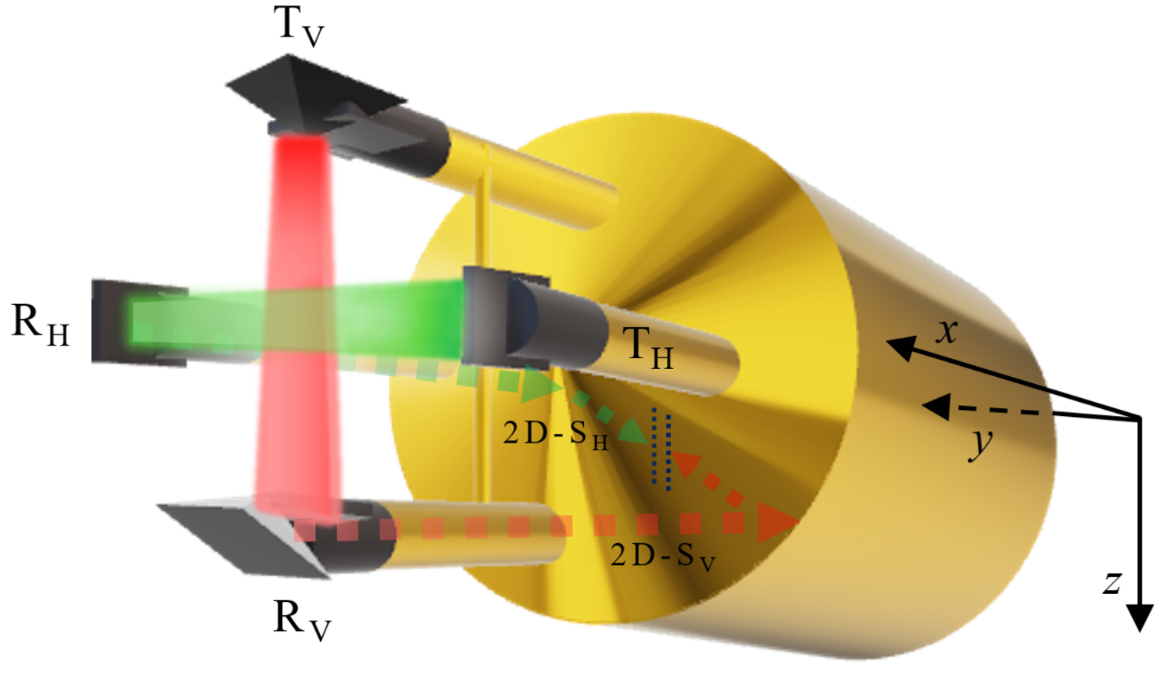
- Simplified Two-Dimensional Stereo Optical Array Probe (2D-S) with the vertical channel (2D-S_{V}) laser path in red and the horizontal channel (2D-S_{H}) in green as it originates at the transmitting (T) arms and is sent through the receiving arms (R). The dashed lines show the path each channel takes inside the 2D-S as it is bent 90 degrees twice and is detected by an array of 128 photodiodes, represented by the dotted lines (blue) for each channel. The aircraft-relative reference frame is given, where the x-axis points forward along the direction of flight (aircraft nose), the y-axis points to the right (starboard) wingtip, and the z-axis points down.
To illustrate what vertically oriented ice crystals may look like on 2D-S imagery, Figure 2 depicts an idealized sampling of various vertically-oriented column and plate ice crystals entering the sampling volume of the 2D-S and how each one would appear if sampled by the horizontal and vertical channels. It should be noted this is not the typical orientation of these types of ice crystals, which most often are oriented with their long axis parallel to the horizontal plane. While it is rare that a single particle gets sampled by both channels as it passes through the 2D-S sampling volume, it does occur about 1% of the time. Usually, the two channels function independently and should also be interpreted independently, rather than seeking to match stereographic images of all sampled particles.
The horizontal channel of the 2D-S captures a prism face view of each vertically oriented columnar ice crystal passing through the beam, while the vertical channel captures the basal face. With a slight rotation away from the zenith axis, a columnar ice crystal may reveal more of an orthographic projection vantage point for the 2D-S vertical channel. A vertically oriented plate ice crystal could rotate any direction about its zenith axis and still be considered vertically oriented, which would allow the 2D-S horizontal channel to capture either the basal or prism face of a plate crystal, or some combination thereof. The 2D-S vertical channel is more likely to capture the prism face of a plate crystal in vertical orientation, unless there is some slight rotation about the plate crystal’s horizontal axis, in which case a portion of the basal face may be captured by the vertical channel, as shown in the last plate crystal (example “j”) to pass through in the figure.
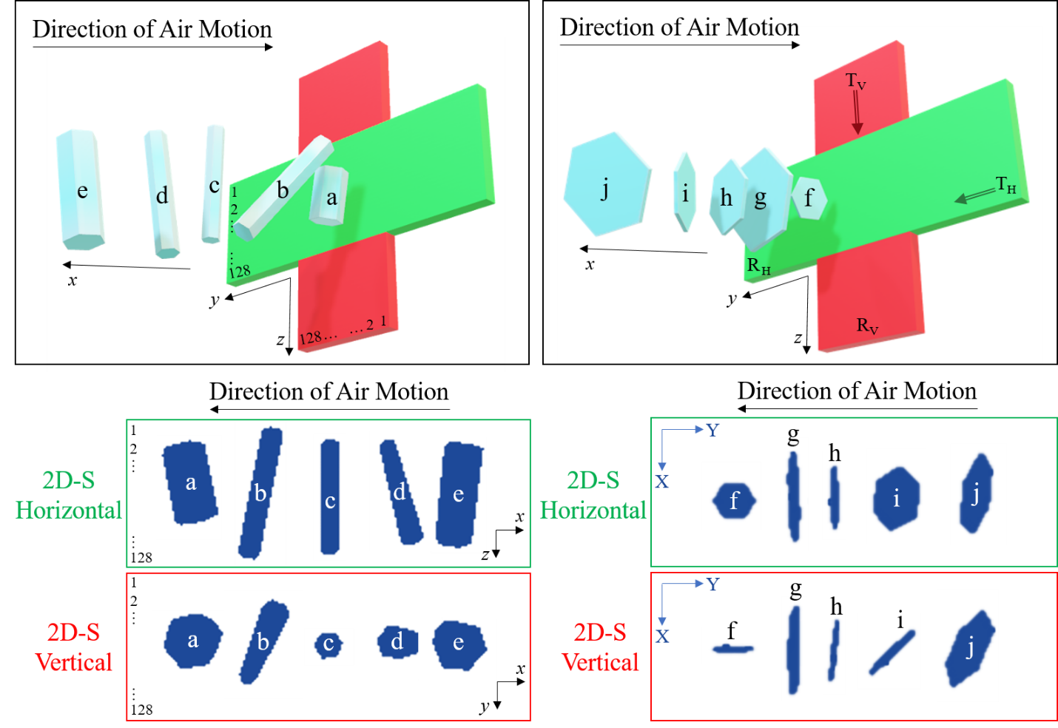
- Artistic rendering of how a variety of vertically oriented columnar and planar ice crystals would appear in the two-dimensional shadow image data of the Two-Dimensional Stereo Optical Array Probe (2D-S) if captured by both the horizontal (green) and vertical (red) channels. The ice crystal and laser beam depictions are not to scale. Each 3-D model of an ice crystal in this figure was given a 90 degree rotation to provide an accurate representation of orthogonal shadow image sampling. Note that the images appear on the 2D-S image strip in succession from left to right as the ice crystals pass through the sampling volume sequentially, which appears to be a mirrored image due to the viewing angle of the figure. The x, y, z labels in the diagram indicate the aircraft-relative coordinate system, whereas the X and Y labeled in blue on the image strip are relative to the 2D-S array axis. The array of 2D-S photodiodes are labeled as 1 to 128 in both the diagram and the image strips in the columnar example. The relative position of the transmitting (T) and receiving (R) arms of the 2D-S are labeled in the planar example for both the horizontal (H) and vertical (V) laser beams.

data processing
The Airborne Data Processing and Analysis (ADPAA) (Delene 2011) is a comprehensive software suite comprised of numerous programs and scripts developed by the research group at UND led by Dr. David Delene and shared open source with many other research entities to facilitate the processing and analysis of data obtained from instruments located on various airborne platforms. Data acquired by the M300 is written to an *.sea file, which goes through a few successive levels of processing post-flight. The *.sea file is initially processed by an ADPAA script called process_raw, which outputs a slew of raw files into a post processing directory. The files are further processed by an ADPAA script called process_all and then a project-specific wrapper script called process_all_impacts, which calls a number of programs including the image processing scripts contained in the System for OAP Data Analysis (SODA-2) package (Bansemer 2016).
SODA-2 is an Interactive Data Language (IDL) based data processing package specifically designed by the National Center for Atmospheric Research (NCAR) to handle the processing and viewing of data collected from optical array probes. In order to process the 2D-S base files, SODA-2 requires a true airspeed (TAS) input contained in the flight housekeeping data file. An accurate TAS is critical in the processing of 2D-S data because an airspeed that is either too fast or too slow would result in an artificially elongated or foreshortened 2D-S image, respectively, and lead to unrepresentative images and attribute data. During the operation of the 2D-S in the data collection phase, the TAS was routinely monitored throughout the flight to ensure accuracy of operation.
In particular, the 2D-S relies on the process_raw script to produce the *.basic.1Hz file which contains the TAS data throughout the flight. This file is used by a script called tas_soda2 to yield the *.SODA_TAS.dat file, which is then used by the IDL initialize_structure processing routine to produce the horizontal and vertical data files, housekeeping files, and particle-by-particle files. The previously mentioned process_all and process_all_impacts scripts call the process_soda2 script, which ultimately produces all the *.1Hz finished product files. The process_soda2 script allows for customization of processing methods and types based on the user’s needs and nature of the sampled data.
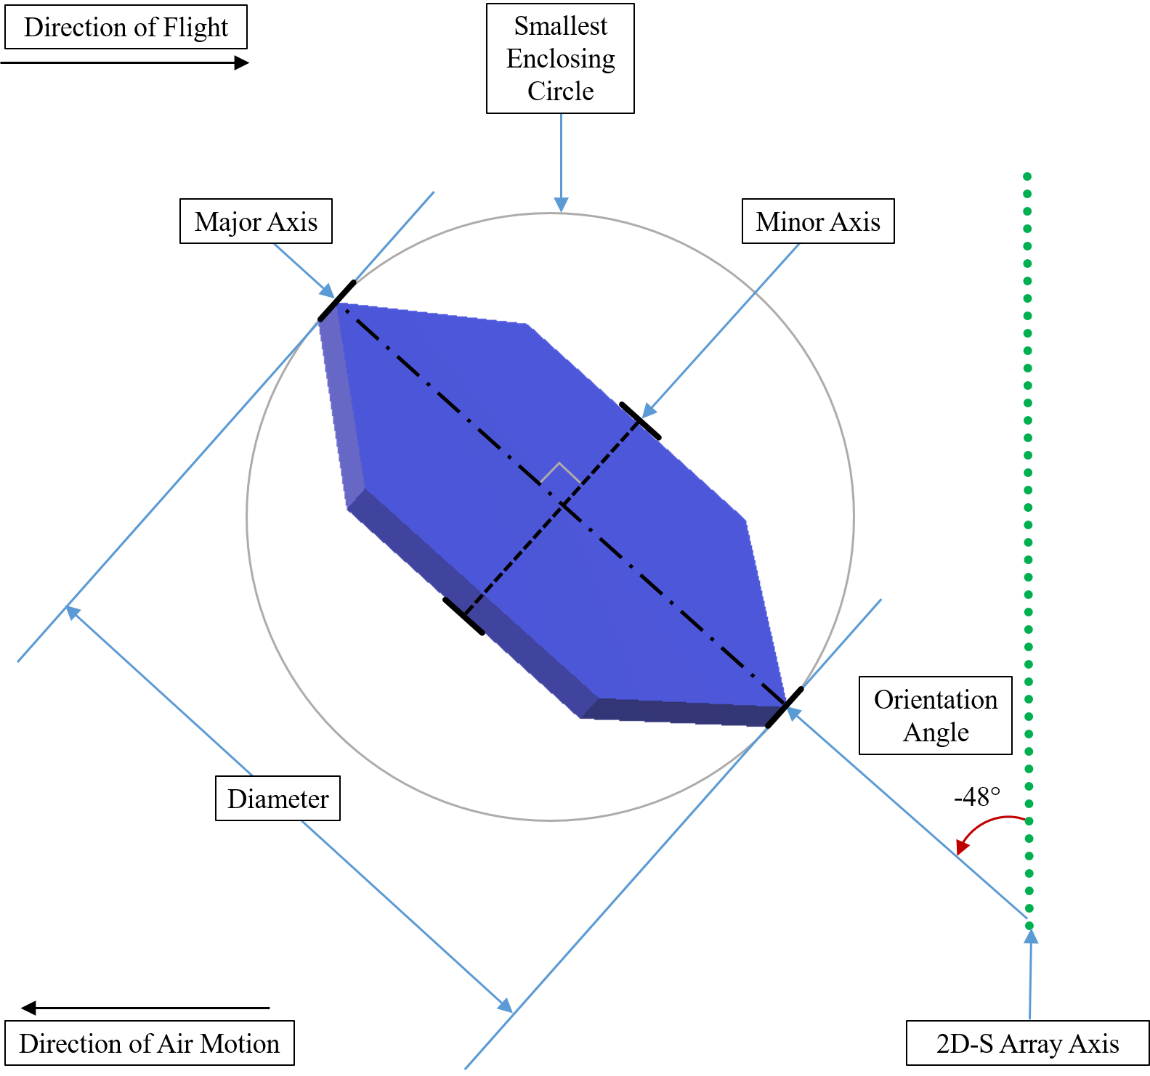
- Diagram showing how an in situ idealized hexagonal plate crystal encountering the sampling volume of the Two-Dimensional Stereo Optical Array Probe (2D-S) is recorded in the image data and parameterized by the System for Optical Array Probe (OAP) Data Analysis (SODA-2) processing software using the Fast Circle Method, which generates the smallest enclosing circle for each particle. The measured particle diameter is equal to the diameter of the smallest enclosing circle. The major axis of the particle is identified based on the maximum dimension and is equal to the particle diameter, and the minor axis is orthogonal to the major axis. The Orientation Angle parameter is the angle between the major axis and the 2D-S array axis, with clockwise rotations (towards the direction of flight) being positive angles and counterclockwise rotations being negative angles.
The Fast Circle Method was selected as the SODA-2 processing method for ice crystals sampled by the 2D-S during the IMPACTS field campaign, and it involves fitting a circle around each crystal just large enough so as to fully encompass the crystal within the circle (Delene et al. 2020). The diameter of the circle is equal to the length of the major axis of the crystal. The angle of the major axis in relation to the direction of flight defines the Orientation Angle parameter in units of degrees (Figure 3), given in values ranging between -90.0 and +90.0 degrees (Figure 4).
$$Particle Orientation Angle=\cos^{-1}{(\frac{B∙C}{\sqrt{B^{2}∙C^{2 }}})}$$ | (1)
SODA-2 computes the Orientation Angle of each particle through a simple trigonometric calculation.
Sides “B” and C” indicate the adjacent and hypotenuse sides of a right angle triangle formed by comparing a particle’s major axis versus the 2D-S laser diode array axis, and the angle between constitutes the particle’s orientation angle.
In the data processing, an orientation angle is calculated for every particle, even if the particle is a perfect circle and has no orientation. Therefore, in order to make practical sense of this parameter, it is important to exclude the circular particles from the dataset. Specifically, a vertically oriented ice crystal must be defined as having a vertical dimension that is greater than its horizontal dimension. A good way to characterize this desired attribute is by aspect ratio, which is the unitless ratio of the major to the minor axis of the particle (Figure 3), with values ranging between zero and one.
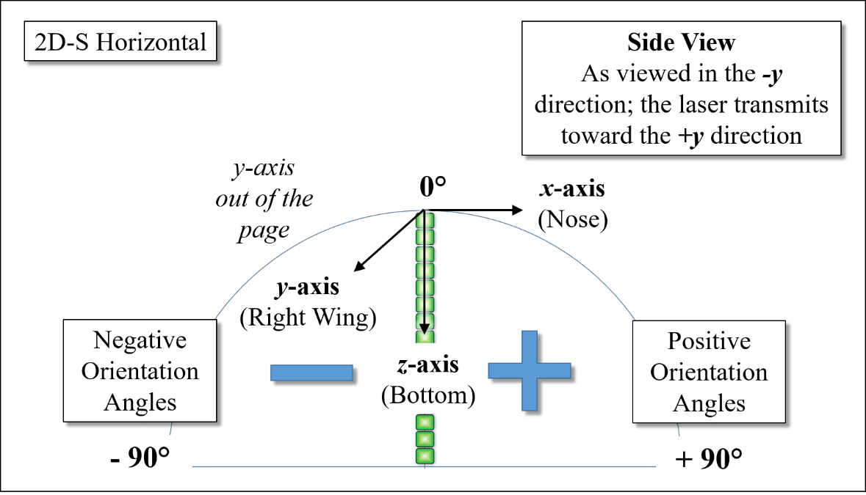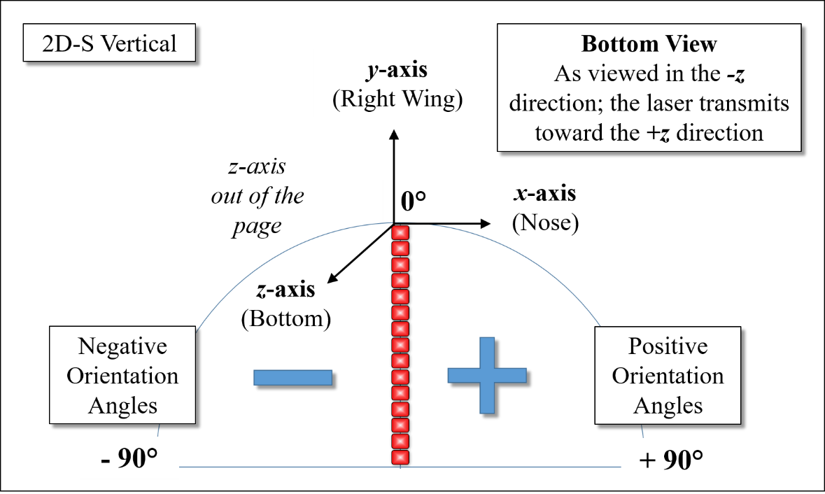
(b)
(a)
- Depicts how particles sampled by the Two-Dimensional Stereo Optical Array Probe (2D-S) and parameterized by System for OAP Data Analysis (SODA-2) define the Orientation Angle parameter of each non-circular particle based on the angle between the major axis of the particle and the array of diodes that receives the laser beam across the sampling volume. A sampled particle that has a major axis parallel with the diode array will result in an Orientation Angle of zero degrees. A clockwise rotation away from the diode array axis is measured as a positive Orientation Angle, and a counterclockwise rotation away from the diode array is a negative Orientation Angle. The range of possible values includes -90 to +90 degree angles. The Orientation Angle is measured by both orthogonally-positioned channels of the 2D-S, with a depiction of the horizontal channel shown in (a) and the vertical channel shown in (b).
Initial analysis of 2D-S data showed a high number of particles with an orientation angle near ±90 degrees and exactly 0.0 degrees. It is important to understand if the clustering at these orientation angles is a data processing artifact or a valid observation. A direct comparison of every individual particle image with the associated 2D-S particle-by-particle attributes is not immediately feasible due to lack of robust visualization software. Hence, the data set is filtered to obtain times when particles had particular orientation angles. The filtering of the particle-by-particle data to only include “all in” particles eliminated the peak in the frequency distribution near ±90 degrees. The “all in” term means that the boundaries of the entire particle are within the diode array and excludes particles that are in contact with array ends.
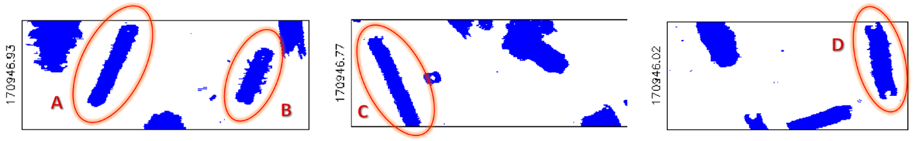
- Randomly selected Two-Dimensional Stereo Optical Array Probe (2D-S) image data that corresponds with the attribute data shown in Table 1. Selected particle images are circled in orange and were sampled by the 2D-S horizontal channel (examples A and B) and the vertical channel (examples C and D). The image buffer timestamp is displayed along the left of each respective image strip in a [HHMMSS.ss UTC] format.
- Two-Dimensional Stereo Optical Array Probe (2D-S) attribute data as recorded in the particle-by-particle file corresponding to image data (Figure 5). Two examples are shown from the 2D-S horizontal (H) channel and two from the 2D-S vertical (V) channel. The three linear measurements given for each imaged particle include the particle diameter based on the fast circle method of processing, and an X and Y measurement, with X representing the dimension parallel to the array axis and Y representing the dimension parallel to the direction of flight. The “all in” flag is a 1 if the particle image is fully contained within the image strip and not in contact with array ends, and the flag is a 0 if the particle is only partially contained within the image strip. The inter-arrival time of each particle is shown in the last column as inter-particle time (IPT). 2DS Ch. is the 2D-S Channel, Dia. is the particle diameter, Asp. Ratio is the aspect ratio, and AI represents the “all in” flag.
2DS Ch. | ID | Time | Dia. | Area Ratio | Asp. Ratio | Ang. | AI | X | Buffer Time | Y | IPT
 |  | (sec) | (μm) |  |  | (deg) |  | (μm) | (sec) | (μm) | (sec)
H | A | 61786.926 | 1097 | 0.22 | 0.24 | -28.0 | 1 | 1000 | 61786.926 | 610 | 0.000671
H | B | 61786.926 | 731 | 0.36 | 0.49 | -33.7 | 1 | 670 | 61786.926 | 460 | 0.003619
V | C | 61786.770 | 1214 | 0.19 | 0.25 | 29.3 | 0 | 1090 | 61786.770 | 640 | 0.001291
V | D | 61786.020 | 927 | 0.29 | 0.33 | 6.9 | 0 | 920 | 61786.020 | 390 | 0.003834
The majority of the particles with an orientation angle equal to 0.0 degrees had diameters of 10 µm, which is the smallest size particle possible for the 2D-S data set since the diodes are 10 µm. Particles of a 10 µm diameter size have only one pixel shaded in the image; hence, the circle fit processing method results in an eccentricity of 1. Such perfect circle particles have a default orientation angle value of 0.0 degrees (Figure 6). Therefore, 100 percent of the 10 µm particles have an orientation angle of 0.0 degrees (Figure 7). Particles of a 20 µm diameter size have two pixels shaded in the image, and they appear in one of two possible configurations: either side-by-side or stacked one atop the other. Therefore, the two possible orientation angles for the 20 µm diameter particles are +90.0 degrees and 0.0 degrees (Figure 6, Figure 8). Particles greater than 20 µm but less than or equal to 30 µm have four possible configurations (Figure 6, Figure 9): three pixels side-by-side, three pixels stacked, two pixels diagonal with either a positive or negative 45 degree angle rotation away from the 2D-S array axis.
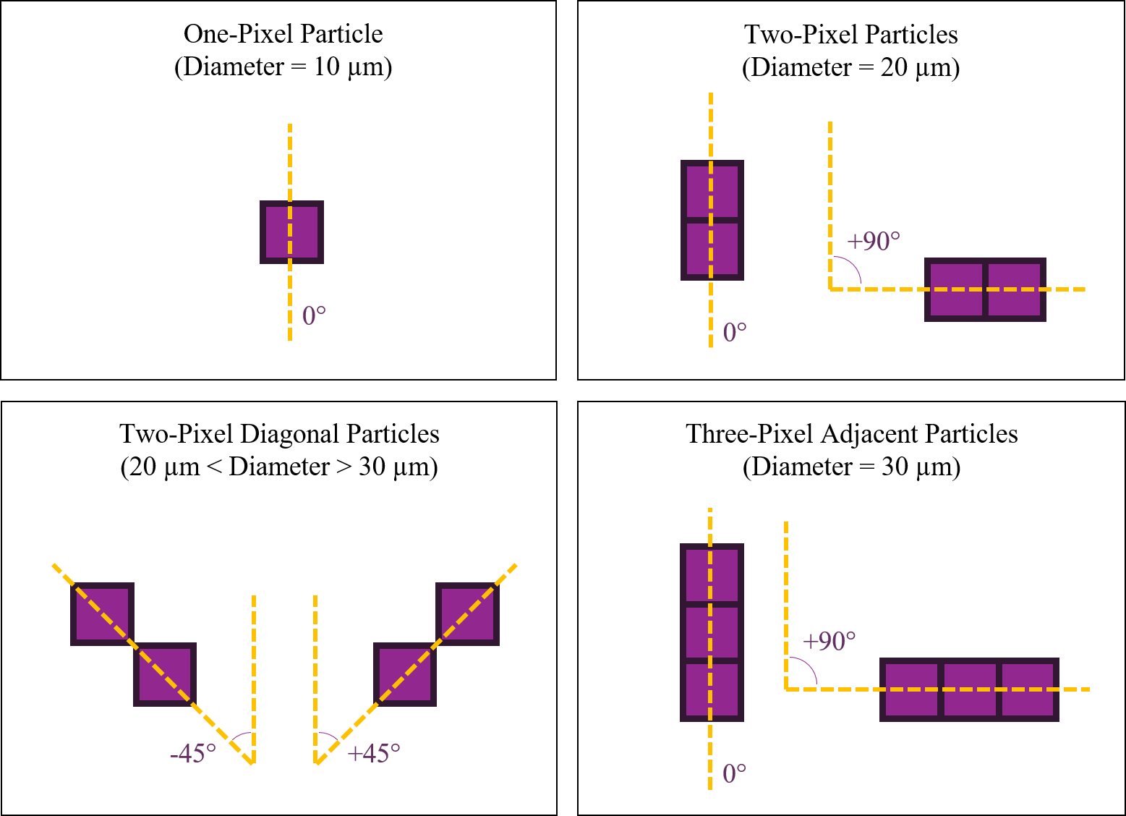
(b)
(a)
(d)
(c)
- The possible shaded pixel configurations of single (a), dual (b) and (c), and up to three (d) pixel particles, as would be depicted in Two-Dimensional Stereo Optical Array Probe (2D-S) image data and the default orientation angles for each possible pixel configuration.
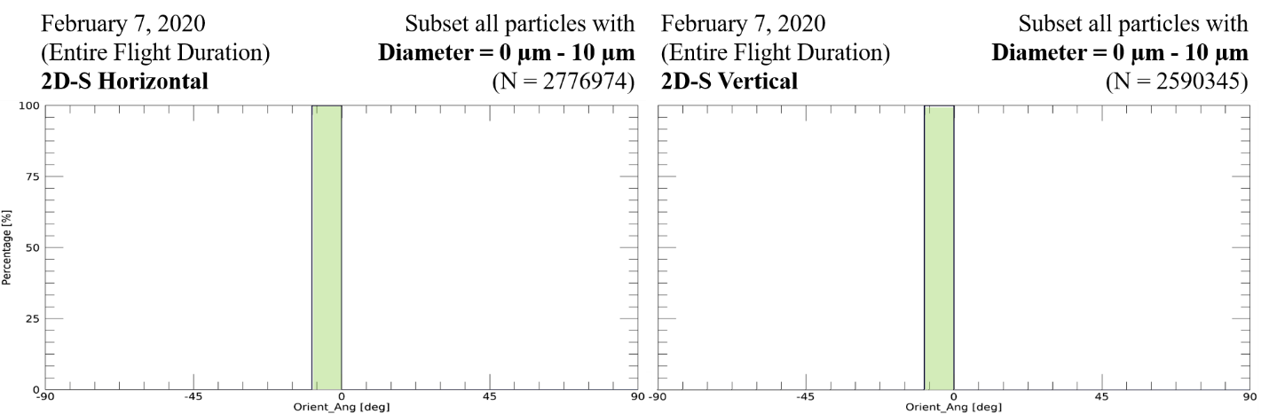
- Orientation angle histograms for particles with diameters of 10 µm sampled during the 07 February, 2020 Investigation of Microphysics and Precipitation for Atlantic Coast-Threatening Snowstorms (IMPACTS) flight for the Two-Dimensional Stereo Optical Array Probe (2D-S) horizontal (left) and vertical (right) channels.
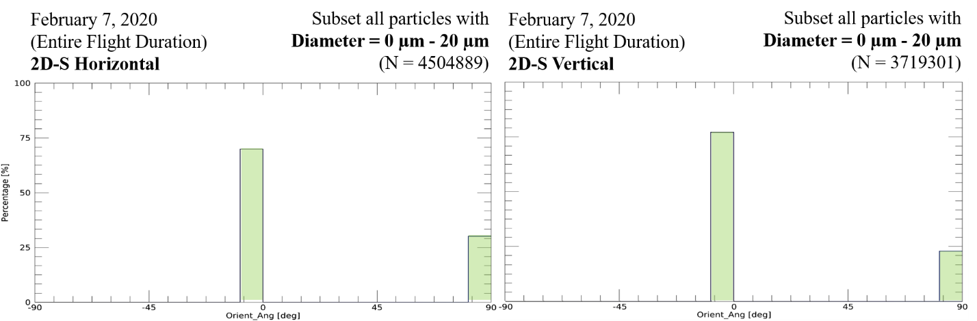
- Similarly, the orientation angle histogram for particles up to 20 µm diameter sampled during the 07 February, 2020 Investigation of Microphysics and Precipitation for Atlantic Coast-Threatening Snowstorms (IMPACTS) flight for the Two-Dimensional Stereo (2D-S) Optical Array Probe (OAP) horizontal (left) and vertical (right) channels.
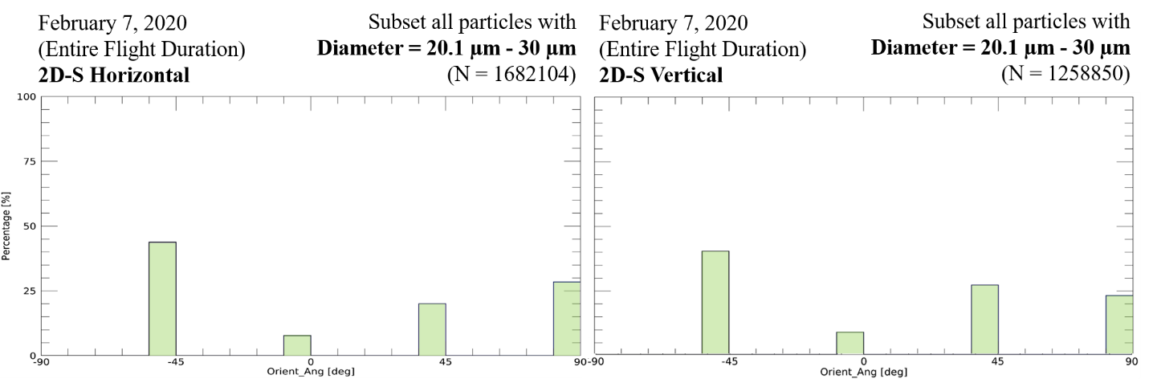
- Finally, the orientation angle histogram for particles greater than 20 µm but less than or equal to 30 µm in diameter sampled during the 07 February, 2020 Investigation of Microphysics and Precipitation for Atlantic Coast-Threatening Snowstorms (IMPACTS) flight for the Two-Dimensional Stereo Optical Array Probe (2D-S) horizontal (left) and vertical (right) channels.
$$Number of Possible Orientaton Angles=2^{n-1}{for diameter n×{10}^{1}μm}$$ | (2)
The histograms, comprising one, two, and four-node data representations, demonstrate that particles with diameters of 30 µm or smaller exhibit a pronounced concentration of orientation angles at 0, -45, +90, and +45 degrees within the dataset. For all particles up to and including 40 µm in diameter, the mathematical relationship given in Equation (2) was found to describe the number of possible orientation angles that the 2D-S could assign based on the pixel resolution. For particles with diameters greater than 40 µm, more random possibilities for orientation angles exist, and the relationship in Equation (2) no longer applies.
Consequently, it is necessary to exclude these particles from the analysis. The non-randomized distribution of orientation angles is not limited to particles with diameters of 40 µm or less but extended to those with diameters of 100 µm or less, warranting their removal from the dataset. After filtering out particles with diameters of 100 µm or less, the subset displays a more uniform distribution of orientation angles, enabling an exploration of potential patterns and preferred orientation angles within the remaining periods of interest.
- Quality Assurance
Regarding SODA-2 Processing of 2D-S image data, the high frequency of orientation angle near ±90 degrees and 0.0 degrees analysis resulted in discovery of possible processing issues. The 2D-S orientation analysis manually matched individual particles with the associated particle attribute. The manual matching looked at particles during periods of high particle concentration when the data buffers would fill. During such periods, particles captured by the 2D-S could span two subsequent buffers. The occurrence of particle frames being split across separate buffer boundaries is not an unusual event and is detailed in the 2D-S Technical Manual Rev. 3.1, para. 4.2.3 (Stratton Park Engineering Company, 2011). The particle attributes of two such buffer-spanning particles indicated that a single particle had two corresponding attributes, which results in inaccurate particle attributes since neither attribute corresponded to particle spanning the buffers.
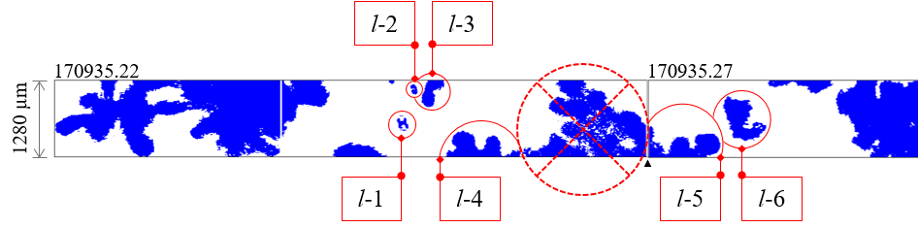
- Buffer of Two-Dimensional Stereo Optical Array Probe (2D-S) images from the 07 February, 2020 Investigation of Microphysics and Precipitation for Atlantic Coast-Threatening Snowstorms (IMPACTS) flight at 17:09:35 UTC for the vertical channel. The subsequent buffer is positioned to the right of the preceding buffer to demonstrate a case where an ice crystal was sampled near the end of a data buffer and continued in the next buffer. The black triangle along the bottom of the strip denotes the transition point between buffers, and the timestamp in [HHMMSS.ss UTC] format is labeled along the top of each image strip.
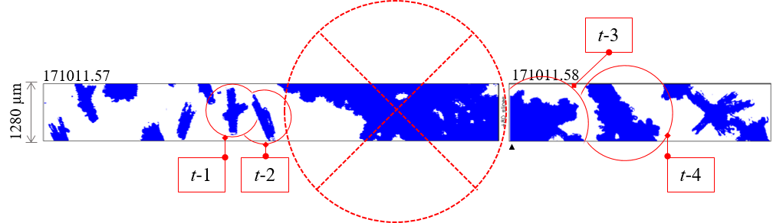
- An additional example showing the buffer of Two-Dimensional Stereo Optical Array Probe (2D-S) images from the 07 February, 2020 Investigation of Microphysics and Precipitation for Atlantic Coast-Threatening Snowstorms (IMPACTS) flight at 17:10:11 UTC for the vertical channel. The subsequent buffer is positioned to the right of the preceding buffer to demonstrate a case where an ice crystal was sampled near the end of a data buffer and continued in the next buffer. The black triangle along the bottom of the strip denotes the transition point between buffers, and the timestamp in [HHMMSS.ss UTC] format is labeled along the top of each image strip.
- Two-Dimensional Stereo Optical Array Probe (2D-S) particle-by-particle attribute data for 07 February, 2020 Investigation of Microphysics and Precipitation for Atlantic Coast-Threatening Snowstorms (IMPACTS) flight, vertical channel, which corresponds to the images shown in Figure 10 and Figure 11. The time is given in a [HH:MM:SS UTC] format and a seconds-from-midnight [SSSSS.ss sfm] format. The three linear measurements given for each imaged particle include the particle diameter based on the fast circle method of processing, and an X and Y measurement, with X representing the dimension parallel to the array axis and Y representing the dimension parallel to the direction of flight. The “all in” flag is a 1 if the particle image is fully contained within the image strip and not in contact with array ends, and the flag is a 0 if the particle is only partially contained within the image strip. The inter-arrival time of each particle is shown in the last column as inter-particle time (IPT). More examples of buffer-spanning particles and associated particle attributes are detailed in Appendix B.
Time | ID | Time | Diam. | Aspect Ratio | Angle | All In | X | Buffer Time | Y | IPT
[UTC] |  | [sfm] | [μm] |  | [deg] |  | [μm] | [sec] | [μm] | [sec]
17:09:35 | l-1 | 61775.2230 | 276 | 0.64 | 19.8 | 1 | 260 | 61775.2230 | 200 | 0.000112
 | l-2 | 61775.2230 | 185 | 0.58 | 18.4 | 1 | 180 | 61775.2230 | 130 | 0.000512
 | l-3 | 61775.2230 | 532 | 0.59 | -32.5 | 0 | 470 | 61775.2230 | 380 | 0.004521
 | l-4 | 61775.2230 | 1261 | 0.38 | -87.3 | 0 | 430 | 61775.2230 | 1260 | 0.000841
 | l-5 | 61775.2700 | 1260 | 0.41 | 87.7 | 0 | 510 | 61775.2700 | 1210 | 0.000026
 | l-6 | 61775.2700 | 871 | 0.70 | 38.9 | 1 | 740 | 61775.2700 | 730 | 0.000412
 |  | 61775.2700 | 1110 | 0.20 | 89.5 | 0 | 220 | 61775.2700 | 1110 | 0.006587
17:10:11 |  | 61811.5670 | 161 | 0.58 | -82.4 | 0 | 80 | 61811.5670 | 160 | 0.000681
 |  | 61811.5670 | 869 | 0.42 | -9.7 | 1 | 860 | 61811.5670 | 440 | 0.000257
 |  | 61811.5670 | 579 | 0.57 | 39.3 | 0 | 470 | 61811.5670 | 400 | 0.000325
 |  | 61811.5670 | 95 | 0.82 | 69.4 | 1 | 60 | 61811.5670 | 90 | 0.002299
 | t-1 | 61811.5670 | 1093 | 0.56 | 9.4 | 1 | 1080 | 61811.5670 | 580 | 0.000997
 | t-2 | 61811.5670 | 1151 | 0.27 | 25.4 | 0 | 1040 | 61811.5670 | 540 | 0.003118
 | t-3 | 61811.5820 | 1945 | 0.77 | 58.5 | 0 | 1150 | 61811.5820 | 1660 | 0.000428
 | t-4 | 61811.5820 | 2030 | 0.59 | 52.8 | 0 | 1280 | 61811.5820 | 1680 | 0.00116
 |  | 61811.5820 | 2703 | 0.48 | 62.1 | 0 | 1280 | 61811.5820 | 2440 | 0.000949
 |  | 61811.5820 | 24 | 0.62 | -45.0 | 1 | 20 | 61811.5820 | 20 | 0.000619
Note that the attribute data in Figure 11 appears to accurately describe all the particles shown in the associated images (Figure 10, Figure 11), except for the last particle in the first buffer of each example. There is no particle attribute data in the particle-by-particle file that describes these large particles at the end of a buffer, and this omission causes an inaccurate representation of particle dimensions, and while still only counting it as a single particle, the overall particle count and concentration integrity remains intact. This processing error was brought to the attention of the software developer who has since rectified the issue.

Data set
IMPACTS was a major five-year NASA Earth Venture project that had three field campaigns to collect ground based, satellite based, and airborne in situ and high-altitude data across the Northeastern and Midwestern United States in January and February of 2020, 2022, and 2023. The field projects obtained observations during synoptic and mesoscale baroclinic winter storm events. The science team was led by the University of Washington. The team included researchers from the National Oceanic and Atmospheric Administration (NOAA), NASA, NCAR, and the National Weather Service (NWS), students and professors from the University of North Dakota (UND) and several other universities.
- Observational Platforms
The IMPACTS field campaigns utilized the NASA P-3 Orion research aircraft to conduct in situ sampling of middle and lower tropospheric clouds. The P-3 Orion was originally designed to be used as a long-range, military, maritime patrol aircraft able to carry explosive ordinance. The P-3 is still widely used in both military and civilian operations. The NASA P-3 has been extensively modified to conduct a wide variety atmospheric observations all around the globe. In addition to the P-3, the NASA ER-2 High-Altitude Airborne Science Aircraft was a key platform in the IMPACTS campaign. The ER-2 is a single occupant, high altitude research aircraft operated by NASA’s Armstrong Flight Research Center. During IMPACTS, ideally, the ER-2 was deployed coincidently with the NASA P-3 Orion research aircraft and provided concurrent remote sensing observations from an overhead vantage point at an altitude of approximately 20 km. The ER-2 was outfitted with four different radars, including the Cloud Radar System (CRS), ER-2 X-Band Doppler Radar (EXRAD), Cloud Physics Radar (CPR), and a Ka-band radar called the High-Altitude Imaging Wind and Rain Airborne Profiler (HIWRAP), two different radiometers, which were the Conical Scanning Millimeter-Wave Imaging Radiometer (CoSMIR) and the Advanced Microwave Precipitation Radiometer (AMPR), and a Lightning Instrument Package (LIP). The IMPACTS project included space-based platforms, such as the Geostationary Orbiting Earth Satellite GOES-16/17, NASA’s CloudSat, and NASA’s Global Precipitation Measurement (GPM) satellite to provide a broader atmospheric context and contribute to the understanding of winter storm dynamics and microphysics. The 2020 field project had ground-based support from Stony Brook University and University of Illinois Urbana-Champaign mobile sounding teams.
For the IMPACTS field campaign, the NASA P-3 (Figure 12) was equipped with a full suite of microphysics probes, including multiple optical and hot wire probes, an advanced counterflow virtual impactor called the Water Isotope System for Precipitation and Entrainment Research (WISPER), an Advanced Vertical Atmospheric Profiling System (AVAPS) that deployed dropsondes, and a Turbulent Air Motion Measurement System (TAMMS) from NASA Langley Research Center. The hot wire probes included the Nevzorov Probe in 2020, which was replaced by the Water Content Monitor 3000 (WCM-3000) for 2022 and 2023. Additionally, all three projects included the King Liquid Water Content 100 (LWC-100) Probe, which was mounted on the left (port) wing, outboard pylon; henceforth, termed the hot wire boom. The hot wire boom also hosted a Cloud Droplet Probe (CDP). The optical probes included two adjacent High-Volume Precipitation Spectrometers (HVPS-3) by Stratton Park Engineering Company (SPEC) on the left wing, inboard pylon. The right wing, inboard pylon had a SPEC Hawkeye, which contained the Fast Cloud Droplet Probe (FCDP), two Two-Dimensional Stereo Optical Array Probes (2D-S) and a Cloud Particle Imager (CPI). The left canister, outboard pylon on the right wing had a standalone 2D-S probe, while the right canister had a Karlsruhe Institute of Technology Particle Habit Imaging and Polar Scattering (PHIPS) instrument. Additionally, a Collins Aerospace Rosemount Icing Detector (RICE) was located on the right side fuselage. Structurally, the P-3 was modified between the 2020 and 2022 campaigns due to a catastrophic aileron stress fracturing on both wings that occurred at the end of the 2020 campaign. The pylon redesign used a different method to secure wing-mounted probes, which may have contributed to slightly different airflow around the probe.
Data was obtained from the CDP and RICE using serial (RS-422) lines and recorded using a Science Engineering Associates (SEA) model 300 Data Acquisition System (M300). The Nevzorov and King Probe data were acquired by the M300 using an Analog-to-Digital Board. The SPEC probes each had their own data acquisition system. All the data acquisition systems were time synced using the on-board Network Time Protocol (NTP) server at the start of each flight and checked to ensure all times were synced to within 1 s.

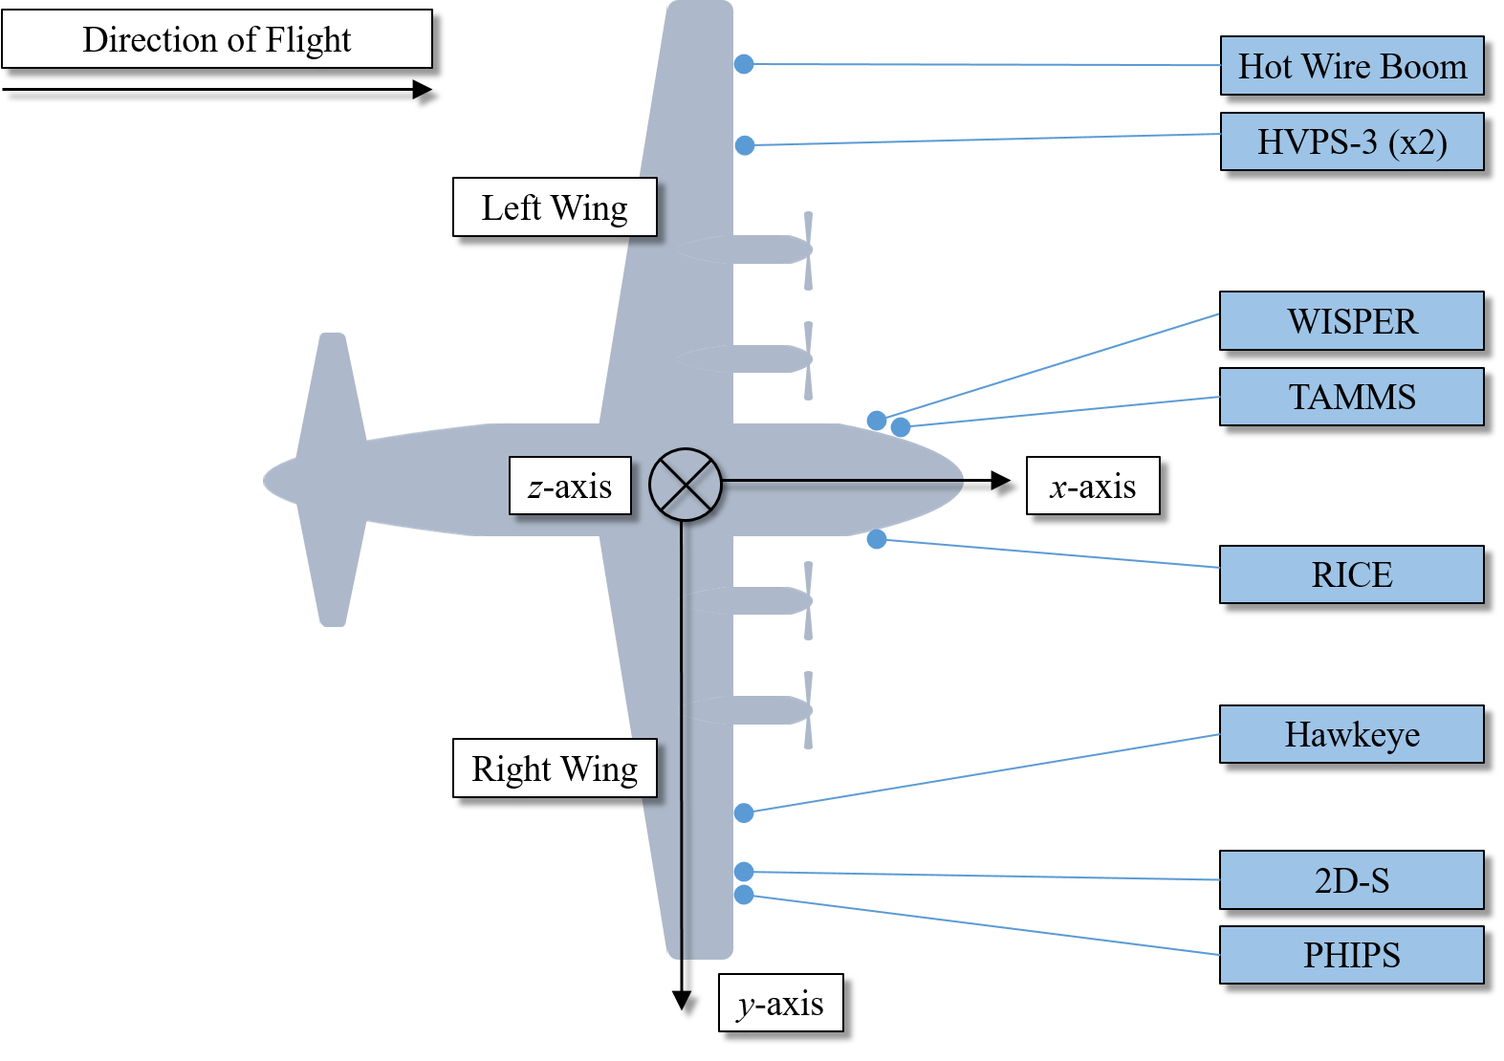
- Simplified rendering of a top-view of the NASA P-3 Orion research aircraft and its local frame of reference coordinate system, where the x-axis points out the nose of the aircraft along the direction of flight, the y-axis is aligned with the right wing (starboard side) of the aircraft, and the z-axis points down towards the ground when in level flight. The instrument labels shown in blue mark the mounting locations of each probe assembly when configured for the Investigation of Microphysics and Precipitation for Atlantic Coast-Threatening Snowstorms (IMPACTS) campaign.
- Additional Observations
The IMPACTS campaign included the use of a total of two 2D-S instruments. One 2D-S is a standalone mounted on the inboard side of the outboard pylon on the right (starboard) wing as shown in Figure 12, and is responsible for providing the 2D-S dataset used in this study. The additional 2D-S instrument was part of the Hawkeye multi-instrument suite, which included a CPI, FCDP, and a 2D-S processed at 10 µm and 50 µm resolutions. Data from the Hawkeye 2D-S instrument was not used in this study due to an assumption that particles entering the Hawkeye airstream may undergo significant re-orientation.
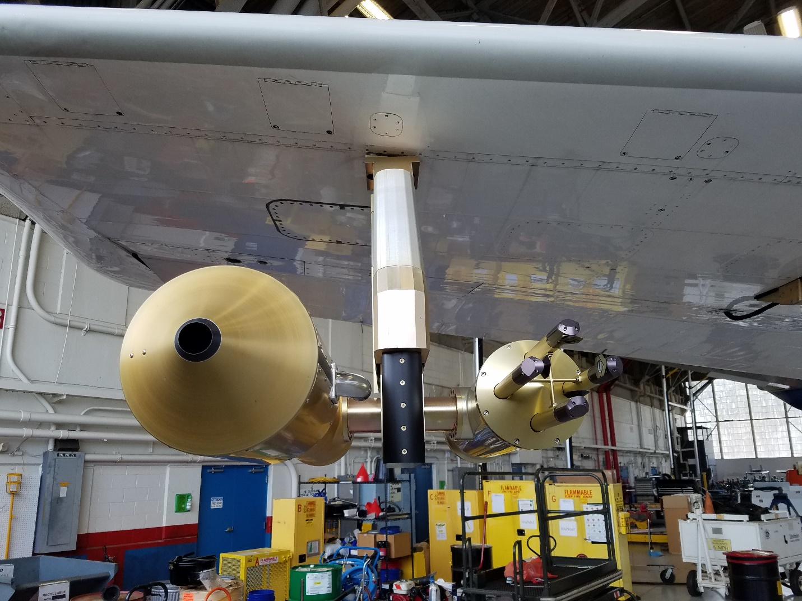
- Photo of the mounting location of the Particle Habit Imaging and Polar Scattering (PHIPS) Probe and Two-Dimensional Stereo Optical Array Probe (2D-S) on the outer pylon of the starboard wing of the NASA P-3 aircraft during the Investigation of Microphysics and Precipitation for Atlantic Coast-Threatening Snowstorms (IMPACTS) 2020 field campaign.
In order to conduct airborne measurements of the electric field, the ER-2 was equipped with seven electric field mills that together comprise the LIP. Each field mill was identical in its theory of operation to one another but each measured a specific component of the electric field, depending on where it was mounted on the ER-2 aircraft. During the IMPACTS field campaign, the seven unique mounting locations of the field mills were on the top of the fuselage immediately aft of the canopy, on the bottom of the fuselage forward of the canopy, one atop the right wing, one under the right superpod (forward the leading edge of the wing), one atop the left wing, and two under the left superpod (one forward and one aft the leading edge of the wing). Each field mill contained a rotating vane that when rotating, exposed a direct current sinusoidal wave that emanated from the mill. Also exposed by the rotating vane were the stator electrodes underneath the vane that sensed the atmospheric electric field component charge. The internal circuitry of the field mill were designed to be held at a constant, near-ground charge value, and any deviation from that value were calculated as fluctuations in the atmospheric electric field. With the full set of electric field mills, the LIP was able to derive a measurement for the magnitude and direction of each component vector of the atmospheric electric field charge ($Q$) at the cloud tops as well as a measurement of the local charge on the ER-2 aircraft ($E_{q}$). Through the data processing conducted by the principle investigators based at NASA Marshall Space Flight Center (Schultz et al. 2021), the LIP data (Mach et al., 2020) was conveniently made available in either aircraft-based coordinates ($E_{x}$, $E_{y}$, $E_{z}$, $E_{q}$) or earth coordinates ($E_{n}$, $E_{w}$, $E_{u}$, $E_{m}$).
An icing detector is a common accoutrement on an aircraft, and during the IMPACTS campaign, the RICE was utilized to detect the presence of supercooled liquid water in flight. The instrument consists primarily of a metal sensing rod that protrudes from an airfoil strut mounted to the instrument base. During IMPACTS, the mounting location of the RICE was on the right side of the fuselage of the P-3, forward of the wing (Figure 14). The sensing rod vibrates at a frequency of approximately 40,000 Hz. Supercooled liquid water is known to freeze near instantaneously upon contact with metal surfaces such as the sensing rod of the RICE. As ice accretes onto the sensing rod, the 40,000 Hz vibration rate decreases to a lower frequency proportionally to how quickly it accretes. Any decrease, therefore, in frequency can be interpreted as the presence of supercooled liquid water, and a rapid decrease in frequency indicates a greater amount of supercooled liquid water. At a preset threshold, the RICE activates an airfoil strut heater until the accumulated ice has melted off the probe to allow for further detections of supercooled liquid water. The frequency data of the RICE was shown for the selected cases of vertical ice crystal orientation to provide further context for each case.
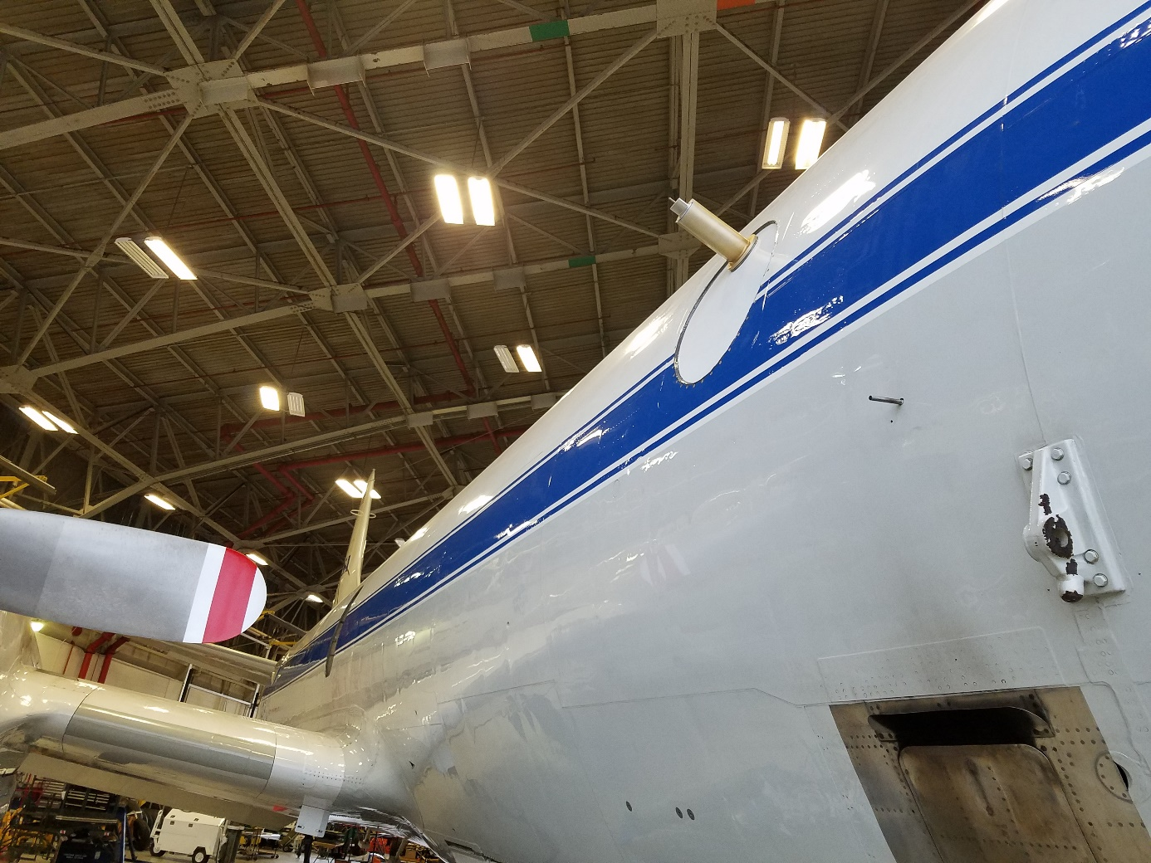
- A photo taken during ground testing of the NASA P-3 during the Investigation of Microphysics and Precipitation for Atlantic Coast-Threatening Snowstorms (IMPACTS) campaign in 2020 shows a wide angle view of Rosemount Icing Detector (RICE) mounting location on the right (starboard) side of the fuselage.

The CDP uses a forward-scattering optical system to transmit a laser beam of light from a transmitting to a receiving arm, and it includes only one set of transmitting and receiving arms that can be mounted either vertically or horizontally. The specialty of the CDP is to focus on cloud droplets, hence its smaller operating range of 2 to 50 µm. The CDP provides useful information about the sizing, shape, and count of cloud droplets, which is useful in determining the concentration and LWC in situ. The CDP concentration and LWC data are provided for each case in order to further characterize the environment in which cases of vertical ice crystal orientation were observed. During the 2020 IMPACTS field campaign, the CDP was initially mounted in a vertical beam position on the inboard side of the outboard pylon on the left (port) wing as part of the hot wire boom (Figure 15). Midway through the campaign, the CDP position was altered to the outboard position of the hot wire boom (Figure 16).
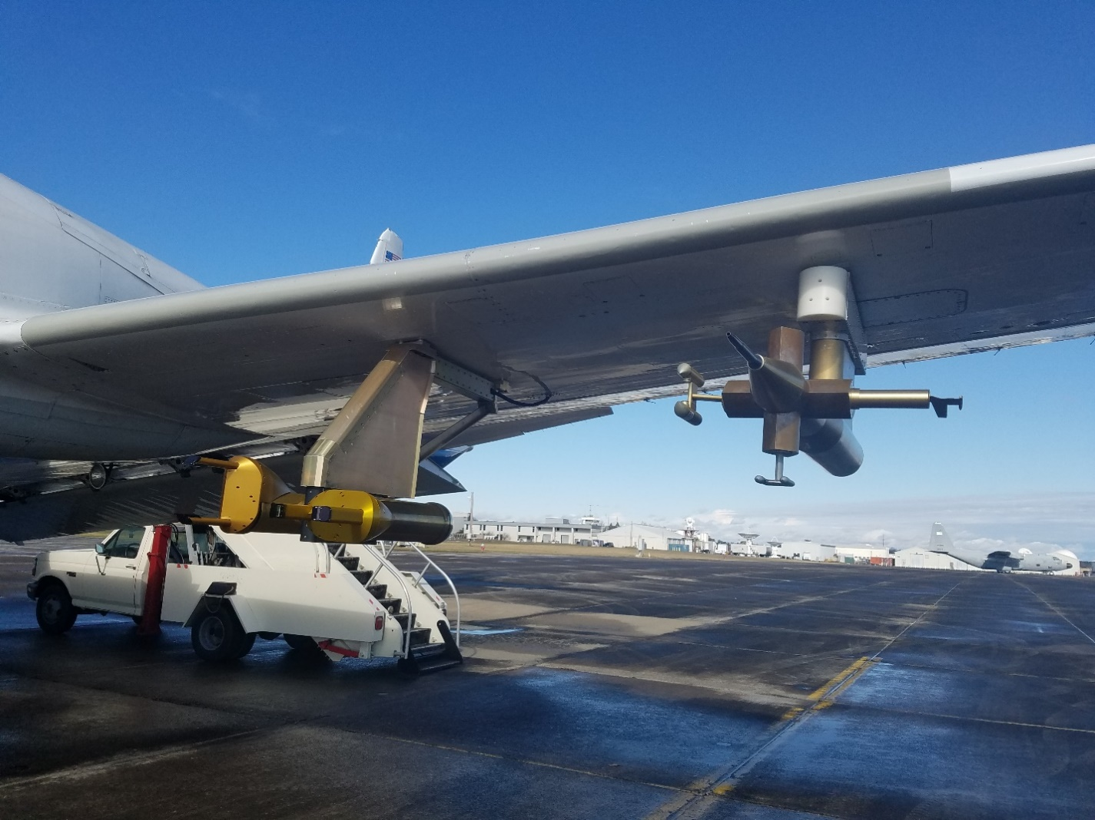
- Photo depicting the left (port) wing probes on the NASA P-3 during the preflight inspection of the 18 January, 2020 Investigation of Microphysics and Precipitation for Atlantic Coast-Threatening Snowstorms (IMPACTS) flight. The instruments mounted here include the two adjacent, orthogonally mounted High Volume Precipitation Spectrometers (HVPS-3) on the inboard pylon and the Cloud Droplet Probe (CDP), King Liquid Water Content 100 (LWC-100), and Nevzorov Probe on the outboard pylon hot wire boom. Note the inboard mounting location of the CDP on the hot wire boom.

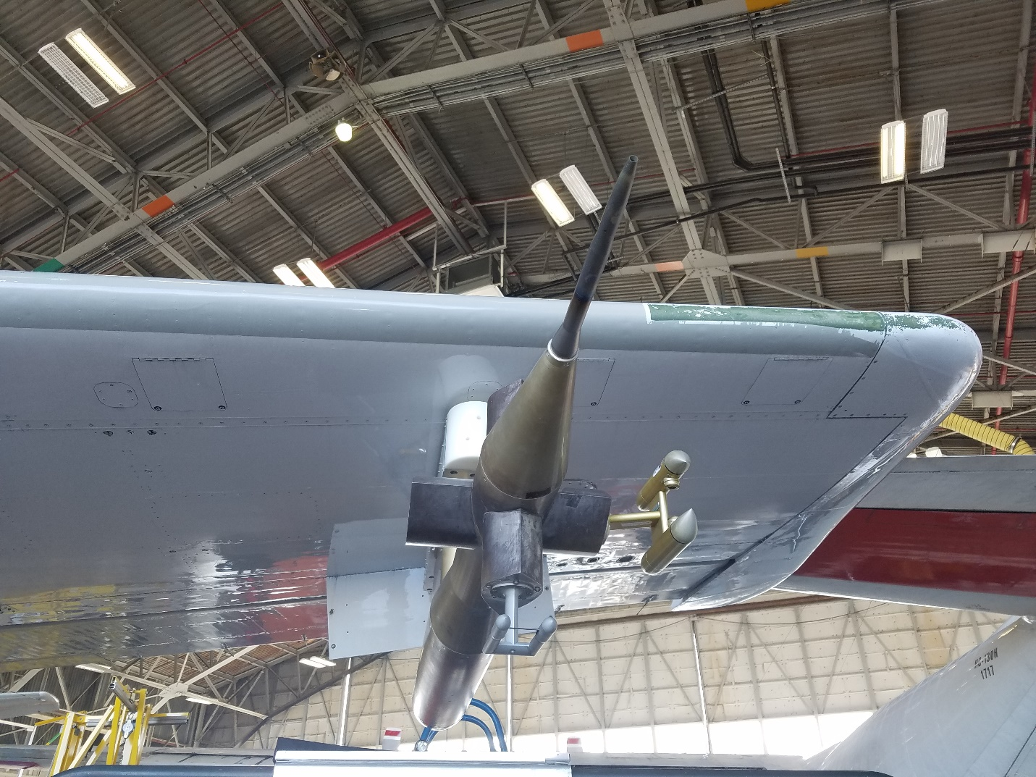
- Later in the campaign, a photo taken on 01 February, 2020 during ground testing of the NASA P-3 wing-mounted probes during the Investigation of Microphysics and Precipitation for Atlantic Coast-Threatening Snowstorms (IMPACTS) campaign shows the modified mounting position of the Cloud Droplet Probe (CDP) on the outboard side of the hot wire boom.
The CPI and PHIPS were used in this study as supplemental data to view images of particles encountered during the selected cases in order to better illustrate or enhance confidence about the particle habit classifications. The CPI is an imaging instrument that captures high-speed images of cloud and aerosol particles and can also provide information about particle habit, size, and concentration. The CPI that was flown aboard the P-3 on the inboard pylon of the starboard (right) wing, housed within the Hawkeye multi-instrument suite, which also contained a FCDP and a 2D-S instrument. The PHIPS (Figure 17) is another imaging instrument that was flown on the P-3 during the IMPACTS campaign that provides polarimetric imaging of particles in situ using a laser beam illumination and also records the incident light-scattering properties of each unique particle.
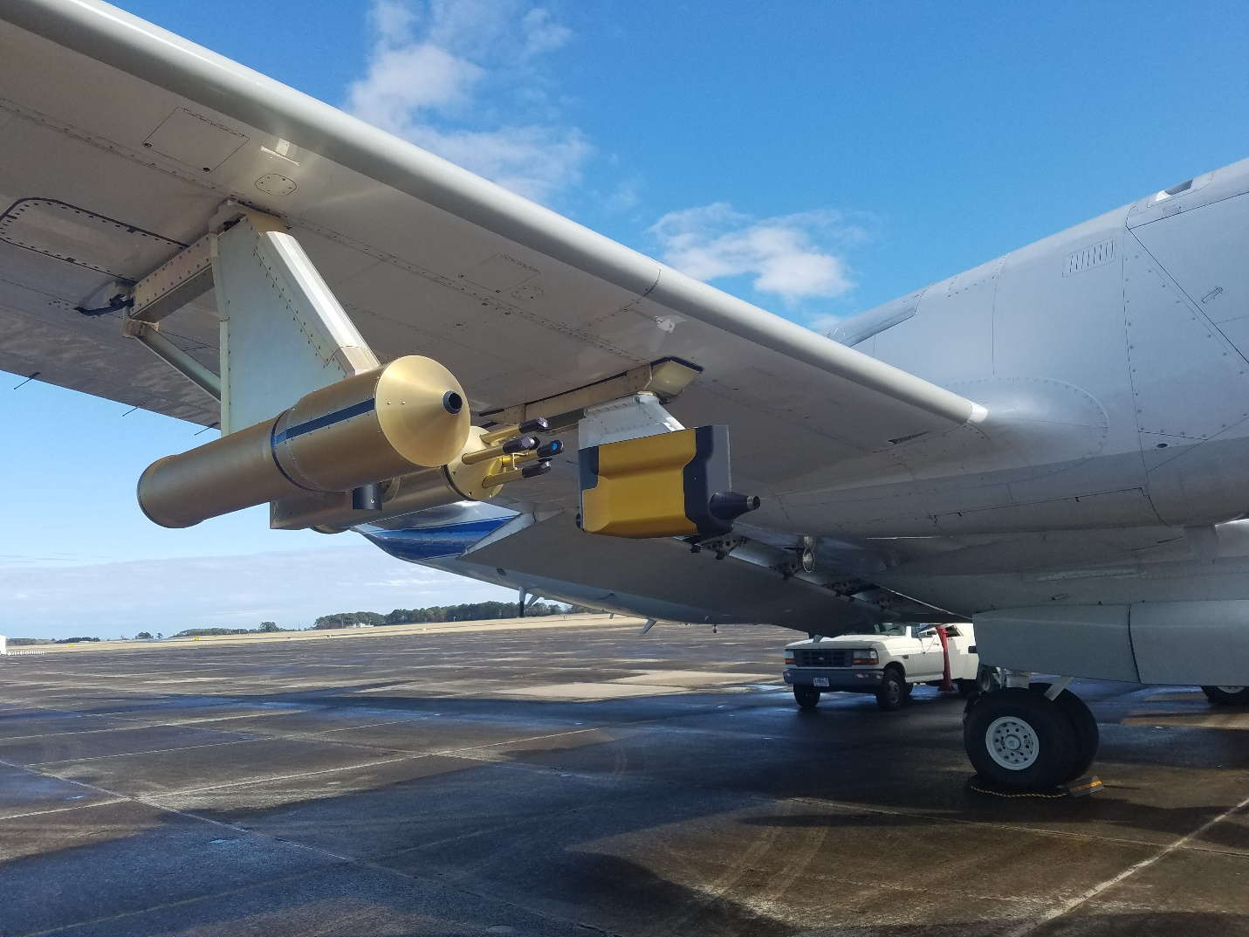
- Captured during the preflight inspection of the 18 January, 2020 Investigation of Microphysics and Precipitation for Atlantic Coast-Threatening Snowstorms (IMPACTS) flight, this photo displays the right (starboard) wing probes on the NASA P-3, including the Particle Habit Imaging and Polar Scattering (PHIPS) on the outboard side of the outboard pylon, the standalone Two-Dimensional Stereo Optical Array Probe (2D-S) on the inboard side of the outboard pylon, and the Hawkeye on the inboard pylon, which contained the Cloud Particle Imager (CPI).

METHODOLOGY
Based on an initial examination of the dataset, it was determined that an appropriate range of aspect ratios to include in this study is up to 0.6 for plates and columnar ice crystals, and in the range of 0.2-0.3 for needle ice crystals.
- Case Selection
Going back to the concept of idealized cases of vertical ice crystal orientation presented earlier (Figure 2), a vertical ice crystal orientation event should bring about a near zero orientation angle in the 2D-S horizontal channel and potentially a near zero or another commonly preferred angle within the 2D-S vertical channel. In order to quickly and comprehensively identify periods when such orientation angle groupings were occurring, a time series of orientation angles for all particles sampled within a flight were plotted. The 07 February, 2020 IMPACTS flight was initially selected due to the abundance of cloud particle data throughout the flight.
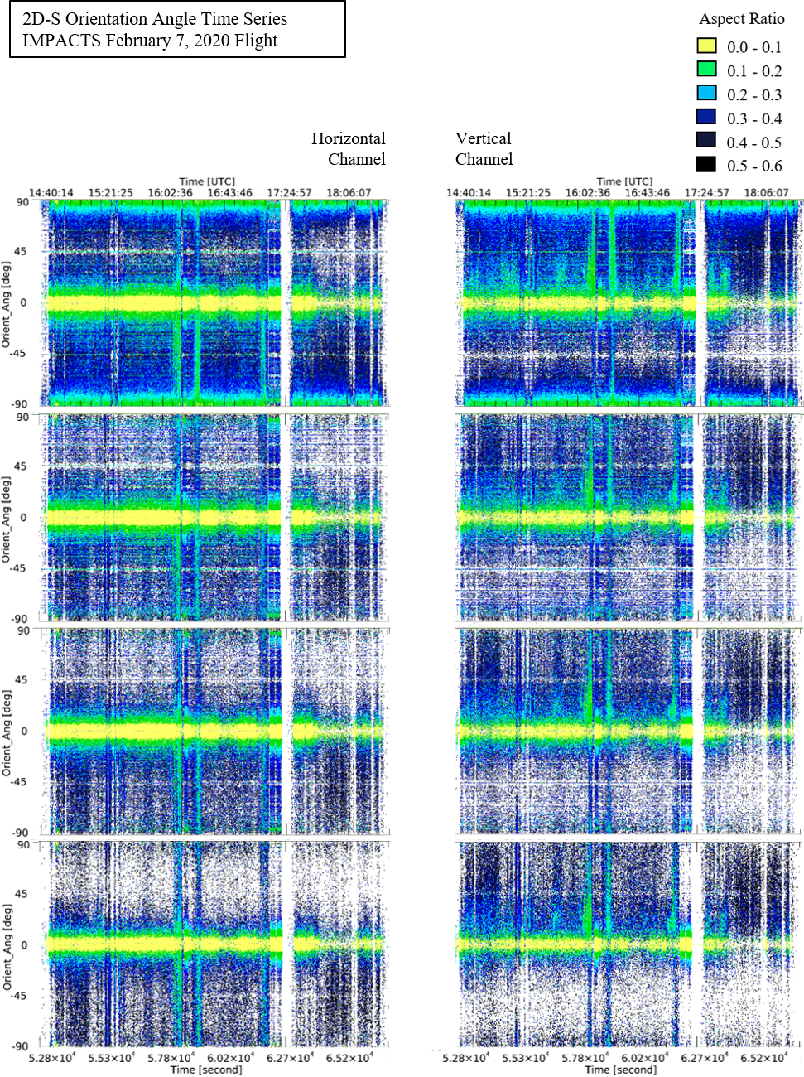
(d)
(c)
(b)
(a)
- Four pairs of time series plots from the Two-Dimensional Stereo Optical Array Probe (2D-S) horizontal and vertical channels of the orientation angles of all particles sampled during the 07 February, 2020 Investigation of Microphysics and Precipitation for Atlantic Coast-Threatening Snowstorms (IMPACTS) flight that met the following subset criteria: (a) particles with aspect ratios up to 0.6; (b) all-in particles with aspect ratios up to 0.6; (c) all-in particles greater than 100 µm in diameter with aspect ratios up to 0.6; (d) all-in particles greater than 200 µm in diameter with aspect ratios up to 0.6. Particles are assigned a color based upon the aspect ratio of the particle. The apparent lapse in the data around the 17:24:57 UTC mark is due to a momentary cloud-free segment.
The initial set of plots in Figure 18 had a high occurrence of particles with an orientation angle near ± 90.0 degrees and near 0.0 degrees (a), but the exclusion of particles that were not flagged as being “all in” reduced the high occurrence of particles with angle near ± 90.0 degrees (b). It was less apparent to identify any benefit of limiting the dataset to particles greater than 100 µm in diameter (c), but it was necessary to discard these smaller particles and fragments due to the non-uniformity of orientation angle distributions as shown previously. Raising the lower threshold to 200 µm diameters did not eliminate the high occurrence near 0.0 degrees (d), and in an effort to preserve as much of the dataset as was practical, the 100 µm diameter was selected to be an acceptable lower threshold for the case selection process.
Therefore, set (c) was used to select and examine cases. Figure 19 shows, once again, the time series plot using the subset parameters for set (c), but with interesting periods showing a pattern of non-uniform distribution of orientation angles outlined in red. This method was the starting point for selecting cases to examine. Cases were based on interesting periods of groupings of orientation angles, which could be indicative of a preferred angle and/or a vertical orientation event.
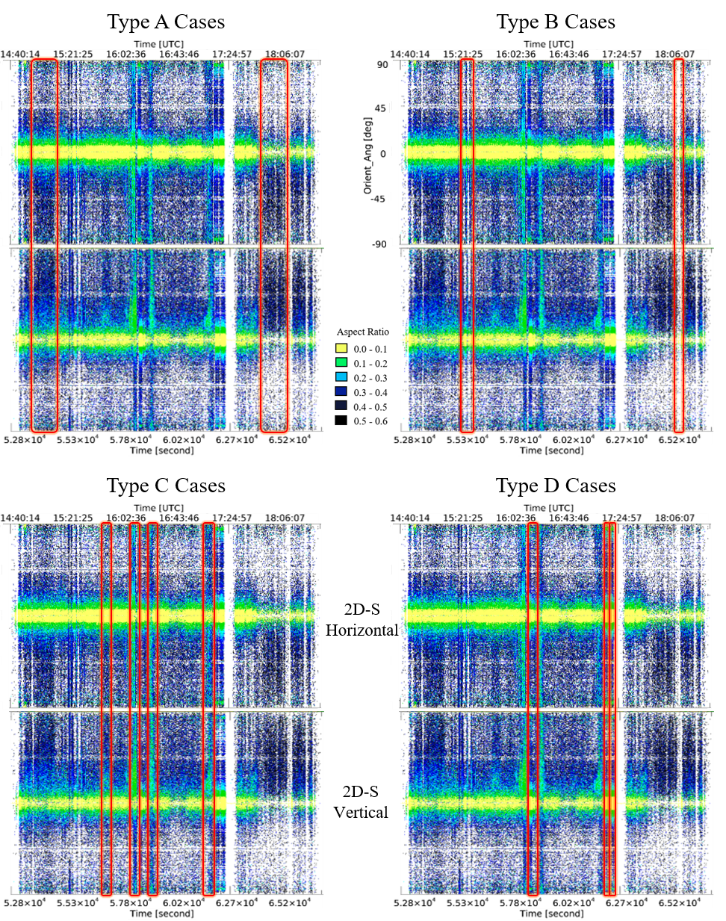
- The same two time series plots from the Two-Dimensional Stereo Optical Array Probe (2D-S) horizontal and vertical channels are shown along the top and bottom of each quadrant of this figure. The data shown is a plot of the orientation angles of all particles sampled during the 07 February, 2020 Investigation of Microphysics and Precipitation for Atlantic Coast-Threatening Snowstorms (IMPACTS) flight that met the following subset criteria: all-in particles greater than 100 µm in diameter with aspect ratios up to 0.6. Interesting periods are outlined in red and categorized by similar patterns into four types: A, B, C, and D, which will be used as the basis for further investigation and possible identification of particle orientation cases.
The breakdown into four type categories was a reflection of certain patterns that appeared in the orientation angle time series plots from the 2D-S horizontal and vertical channels. This does not constitute an analysis of the data, but rather an initial impression from which cases were selected. The Type A cases appeared to favor opposing polarity of orientation angles between the horizontal and vertical channels. Type B cases seem to have lower concentrations in general, and/or a higher preference towards near-zero orientation angles. Type C cases appear to be of a higher concentration that are more uniformly distributed but with an apparent grouping distinct from the overall high occurrence of near-zero orientation angles. Finally, Type D cases either have a very high occurrence of near-zero orientation angles particularly within the lower aspect ratio particles, or otherwise an especially high percentage of lower aspect ratio concentrations.
Further examination of the potential cases of interest revealed a high occurrence of low aspect ratio particles grouped near orientation angles of zero degrees, which did not appear to be consistent with the bulk of the image data of interest. Requiring an area ratio of 0.1 or greater eliminated most of the contaminating noise and yielded a higher quality subset as shown in Figure 20 -. The same periods of interest identified previously were used for the final case selection with the refined subset parameters applied.

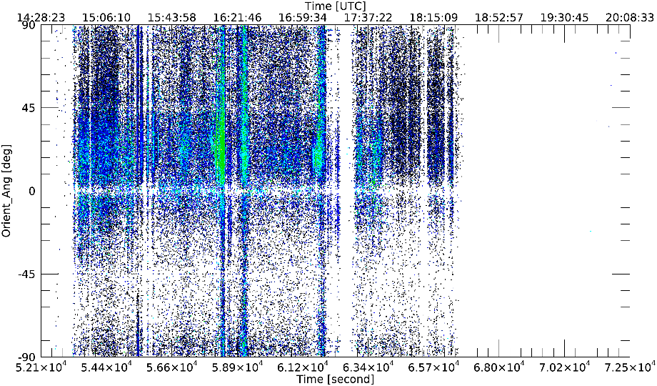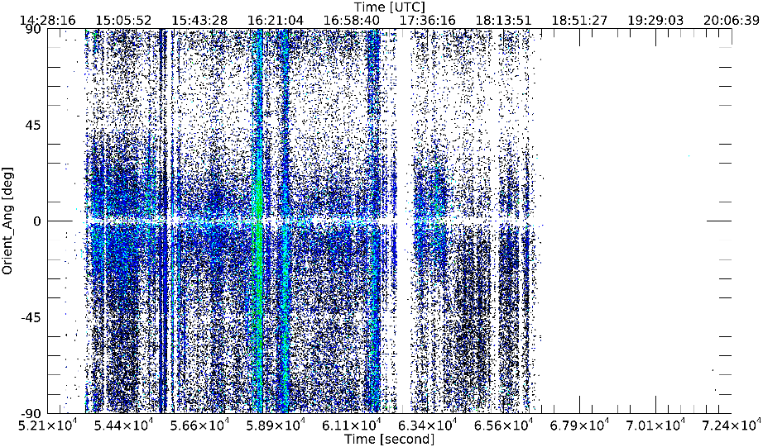
- A final look at two time series plots from the Two-Dimensional Stereo Optical Array Probe (2D-S) horizontal and vertical channels of the orientation angles of all particles sampled during the 07 February, 2020 Investigation of Microphysics and Precipitation for Atlantic Coast-Threatening Snowstorms (IMPACTS) flight that met the following refined subset criteria: all-in particles greater than 100 µm in diameter with aspect ratios up to 0.6 and area ratios greater than 0.1.
- Analysis Approach
In order to identify special occurrences of vertical ice crystal orientation, it was equally important to be able to demonstrate occurrences of either random ice crystal orientation or predominantly horizontally-oriented ice crystals as would be expected as the natural fall orientation during precipitation events. Thus, the analysis must seek to identify cases of vertically oriented ice crystals as well as null cases if any meaning can be derived from the observations of either. If the sought out cases of predominantly vertical orientation could not be directly observed in the dataset, a secondary approach to the analysis was to identify if any cases revealed that groupings of a preferred orientation angle exists.
As availability of data allowed, LIP data was provided for all cases of vertical ice crystal orientation or preferred angle orientation and for any null cases. In doing so, the analysis established if any relationship exists between any identified cases of ice crystal orientation within the cloud and the electric field at cloud top, as measured by the LIP. If cases of vertical ice crystal orientation tend to occur during periods when the electric field departs from the static field and becomes more polarized or active, then it could be said there must be some relationship between the cloud top electric field and the ice crystals becoming vertically oriented or oriented to a preferred angle apart from a uniform distribution of orientation angles.
Select cases were further analyzed by the associated particle concentration measurements taken during the time period of each case. The analysis attempted to classify subcases of high concentration and low concentration. For each concentration subcase, the original analysis was repeated by producing a histogram of orientation angles for all particles within the dataset during the low concentration period and the high concentration period. Partitioning the cases of ice crystal orientation under such scrutiny revealed if the preferred angles of orientation amplify, dampen, or remain unchanged as the overall particle concentration during the period varied between low and high. This investigation helped characterize if there are any contributions that particle concentration may have on the factors behind ice crystal orientation events in the absence of an electric field measurement within the cloud.

DATA
The 07 February, 2020 IMPACTS flight involved a mature synoptic low pressure system that was situated over the northeastern United States after it had travelled eastward along the Canadian-United States border in the days prior. The low pressure system was associated with a deep, negatively tilted trough and was supported by a significant, combined jet region in excess of 200 knots comprised of the Polar Front and Subtropical Jets. The cyclone had a history of producing hazardous winter weather, including heavy snowfall, mixed-phase precipitation, strong winds, and blizzards across the northern United States and was forecasted to be a significant event for the New England states on February 7th as it was continuing to rapidly deepen. The IMPACTS Science Team fully mobilized with extensive preparation, forecasting, and ongoing coordination between ground crews, the NASA P-3, and the NASA ER-2, targeting snow bands over the New York region, where heavy snow and traffic repercussions were already being reported. The P-3 flew in a clockwise racetrack pattern (Figure 21) at varying altitudes within the extensive cloud cover associated with the comma head deformation zone over an occluded front. Also displayed in Figure 21 is the ground-based, national radar mosaic of composite reflectivity, which shows a gradual reflectivity gradient in the west, consistent with stratiform snow clouds, and a concentration of higher reflectivity values in the east where cumuliform generating cells were present. It is notable that at approximately equal altitudes, the ambient temperature tended to be warmer when flying through the generating cells, consistent with the upward vertical motion found in these areas, and located overhead of rain reports at the surface. Due to the science objectives for this thesis, the cases selected sought to isolate cases of low aspect ratio particles encountered during the flight.
- All cases examined during the 07 February, 2020 Investigation of Microphysics and Precipitation for Atlantic Coast-Threatening Snowstorms (IMPACTS) flight during the search for ice crystals with vertical orientation or a preferred angle. The start and end times for each case are presented in both UTC and in seconds from midnight (sfm). The number of particles sampled within the previously defined subsets is given for the horizontal (N_{H}) and vertical (N_{V}) channels. The duration of each case is listed in total number of seconds (s) as well as the equivalent minutes (min).
ID |  | Case Start Time |  |  | Case End Time |  |  | Particle Count |  |  | Case Duration
# | [UTC] |  | [sfm] | [UTC] |  | [sfm] | N_{H} |  | N_{V} | [s] |  | [min]
1 | 14:57:00 |  | 53820 | 15:19:59 |  | 55199 | 20816 |  | 24493 | 1379 |  | 23.0
2 | 15:23:40 |  | 55420 | 15:30:40 |  | 55840 | 15007 |  | 18163 | 420 |  | 7.0
3 | 15:48:00 |  | 56880 | 15:55:50 |  | 57350 | 5980 |  | 7179 | 470 |  | 7.8
4 | 16:09:40 |  | 58180 | 16:15:40 |  | 58540 | 31575 |  | 35015 | 360 |  | 6.0
5 | 16:22:00 |  | 58920 | 16:28:20 |  | 59300 | 12988 |  | 13275 | 380 |  | 6.3
6 | 17:04:50 |  | 61490 | 17:12:00 |  | 61920 | 9406 |  | 9830 | 430 |  | 7.2
7 | 17:29:25 |  | 62965 | 17:36:35 |  | 63395 | 3213 |  | 3760 | 430 |  | 7.2
8 | 17:36:36 |  | 63396 | 17:43:40 |  | 63820 | 2833 |  | 3326 | 424 |  | 7.1
9 | 17:46:00 |  | 63960 | 18:07:20 |  | 65240 | 8243 |  | 9678 | 1280 |  | 21.3
10 | 18:11:30 |  | 65490 | 18:21:17 |  | 66077 | 4744 |  | 5646 | 587 |  | 9.8
- The predominant particle habit types as determined by visual assessment of corresponding Cloud Particle Imager (CPI) images for all cases examined during the 07 February, 2020 Investigation of Microphysics and Precipitation for Atlantic Coast-Threatening Snowstorms (IMPACTS) flight during the search for ice crystals with vertical orientation or a preferred angle.
ID | Particle Habit(s) Observed | Pitch Changes | Roll Angle Changes
1 | Plates | no | yes
2 | Columns | no | yes
3 | Plates, Plate Aggregates, Plates Fragments | no | yes
4 | Needles, Columns, Prisms | no | yes
5 | Column Aggregates | not examined | not examined
6 | Columns, Needle Aggregates | not examined | not examined
7 | Plates, Sectored Plates, Plate Aggregates | not examined | not examined
8 | Plates, Prisms | not examined | not examined
9 | Plates Aggregates, Columns, Prisms, Plates | not examined | not examined
10 | Rimed Plate Aggregates. Rimed Columns, Plate Aggregates, Columns, Prisms | not examined | not examined
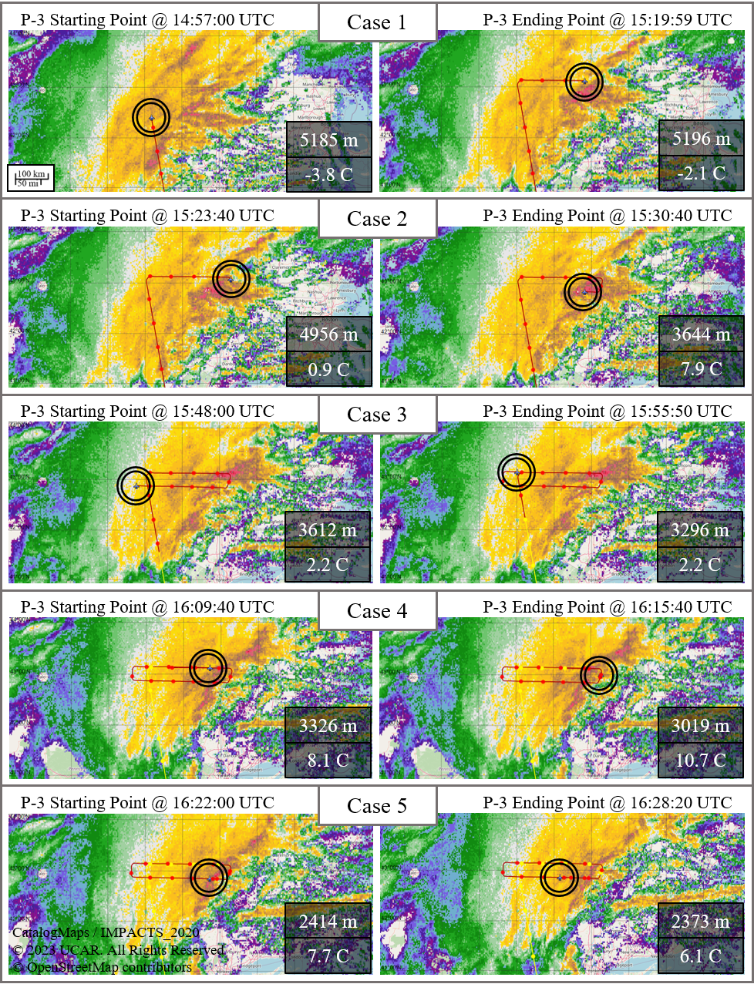
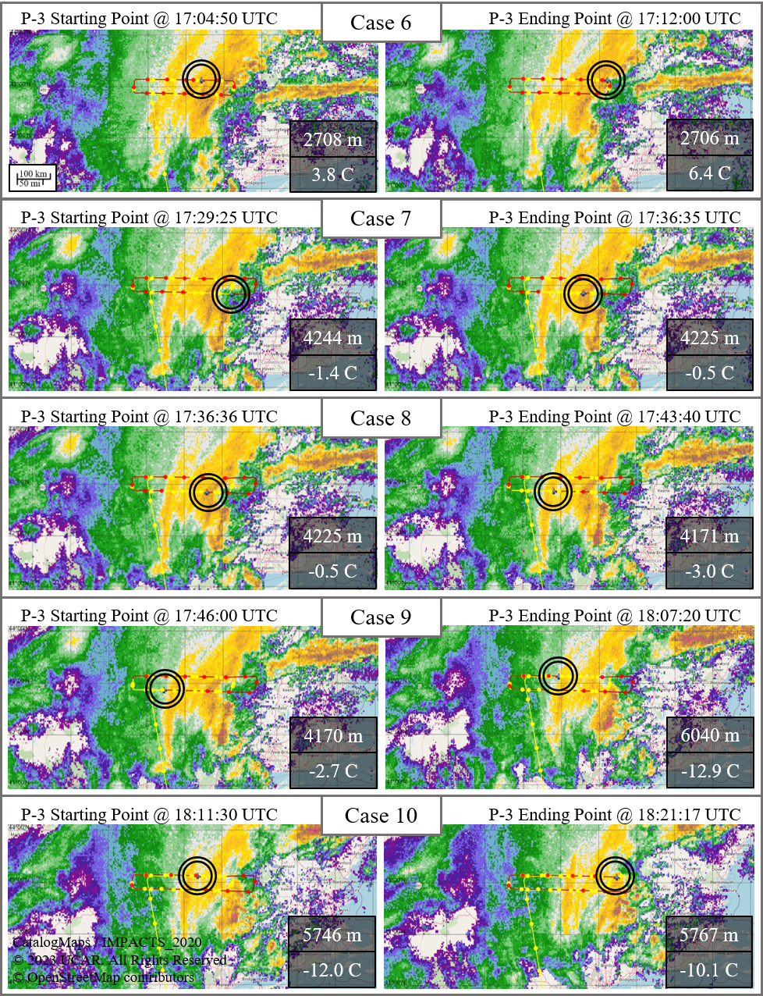
- Maps showing the NASA P-3 starting and ending point locations and flight track (red) of each selected case during the 07 February, 2020 Investigation of Microphysics and Precipitation for Atlantic Coast-Threatening Snowstorms (IMPACTS) flight with the NEXRAD Reflectivity Mosaic displayed. The GPS Altitude (m) of the NASA P-3 is given for each starting and ending point, and the Total Air Temperature (C) is also given for the starting and ending times (UTC) of each case.
While the NASA P-3 flew in a clockwise racetrack pattern at varying altitudes; Cases #1, 4 through 8, and 10 were sampled during periods of a relatively constant altitude, whereas Cases #2, 3, and 9 involved a mid-case altitude change that typically occurred at the completion of a racetrack lap. Due to the flight path of the NASA P-3 maintaining a clockwise circuit, there were six cases that included a banking right maneuver with roll angles of approximately 20 degrees, but no banking left maneuvers were identified during the cases other than slight adjustments with roll angles of less than 5 degrees. Some cases (Table 4) include aircraft maneuvers that resulted in a significant pitch angle change ( ≥ ± 5 degrees) or roll angle change ( ≥ ± 5 degrees) that occur over 30 to 60 seconds; aircraft maneuvering occurrences during Cases #5-10 were not investigated due to Cases #1-4 providing sufficient examples. Although altitude changes were documented during the cases, there were no significant changes to the NASA P-3 pitch angle because the traditional method of changing an aircraft’s altitude relies primarily on modifying the amount of thrust. A comparison of the ice crystal orientation angles during periods of what can be considered “straight and level” flight versus during a change in roll angle or altitude are given in the results and are useful in identifying the integrity of ice crystal preferred orientation angles. The case selection methodology provided a total of ten cases selected from the 07 February, 2020 science flight (Table 3), and while the 2D-S data is the basis for the selection of cases, the CPI was initially employed to identify the particle habits most representative of each case (Table 4).
Interestingly, aside from the end point of Case #9, the highest average altitude and coldest average ambient temperatures of all the cases is Case #10, which is the only case where ice crystals coated with rime icing was among the predominant types observed. The case with the lowest altitude and warmest temperatures was Case #4. The predominant ice crystal habits observed were needles, columns, and prisms, all of which were outside their typical growth region in terms of temperature. This indicates that precipitation of these crystals was likely in progress at the time of sampling. To clarify, the examinations of the types of crystals sampled during this study identified both columns and hollow columns observed throughout the dataset, but no further distinction was made, and thus any references to columns may indicate either subtype.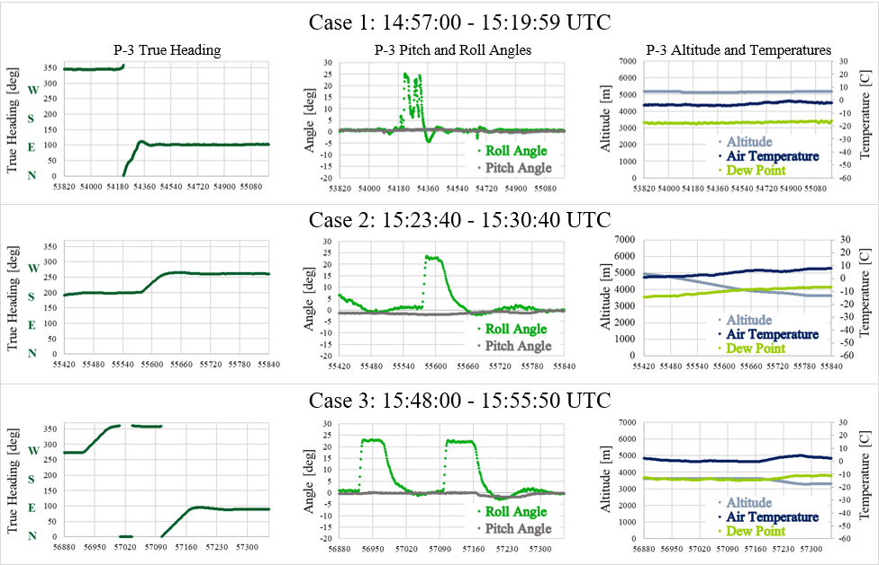
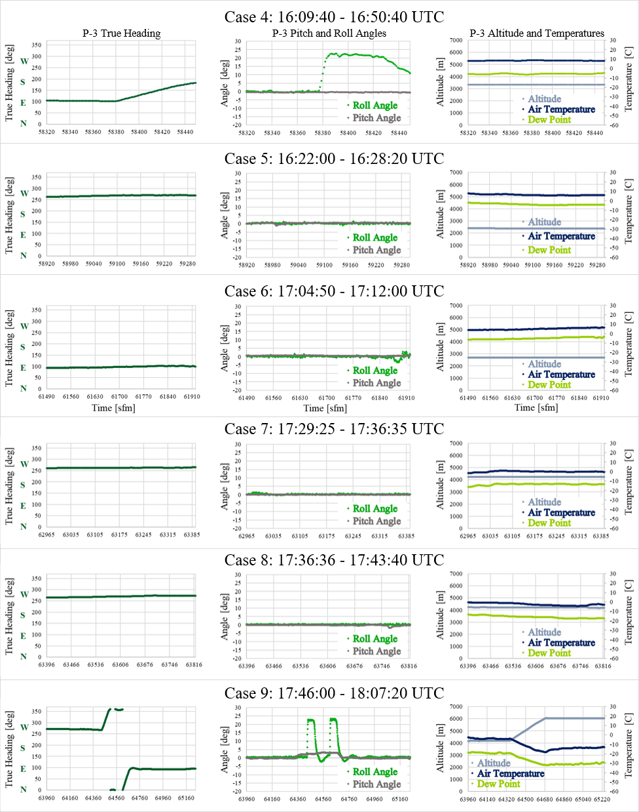
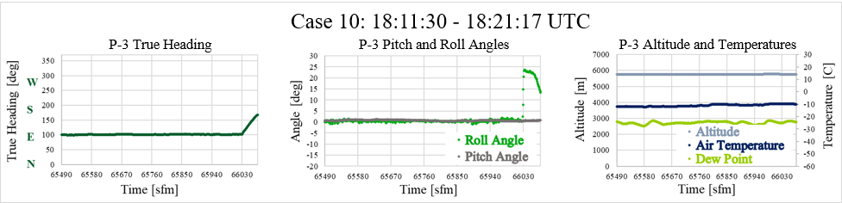
- Plots detailing the NASA P-3 True Heading (dark green), Pitch Angle (gray), Roll Angle (medium green), GPS Altitude (light blue), Total Air Temperature (dark blue), and Dew Point Temperature (light green) data for selected cases of the 07 February, 2020 Investigation of Microphysics and Precipitation for Atlantic Coast-Threatening Snowstorms (IMPACTS) science flights.
Much of the 2D-S Image Data collected during the 07 February, 2020 IMPACTS flight appear to show a similarity in the orientation angles of low aspect ratio particles, such as plate crystals, columns, or needles. Figure 23 shows one such example of 2D-S Image Data that has a large number of what appear to be columnar ice crystals, and these were confirmed to be columns by comparing the 2D-S images with images from the CPI. Concerning the example shown in Figure 23, the similarities in orientation angle are most pronounced in the vertical channel and seem to favor a positive orientation angle of between zero and 45 degrees, which are examined more in depth in the results. In other cases, low aspect ratio particles that appeared to be columns or needles ended up being plate crystals viewed from the side, which underscores the importance of verifying the crystal type through photographic means.
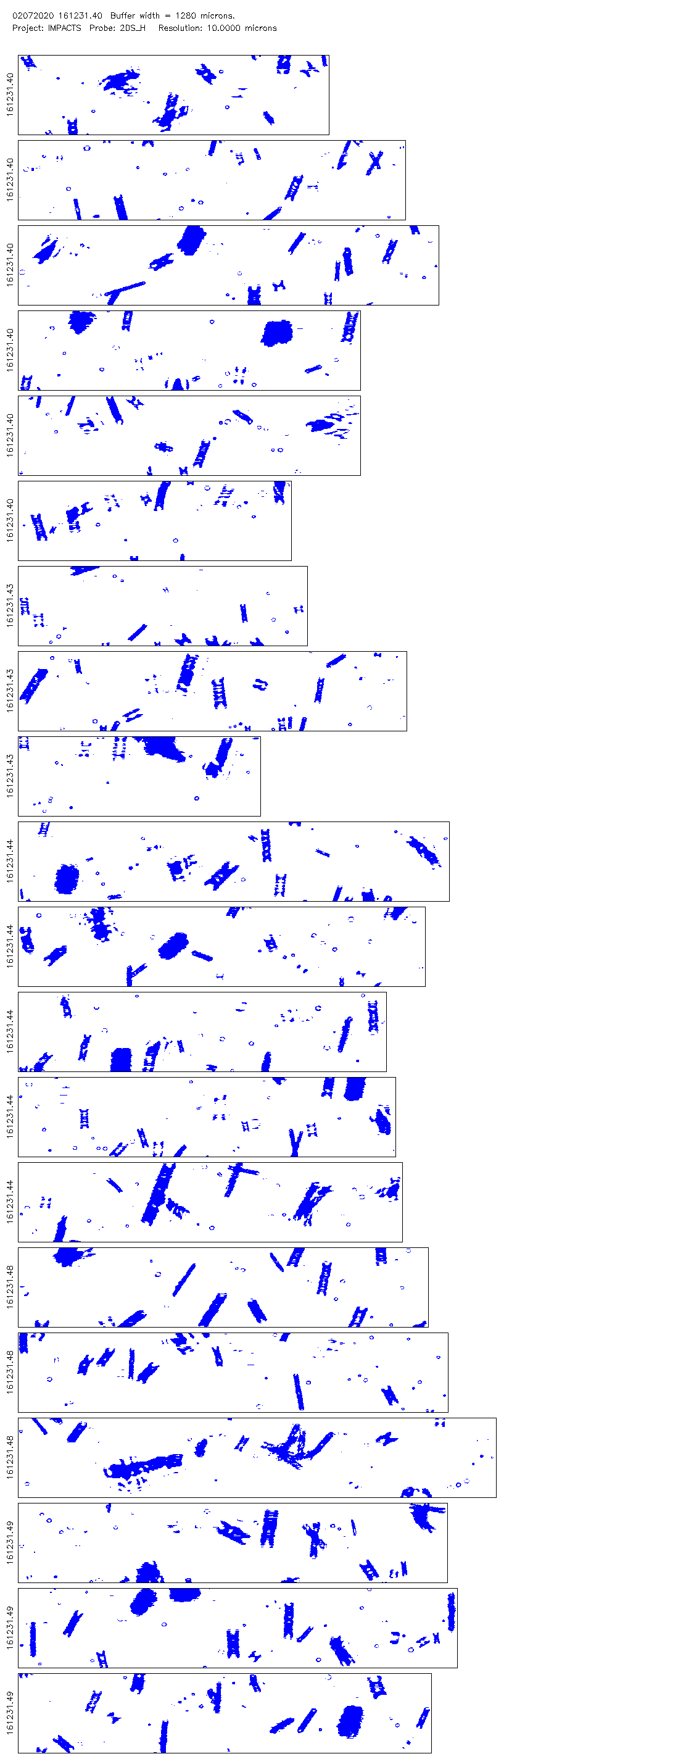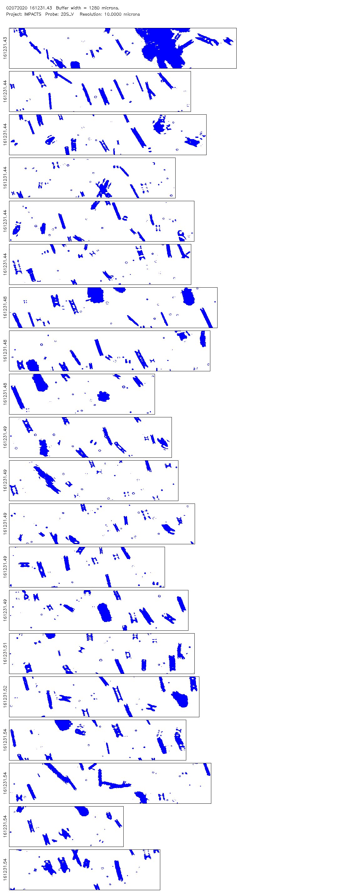
- This figure represents one example of the Two-Dimensional Stereo Optical Array Probe (2D-S) image data collected during the 07 February, 2020 Investigation of Microphysics and Precipitation for Atlantic Coast-Threatening Snowstorms (IMPACTS) flight. The horizontal (vertical) channel is shown on the left (right). The images depicted in blue are the silhouettes of particles sampled by the 2D-S and magnified so that each pixel is equivalent to a width of 10 µm. Each strip of data is a time-series record of the shape, size, orientation, and inter-particle timestamp of sampling occurrence in succession, with a new strip beginning upon the 2D-S reaching its data buffer limit. The beginning timestamp of the buffer is labeled along the lefthand side of each strip in seconds from midnight (sfm). In both channels, the upper left corner of each strip is the origin of the aircraft coordinate system with the positive X-direction pointing down along the short end of the data strip and the positive Y-direction pointing to the right along the long end of the data strip, where the positive X-direction represents the direction of flight, and the positive Y-direction extends away from the aircraft fuselage and toward the right wing tip due to the 2D-S being mounted underneath the right wing.
A significant challenge in acquiring a quantitative assessment of the electric field to see if there was any link between electric charging and occurrences of particle orientation was primarily in maintaining real-time congruity between the flight patterns implemented during the science flights of the NASA P-3 and NASA ER-2 research aircraft, and the varying geographical disparities and altitude differences between the two aircraft were calculated for all ten cases. Table 5 shows only the first four cases because by 16:16:00 UTC, the NASA ER-2 research aircraft had completed its final racetrack pattern for the 07 February, 2020 science flight and initiated its departure from the sampling region. The increasing distance between the NASA ER-2 and NASA P-3 rendered the LIP data unremarkable for Cases #3-10. The NASA P-3 remained in the region to complete a few additional racetrack patterns after the departure of the NASA ER-2, and it is from the solo NASA P-3 period that Cases #5-10 were selected.
- The geographical positions and relative distance of the NASA P-3 and NASA ER-2 research aircrafts during selected cases (ID) of the 07 February, 2020 Investigation of Microphysics and Precipitation for Atlantic Coast-Threatening Snowstorms (IMPACTS) science flights. A factor of 111 km/deg was used to convert latitude (Lat.) and longitude (Long.) positions to distances in km. The ER-2 began to depart after Case #4 and was not available during later cases. The geographical difference is calculated independently of the altitude (Alt.) difference.
ID | Time Segments |  |  | P-3 Position |  |  | ER-2 Position |  |  | Distance
 |  |  |  | Lat. | Long. | Alt. | Lat. | Long. | Alt. | Geographical | Alt.
 |  | [UTC] | [sfm] | [deg] | [deg] | [km] | [deg] | [deg] | [km] | [km] | [km]
1 | Start | 14:57:00 | 53820 | 42.39 | -75.82 | 5.19 | 42.87 | -75.03 | 19.73 | 102.09 | 14.54
 | End | 15:19:59 | 55199 | 43.12 | -74.06 | 5.20 | 43.07 | -74.10 | 19.67 | 6.58 | 14.47
2 | Start | 15:23:40 | 55420 | 43.03 | -73.71 | 4.96 | 43.05 | -73.45 | 19.54 | 29.17 | 14.59
 | End | 15:30:40 | 55840 | 42.85 | -74.25 | 3.64 | 42.83 | -73.78 | 19.76 | 52.59 | 16.11
3 | Start | 15:48:00 | 56880 | 42.88 | -76.22 | 3.61 | 42.91 | -76.31 | 19.80 | 10.54 | 16.19
 | End | 15:55:50 | 57350 | 43.14 | -75.89 | 3.30 | 43.14 | -76.31 | 19.74 | 46.68 | 16.44
4 | Start | 16:09:40 | 58180 | 43.12 | -74.22 | 3.33 | 43.07 | -74.00 | 19.83 | 25.34 | 16.51
 | End | 16:15:40 | 58540 | 42.95 | -73.75 | 3.02 | 42.85 | -73.23 | 19.78 | 58.65 | 16.76
At the beginning of Case #1, the NASA P-3 was just arriving into the sampling region and was able to promptly rendezvous with the NASA ER-2, as demonstrated by the close geographical proximity at the endpoint of Case #1. The LIP data shows a weak, cyclic oscillation of the vector components of the cloud top magnetic field during Case #1 (Figure 24), when the NASA ER-2 was completing the western end of a racetrack lap and banking right to begin an eastward heading. The endpoint of Case #1 is of interest because it signifies a time when both the NASA P-3 and NASA ER-2 aircraft are located in the vicinity of a high-reflectivity snow band with radar returns near 50 dBZ, and the LIP does show a peak in all three vector components. One of the better cases in which LIP data was available during the 07 February, 2020 IMPACTS science flight was Case 2, which also featured some of the highest electric field magnitudes measured during the flight. The peak electric field magnitudes during Case #2 ranged from 10 to 40 V/m. While this was not enough to trigger any observable lightning discharges, it is considered moderate for a winter storm, where fields of 10 to 100 V/m are typical. In comparison, it is widely known that summer thunderstorms often exhibit electric fields that are 1 to 2 orders of magnitude higher than typical of winter storms.
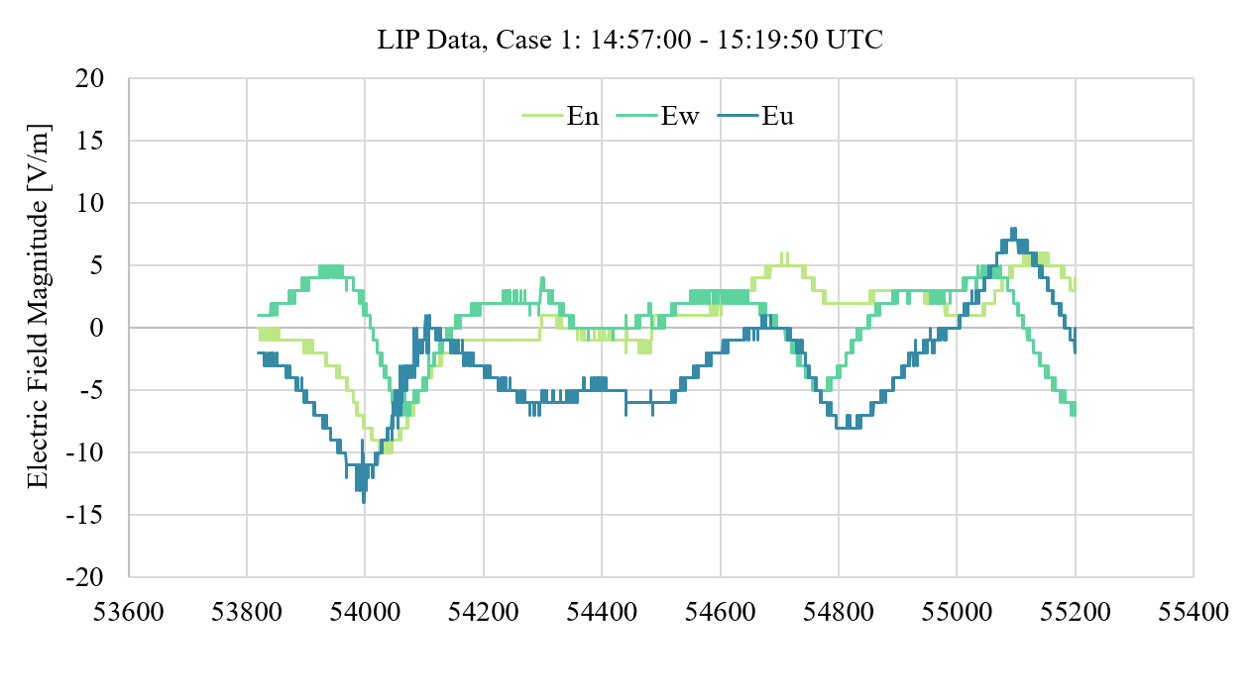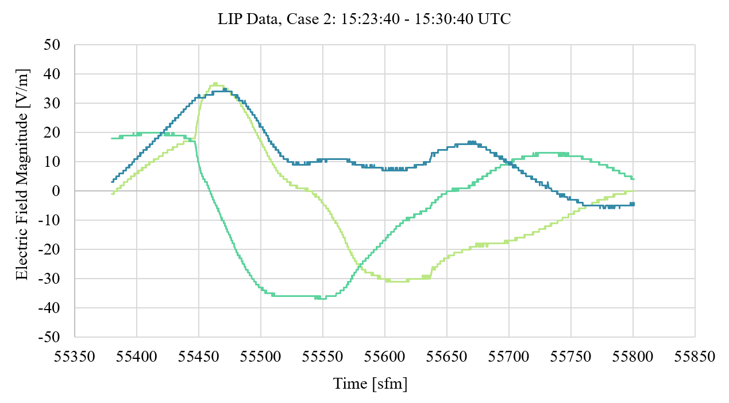
- Lightning Instrument Package (LIP) V2 data from selected cases that were collected during the 07 February, 2020 Investigation of Microphysics and Precipitation for Atlantic Coast-Threatening Snowstorms (IMPACTS) science flight. Each vector component of the cloud top electric field is plotted in Earth coordinates, with En representing the cardinal north direction, Ew positive toward the cardinal west direction, and Eu representing the upward component. Data is smoothed to remove erroneous data points.
Due to the limited availability of LIP data for Cases #3-10, the next best parameter to examine is the particle concentration data from three NASA P-3 platform-based sources, including the 2D-S Horizontal Channel, the 2D-S Vertical Channel, and the CDP. When utilizing concentration measurements, it is important to understand that particle shattering is a constant challenge that in situ airborne measurements strive to overcome and is mitigated well on the 2D-S due to the anti-shatter tips on the leading edge of the probe arms (Stratton Park Engineering Company, 2011). Segments in which the NASA P-3 encountered thin plate crystals or dendrites resulted in an increased amount of shattered particles. During high occurrences of particle shattering, the concentration measurement artificially hit higher peaks unrepresentative of the ambient concentration parameter, and this was uncovered through the examination of CPI and PHIPS image data. Recall that the CDP instrument is restricted to a range of 2 to 50-µm diameter particles, and the 2D-S dataset was subset with a lower diameter bound of 100 µm. Despite the differing focus in particle sizes, similarities appear in the plots (Figure 25) in terms of the timing of peaks and lulls in the particle concentration. Therefore, a qualitative assessment can be made to identify periods of relatively higher particle concentration versus relatively lower particle concentration within each case for further examination in the results. Distinctive periods of high or low particle concentration could not be identified for all cases to due noise in the data for unknown reasons; therefore, Case #3, 7, and 9 will be omitted from that portion of the analysis.
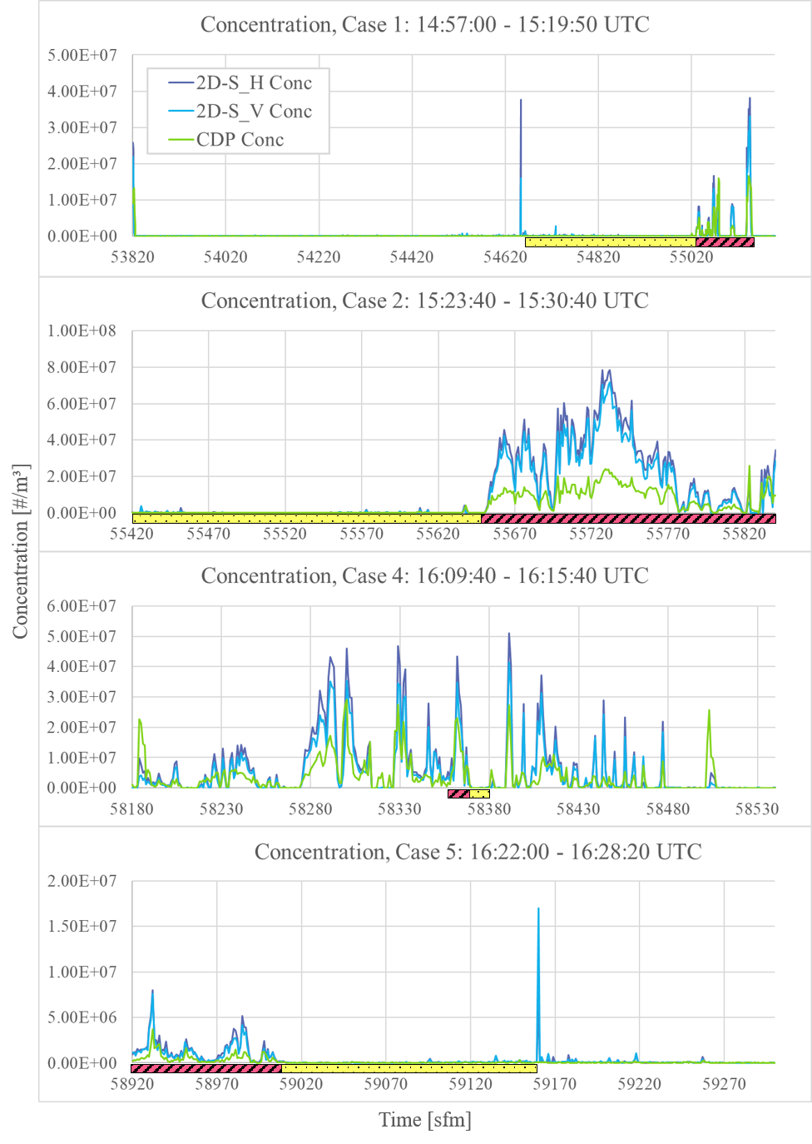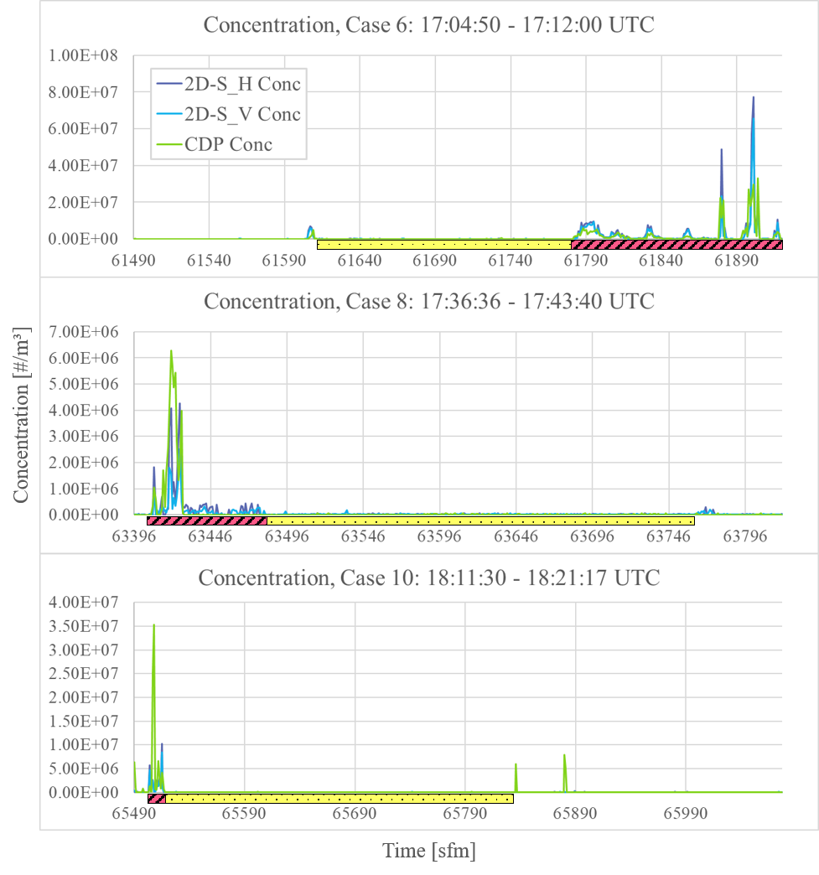
- Plots depict particle concentration measurements made by the Two-Dimensional Stereo Optical Array Probe (2D-S) horizontal (2D-S_H Conc) and vertical channels (2D-S_V Conc) and the Cloud Droplet Probe (CDP) concentration (CDP Conc) during the 07 February, 2020 Investigation of Microphysics and Precipitation for Atlantic Coast-Threatening Snowstorms (IMPACTS) flight selected cases. The plots each include a segmented line below the x-axis, which indicates distinctive periods identified as relatively “low” (dotted yellow bar) or “high” (pink hatched bar) concentration periods within the case.
In addition to the results provided for each case in the following section, a more detailed examination to compare specific sub-cases of interest are also provided. Subcases compare periods of relatively high versus relatively low periods of particle concentration, segments of straight and level flight versus aircraft maneuvering, and variations in subset aspect ratio parameters. Further suggestions regarding how the cases can be compared or approached are discussed in the future work portion of the conclusion.

RESULTS
Once the subset parameters were adjusted as described in the methodology section, the datasets examined for each of the ten cases were intended to reveal the similar orientation angles of the low aspect ratio particles that stand out in the 2D-S Image Data. Grouping the dataset particles by orientation angles depicted in a histogram format would reveal a Gaussian-like curve if a preferred orientation angle exists and an evenly distributed range of orientation angles if the particles are randomly oriented. Preliminary results revealed high occurrences of orientation angles near ± 90.0 degrees and near 0.0 degrees, but this was inconsistent with the majority of interesting ice crystals that appeared to present similar orientation angles in the 2D-S Image Data. Recall, particles that amounted to single, double, and even triple pixel images were particularly problematic and frequent, which drastically skewed the results. Applying a minimum diameter of 100 µm and an area ratio of at least 0.1 was useful in eliminating most of those contaminations without too much loss of the particles of interest from the subset. Additionally, the subset criteria also specified an aspect ratio range of 0.0 to 0.6 in order to focus on the shapes of particles that would emphasize particle orientation.
Furthermore, consideration was given to the depiction of a -90 to +90 degree range of orientation angles for the number (N) of particles in the average case subset, so as to most usefully represent the Gaussian-curve desired and maintain a similar standard across all cases for ease of comparison. To select the number of bins for the histograms, the following equation was used, according to a recommended approach by Wilks (1992).
$$h≅\frac{c IQR}{n^{\frac{1}{3}}}$$ | (3)
The equation solves for h, which is the binwidth, using the interquartile range (IQR) and n, the number of data points in the sample. The IQR is multiplied by a constant, c, which can be adjusted depending on the statistical nature of the data. A value of c = 2.6 is common for Gaussian data, whereas multimodal data may find a lower value, such as c = 2.0, more useful. Due to the multimodal nature of a histogram of the orientation angle parameter across an x-axis of all possible angels between -90.0 and 90.0, a value of c = 2.0 was used. The IQR was based on a spread between a minimum of 0% and a maximum of 100%, which gives an IQR = 50. The values for n varied in each case, and for the sake for comparison between various cases, an average value of n = 5500 was used due to exact vales of n ranging between orders of n = 10² and n = 10⁵. A value of h = 5.7 was the result, which was rounded to a binwidth of 6 degrees. Over the spread of 180 possible orientation angles, a 6 degree binwidth resulted in using 30 bins for each histogram. A 5 degree binwidth was also explored due to a base 10 being easier for consumption, but did not work for all subcases due to small samples and a need for consistent axes bounds for comparison purposes.
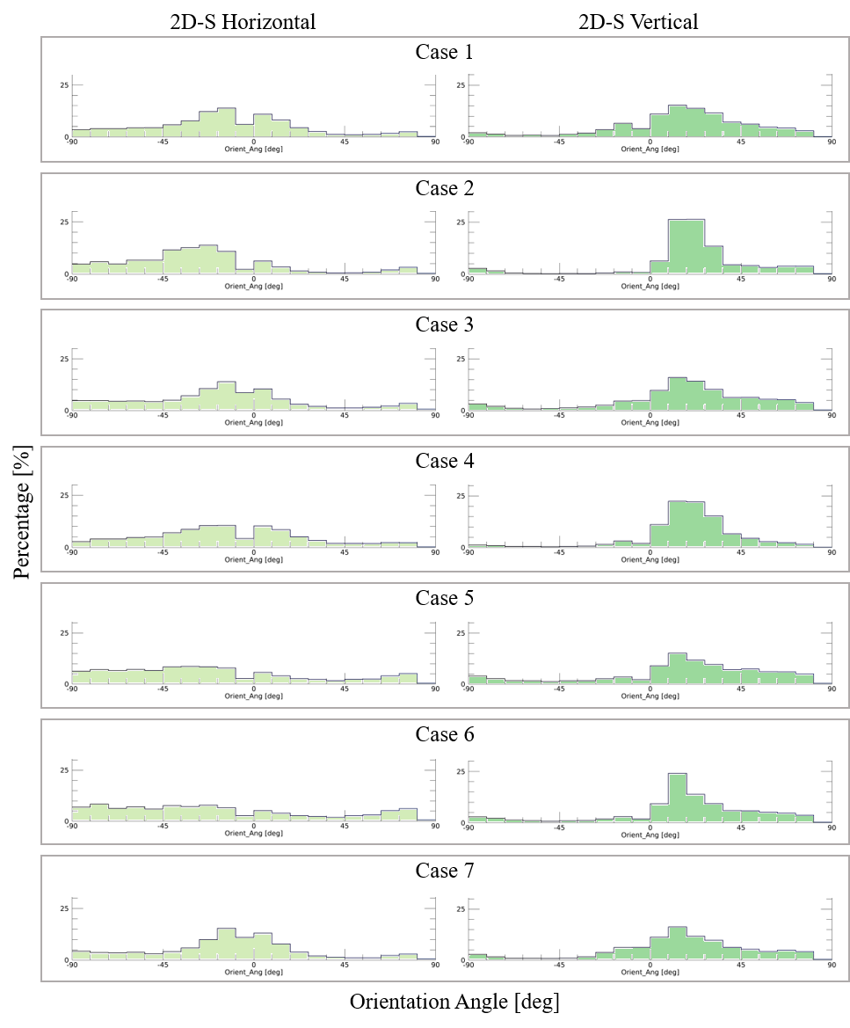
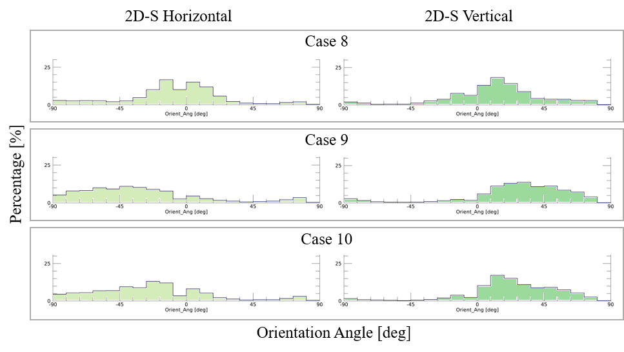
- Histograms show orientation angle occurrences by percentage for all selected cases during the 07 February, 2020 Investigation of Microphysics and Precipitation for Atlantic Coast-Threatening Snowstorms (IMPACTS) flight. The Two-Dimensional Stereo Optical Array Probe (2D-S) horizontal channel is displayed on the left and the vertical channel is displayed on the right. The corresponding time segments and predominant particle habit types are listed for each case in Table 3.
Notice that the 2D-S horizontal channel observed smaller peaks in orientation angle as well as some quasi-random distributions, as in Cases #5, 6, and somewhat with Case #7. The vertical 2D-S channel conversely shows regular consistency with an orientation angle peak in the positive orientation angles. In an effort to further isolate the low aspect ratio particles, the subset was temporarily adjusted to compare between two ranges of accepted aspect ratios, which was determined through a detailed analysis of 2D-S Image Data from Case #4 in which a particularly good example of similarly oriented ice crystals shared an aspect ratio of predominantly 0.2 to 0.3.
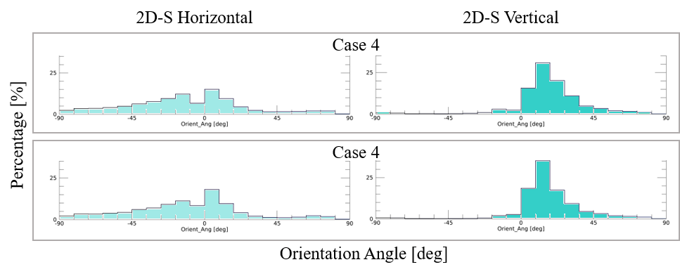
(b)
(a)
- A further investigation of previously shown Case #4 orientation angle histograms from the 07 February, 2020 Investigation of Microphysics and Precipitation for Atlantic Coast-Threatening Snowstorms (IMPACTS) flight at 16:09:40 to 16:15:40 UTC, with refined subset criteria applied. The two subset versions shown involve all orientation angles from particles with an aspect ratio of (a) 0.1 to 0.4, and (b) 0.2 to 0.3. The Two-Dimensional Stereo Optical Array Probe (2D-S) horizontal channel is displayed on the left and the vertical channel is displayed on the right.
The difference in histograms between Figure 26 and Figure 27 indicates that there is a higher occurrence of a preferred orientation angle when focusing in on a narrower range of aspect ratios, which was examined particularly in Case #4 due to the presence of columns and needles during Case #4 with needles being represented by the smaller aspect ratio range. For an additional analysis of Case #4, the data was then subset by orientation angle to examine the peak in both horizontal and vertical channel histograms. The subset of orientation angles were then graphed according to particle diameter to check for any correlation of orientation angles with particle size, and an intriguing pattern emerged, especially in the horizontal channel (Figure 28). The reason for the patterning is due to the limitations of the 2D-S in converting analogue angles to digital data, with a finite number of possible particle angles to record in the data.

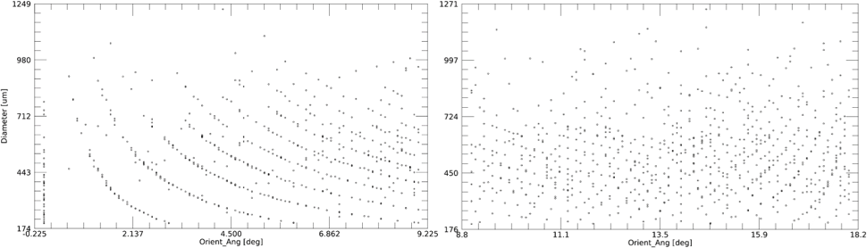
- The particle orientation angles (x-axis) by diameter (y-axis) of the preferred angle peaks of all particles sampled by the Two-Dimensional Stereo Optical Array Probe (2D-S) horizontal channel (left) and the vertical channel (right) during Case #4, which was during the 07 February, 2020 Investigation of Microphysics and Precipitation for Atlantic Coast-Threatening Snowstorms (IMPACTS) flight at 16:09:40 to 16:15:40 UTC, further subset with an aspect ratio of 0.1 to 0.4. The preferred angle peaks were observed in the histograms (Figure 27), with a range of 0.0-9.0 degrees for horizontal and 9.0-18.0 degrees for vertical.
A comparative analysis of ice crystal orientation angles was conducted using data from the 2D-S, specifically examining the horizontal (top) and vertical (bottom) channels during the 07 February, 2020, IMPACTS flight. This comparison focused on distinct intervals of high and low particle concentration to determine if orientation angle distributions varied with concentration. Generally, no significant differences were observed between high and low concentration segments, except in Cases #4 and #6.
In Case #6, which primarily included columnar and needle aggregates, the horizontal channel showed a more random distribution of orientation angles during periods of low concentration. In contrast, during periods of high concentration, the horizontal distribution became increasingly asymmetrical. Unexpectedly, in the vertical channel, a pronounced orientation peak appeared around +20 degrees during low concentration intervals. While the peak orientation remained near this angle during high concentration, the intensity of the peak was markedly reduced, contradicting the initial hypothesis that orientation would remain stable regardless of concentration.
Case #4 exhibited a somewhat different behavior. In the horizontal channel, orientation percentages at peak angles were similar between high and low concentration periods; however, there was an approximate shift of 30-40 degrees from a peak near -36 degrees in the low concentration period to a bimodal distribution centered around 0 degrees in high concentration periods, with the highest orientation percentages near ±18 degrees. The vertical channel showed stronger orientation peaks during low concentration periods, with a preferred orientation angle that persisted even when concentration increased, paralleling the results observed in Case #6.
Overall, these findings suggest that ice crystal orientation may be sensitive to concentration changes in specific cases, particularly within the vertical channel. The stable preferred orientation angles observed across varying concentrations indicate that environmental factors may influence particle orientation differently in high versus low concentration regimes, with potential implications for interpreting particle alignment mechanisms under changing atmospheric conditions.
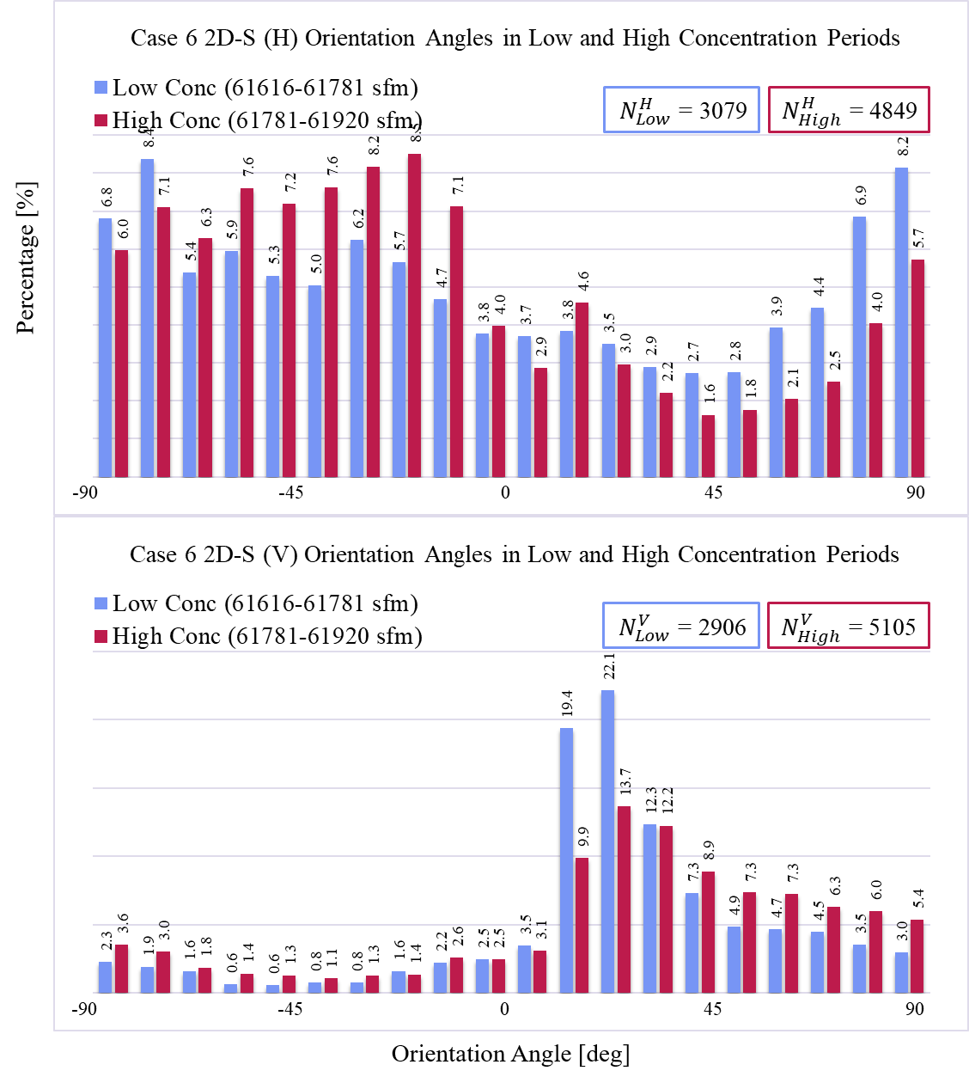
- A histogram comparison of orientation angles observed by the Two-Dimensional Stereo Optical Array Probe (2D-S) horizontal channel (top) and the vertical channel (bottom) during the 07 February, 2020 Investigation of Microphysics and Precipitation for Atlantic Coast-Threatening Snowstorms (IMPACTS) flight within distinct periods of high and low concentration. This example comes from periods identified within Case #6.
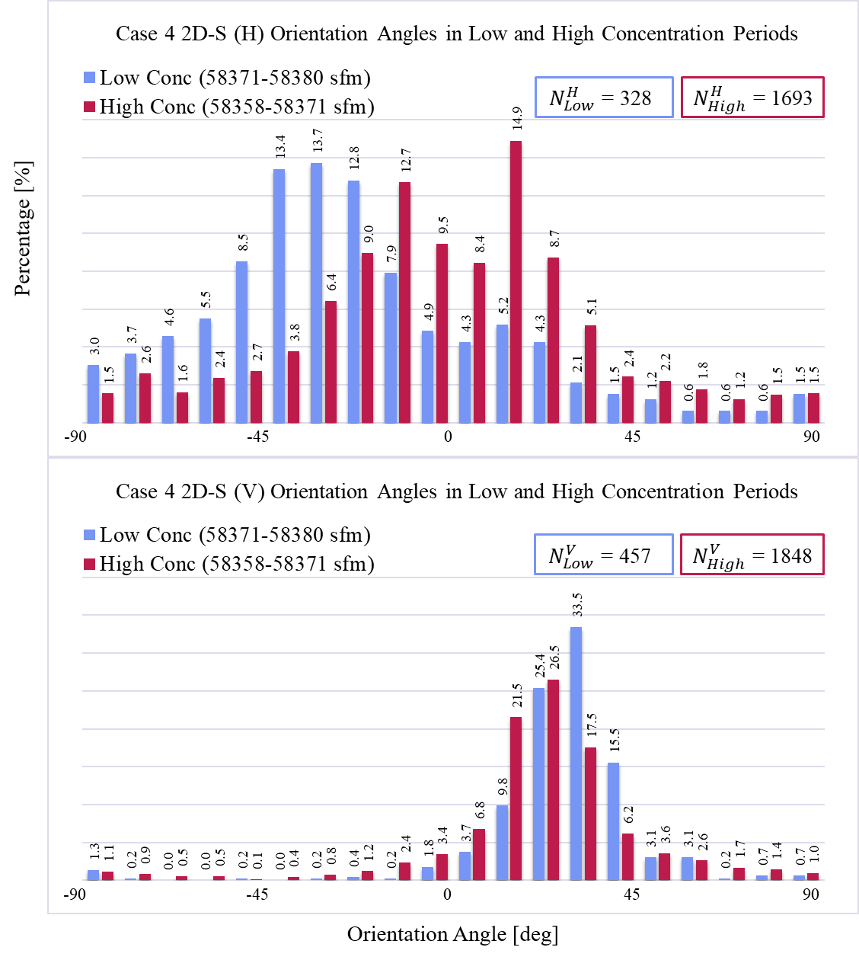
- Similarly, histograms of orientation angles observed by the Two-Dimensional Stereo Optical Array Probe (2D-S) horizontal channel (top) and the vertical channel (bottom) during the 07 February, 2020 Investigation of Microphysics and Precipitation for Atlantic Coast-Threatening Snowstorms (IMPACTS) flight within distinct periods of high and low concentration. This example comes from periods identified within Case #4.
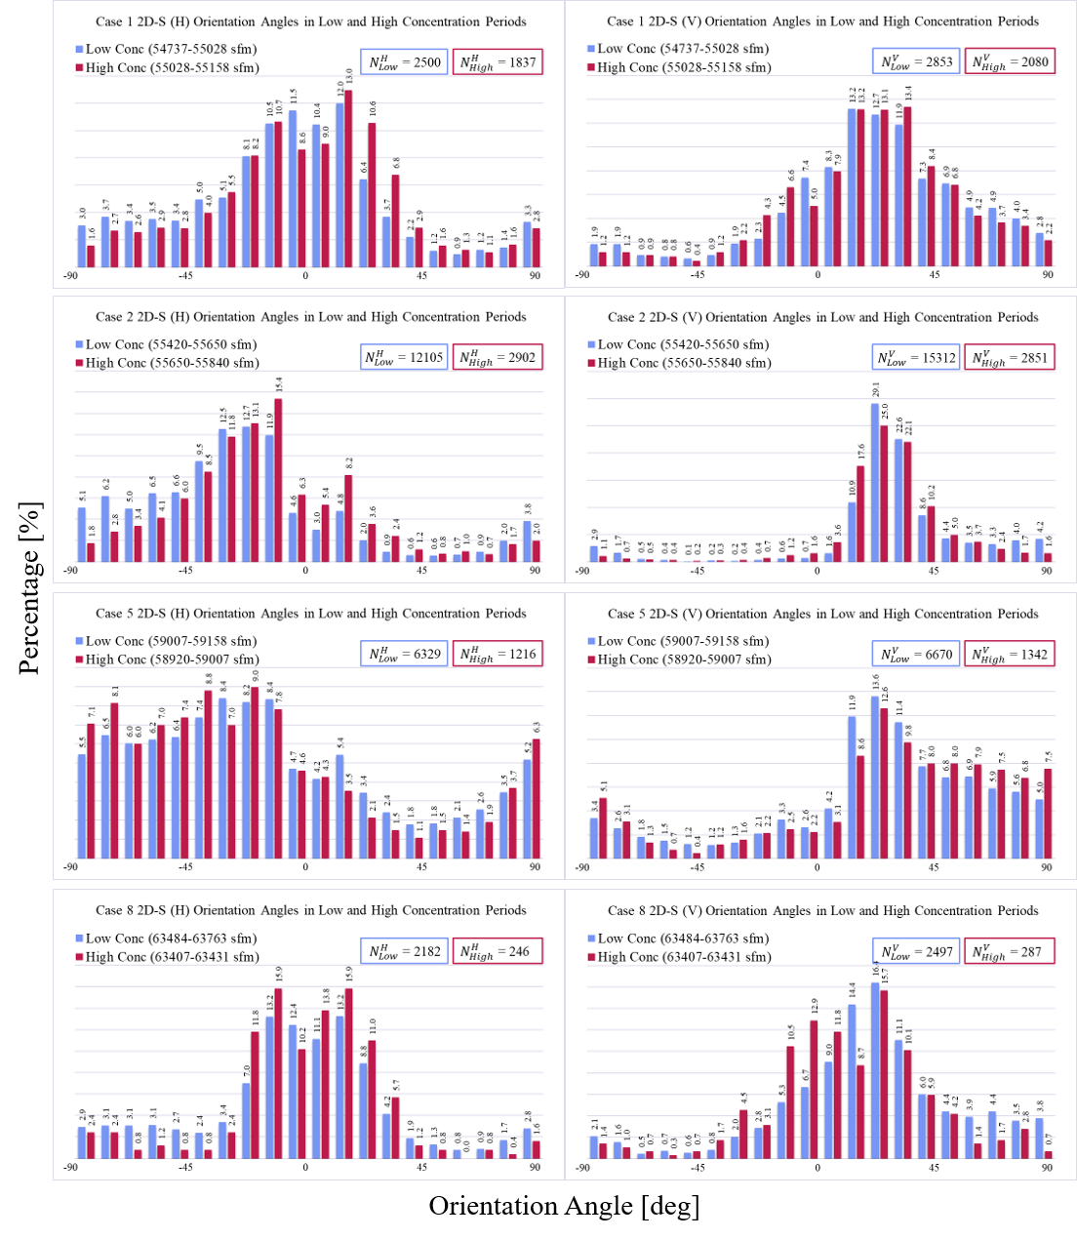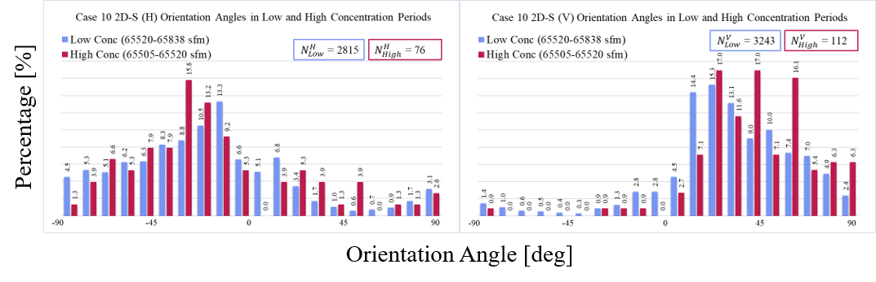
- Additional histograms depict a comparison of orientation angles observed by the Two-Dimensional Stereo Optical Array Probe (2D-S) horizontal channel (left) and the vertical channel (right) during the 07 February, 2020 Investigation of Microphysics and Precipitation for Atlantic Coast-Threatening Snowstorms (IMPACTS) flight within distinct periods of high and low concentration. These examples come from Cases #1, 2, 5, 8, and 10.
The final investigation involved a comparison of orientation angles observed during periods of straight and level flight versus aircraft maneuvers other than straight and level, and the data was selected form within the existing ten cases and using the same subset criteria of diameters greater than 100 µm, aspect ratios up to 0.6, area ratios of at least 0.1. Had the preferred angles of ice crystal orientation resulted in a shift commensurate with a roll angle of approximately 20 degrees, it would aid in the validation of the data collection methods. However, the results shown in Figure 32 reveal an almost identical set of histograms regardless of the roll angle variations of the NASA P-3 aircraft. The only noticeable difference in orientation angles appears to be during Case #2 during a period of descent, but not during any roll or banking maneuvers. There was no discernable difference in true airspeed or pitch angle during the descent case, which raises more questions as to the causation of a more random distribution among the orientation angles in the 2D-S horizontal channel; one hypothesis is that the alteration in thrust to cause the NASA P-3 aircraft to descend temporarily changed the airflow in the vicinity of the wing, where the 2D-S is mounted.
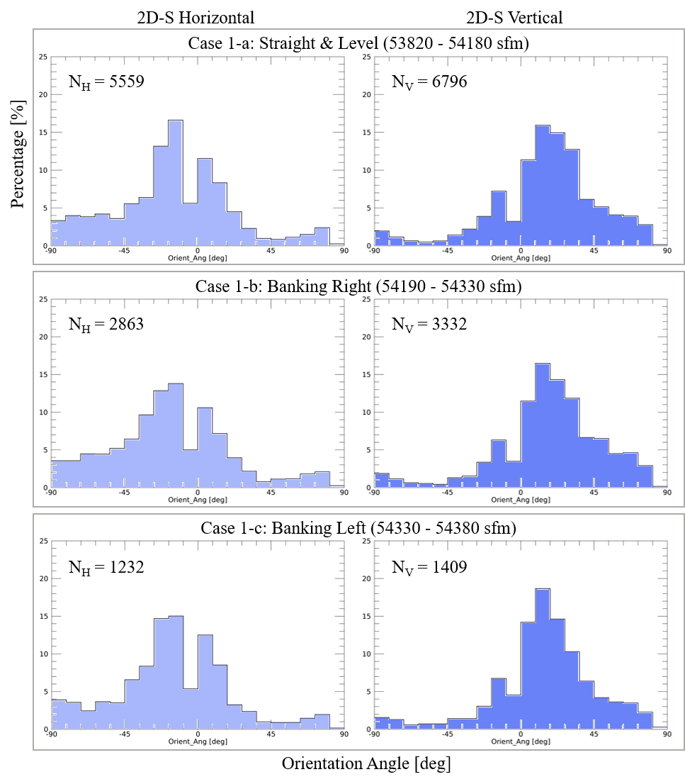
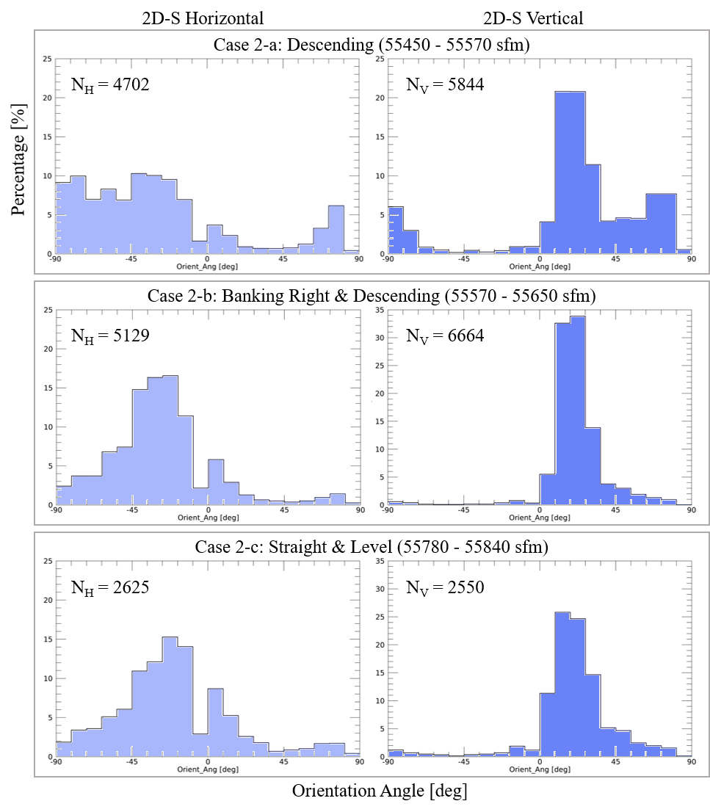
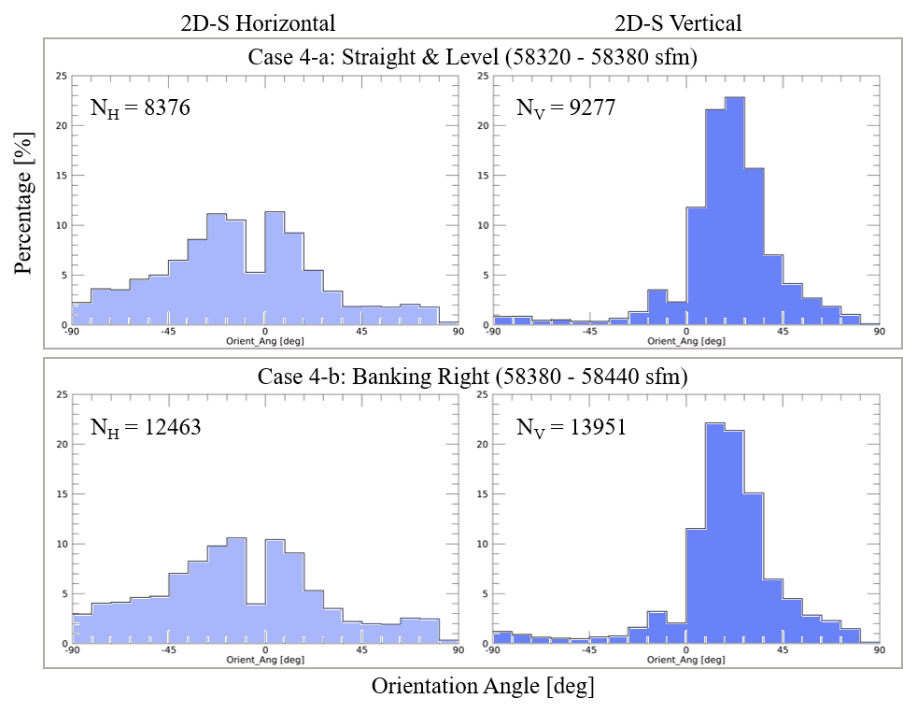
- Orientation angle occurrences plotted in a histogram by percentage for all selected cases during the 07 February, 2020 Investigation of Microphysics and Precipitation for Atlantic Coast-Threatening Snowstorms (IMPACTS) flight in which there were distinct periods of straight and level flight that could be compared to a maneuver other than straight and level flight. The Two-Dimensional Stereo Optical Array Probe (2D-S) horizontal channel is displayed on the left and the vertical channel is displayed on the right.

DISCUSSION
In examining a subset of low aspect ratio ice crystals, it was observed that these crystals consistently exhibited a preferred orientation angle throughout the flight whenever they were present. This uniformity in orientation suggests that various factors typically associated with particle alignment may not be driving the observed orientation in this case. Factors typically hypothesized to influence ice crystal orientation include turbulent air motion, vertical air currents (both updrafts and downdrafts), gravity waves, and electric fields. During the NASA P-3 aircraft's flight, data were collected at multiple altitudes, across varying ambient temperatures, and under fluctuating relative humidity levels. The aircraft frequently encountered supercooled liquid water droplets, which often indicate upward vertical motion within generating cells—a phenomenon frequently linked to turbulence and possible electric field variations. Additionally, the aircraft's geographic position, synoptic setting, and flight attitude varied throughout the mission. Given these dynamic conditions, variations in ice crystal orientation might reasonably be anticipated. However, despite these fluctuations, the orientation angle of the crystals remained consistent, with no instances of random orientation or null cases. This persistent alignment runs counter to expectations of in situ particle behavior, particularly if crystals were freely orienting according to local environmental forces.
This lack of variability raises significant questions regarding the forces influencing particle orientation. Typically, vertical orientation in particles is interpreted as a byproduct of electric field alignment in stormy conditions; however, such interpretations appear insufficient here. The absence of any random orientation cases strongly suggests that an overriding and dominant orienting force is influencing the particles within the sampling environment. Given that orientation consistency was observed regardless of external factors like altitude, temperature, humidity, or supercooled liquid water presence, it is reasonable to conclude that this force may be related to the aerodynamic environment created by the NASA P-3 aircraft itself. As the ice crystals enter the sampling volume of the 2D-S instrument, it appears that the airflow dynamics, influenced by the presence of the aircraft's airfoils and attached instrumentation, may be overriding in situ orientation cues, effectively reorienting the particles along the streamlines induced by the aircraft. Consequently, this consistency in orientation angle across diverse environmental conditions suggests that the aircraft's induced airflow dynamics are the primary influence on particle alignment within the sampling volume. Therefore, interpretations of natural orientation behavior based on these data should consider the potential influence of the aircraft's induced airflow, as it may not represent undisturbed, in situ particle orientations in the free atmosphere.

CONCLUSIONS
This study addresses the orientation, environmental influences, and concentration patterns of ice crystals in winter storms as observed by in situ airborne measurements. Through the systematic examination of observational data collected during the 07 February, 2020 Investigation of Microphysics and Precipitation for Atlantic Coast-Threatening Snowstorms (IMPACTS) flight, key insights emerged concerning the orientation patterns of ice crystals and their relationships with electric field anomalies and particle concentrations. Three questions are addressed on the ice crystal orientation.
The first question explored whether vertically oriented ice crystals could be distinctly observed using airborne in situ instruments. The study found that low-aspect-ratio crystals, including columns and needles, exhibited a preferred orientation angle, which was consistently observed across several periods. However, this alignment does not necessarily meet the strict criteria for "vertical orientation." Rather, the observed orientation may reflect alignment with streamflow patterns, suggesting the crystal alignment is a typical occurrence for similarly shaped ice crystals observed by onboard optical array probes.
While preferred alignment was consistently observed, it likely represents the natural alignment tendencies of low-aspect-ratio crystals within airflow rather than vertical orientation occurring in the atmosphere. The nuanced conclusion here underscores the importance of contextual factors—particularly the role of streamflow in influencing crystal orientation—and highlights the need for a clear definition of "vertical orientation" in future studies of crystal alignment. Understanding whether this alignment represents a fundamental physical behavior or a response to ambient conditions is critical for interpreting such observational data accurately.
The second question addresses the potential relationship between the observed alignment of ice crystals and cloud top electric field anomalies. Results established a consistent, preferred orientation among low-aspect-ratio crystals, the relevance of this question diminishes, as no randomized cases (or "null" cases) of orientation are identified. Without instances where crystal orientations varied independently of environmental conditions, it is not possible to determine if cloud top electric field anomalies exert any influence on crystal alignment within the atmosphere.
Although limited periods of electric field anomalies are evident, no distinct relationship is found between these anomalies and variations in crystal orientation. In all instances of observed low-aspect-ratio crystals, their orientation patterns remained consistent, regardless of the presence or absence of electric field anomalies. Thus, cloud top electric field anomalies are unlikely to have a detectable influence on ice crystal orientation. This conclusion reinforces the importance of obtaining varied orientation cases for assessing potential relationships with environmental anomalies, emphasizing that further investigation with a more comprehensive dataset would be required to draw definitive conclusions about any subtle interactions between electric fields and ice crystal orientation.
The third question investigated whether there is any correlation between the occurrences of vertically oriented ice crystals and regions of high particle concentration. Initial data indicated periods of relatively high particle concentration, which, if linked to vertically oriented crystals, could suggest a dynamic interaction between orientation and particle density within winter storm environments. However, further analysis revealed that these concentration peaks were primarily the result of particle shattering—a known issue within airborne probes—rather than an actual increase in ambient particle concentration.
There is no inherent relationship existing between the orientation of ice crystals and particle concentration, as the observed concentration spikes were artificial artifacts likely caused by shattering effects rather than genuine environmental conditions. This insight is particularly important for future studies and observational campaigns, as it highlights the need for methodological adjustments to minimize the impact of particle shattering and improve the accuracy of concentration data in studies of ice crystal orientation.
In summary, the consistent preferred orientation of low-aspect-ratio ice crystals likely reflects alignment with streamflow, rather than a vertical orientation occurring in the atmosphere. Additionally, no relationship is detected between crystal orientation and cloud top electric field anomalies, and apparent connections with high particle concentrations are attributed to particle shattering artifacts. These conclusions emphasize the complexity of accurately characterizing ice crystal behavior in winter storms and underscore the necessity of refining measurement techniques to reduce the influence of data artifacts. Future research would benefit from more analysis of the IMPACTS datasets, particularly those with diverse orientation cases, to explore potential environmental influences on ice crystal alignment more comprehensively. Such analysis could also investigate advanced in situ techniques or combine airborne with ground-based observations to capture a broader range of meteorological contexts. Overall, this work advances our understanding of ice crystal orientation patterns in winter storms and establishes a foundation for more detailed investigations into the complex interplay between ice microphysics and storm dynamics.
The primary limitation in addressing the original science questions lay in the inherent challenges of in situ data collection, particularly when attempting to sample fragile ice crystals or mixed-phase clouds via aircraft without altering their natural state. The current measurement techniques disturb the sampled air volume, affecting air temperature, flow, and electrostatic charge before it reaches the instrumentation—a critical factor when studying ice crystal orientation. Achieving in situ sampling with minimal interference to these sensitive parameters would be transformative for ice microphysics research.
To bridge this gap, future advancements will likely focus on enhancing remote sensing capabilities, controlled laboratory studies, and computer modeling to accurately parameterize ice crystal orientation without relying solely on direct sampling. Additionally, any future in situ campaigns must prioritize a thorough analysis of airflow, incorporating configurations for a fully equipped aircraft (including pylons, booms, and other mounted instruments) to better anticipate disturbances. Quantifying aircraft-induced static charge is also essential, as variations in electrostatic conditions may significantly impact microphysical measurements. Direct charge quantification, possibly through a mounted LIP or a similar instrument, will enable a more reliable interpretation of in situ ice crystal data, bringing greater precision to the study of ice orientation in winter storms. Through these combined efforts, future campaigns may more accurately observe and model ice crystal behavior, moving closer to answering the complex questions at the heart of this research.
REFERENCES
Bansemer, A., 2016: System for OAP data analysis. GitHub, Inc.
Burrows, D. A., and J. L. Stith, 1986: Alignment of free crystals due to transient electric fields. J. Atmos. Oceanic Technol., 3(2), 265–272, https://doi.org/10.1175/1520-0426(1986)003<0265:AOFCDT>2.0.CO;2.
Delene, D. J., 2011: Airborne data processing and analysis software package. Earth Sci. Inform., 4(1), 29–44, https://doi.org/10.1007/s12145-010-0061-4.
——, A. Skow, J. O'Brien, N. Gapp, S. Wagner, K. Hibert, and K. Sand, 2020: Airborne data processing and analysis software package (Version 3981). Zenodo, https://doi.org/10.5281/zenodo.3733448.
Foster, T. C., and J. Hallett, 2008: Enhanced alignment of plate ice crystals in a non-uniform electric field. Atmos. Res., 90(1), 41–53, https://doi.org/10.1016/j.atmosres.2008.02.017.
——, and ——, 2002: The alignment of ice crystals in changing electric fields. Atmos. Res., 62(1), 149–169, https://doi.org/10.1016/S0169-8095(02)00008-X.
Hogan, R. J., L. Tian, P. R. A. Brown, C. D. Westbrook, A. J. Heymsfield, and J. D. Eastment, 2012: Radar scattering from ice aggregates using the horizontally aligned oblate spheroid approximation. J. Appl. Meteor. Climatol., 51, 655–664, https://doi.org/10.1175/JAMC-D-11-074.1.
Jiang, Z., J. Verlinde, E. E. Clothiaux, K. Aydin, and C. Schmitt, 2019: Shapes and fall orientations of ice particle aggregates. J. Atmos. Sci., 76, 1903–1916, https://doi.org/10.1175/JAS-D-18-0251.1.
King, W. D., 1986: Air flow and particle trajectories around aircraft fuselages. IV: Orientation of ice crystals. J. Atmos. Sci., 43, 2063–2075.
Kubicki, M., A. Odzimek, and M. Neska, 2016: Relationship of ground-level aerosol concentration and atmospheric electric field at three observation sites in the Arctic, Antarctic, and Europe. Atmos. Res., 178–179, 329–346, https://doi.org/10.1016/j.atmosres.2016.03.029.
Mach, D. M., M. Bateman, and C. Schultz, 2022: Lightning Instrument Package (LIP) IMPACTS [07 February 2020 science flight, V2]. NASA Global Hydrometeorology Resource Center DAAC, Huntsville, AL, USA, https://doi.org/10.5067/IMPACTS/LIP/DATA101.
MacGorman, D. R., and W. D. Rust, 1998: The Electrical Nature of Storms. Oxford University Press, 422 pp.
MacPherson, J. I., and D. Baumgardner, 1988: Airflow about King Air wingtip-mounted cloud particle measurement probes. J. Atmos. Oceanic Technol., 5(2), 259–273, https://doi.org/10.1175/1520-0426(1988)005<0259:AAKAWM>2.0.CO;2.
Magono, C., and T. Nakamura, 1965: Aerodynamic studies of falling snowflakes. J. Meteor. Soc. Japan, 43(3), 139–147, https://doi.org/10.2151/jmsj1965.43.3_139.
McMurdie, L. A., 2020: IMPACTS field campaign data collection. NASA EOSDIS Global Hydrology Resource Center DAAC, Huntsville, AL, USA, https://doi.org/10.5067/IMPACTS/DATA101.
——, G. Heymsfield, J. E. Yorks, and S. A. Braun, 2019: Investigation of microphysics and precipitation for Atlantic Coast-threatening snowstorms (IMPACTS) collection [Full 07 February 2020 dataset]. NASA EOSDIS Global Hydrology Resource Center DAAC, Huntsville, AL, USA, https://doi.org/10.5067/IMPACTS/DATA101.
O’Brien, J. R., 2022: Sensitivity of two-dimensional stereo (2DS) probe-derived parameters to particle orientation. ProQuest, https://www.proquest.com/openview/70b4ce484f793eb78a63c1b474f4962e/1?pq-origsite=gscholar&cbl=18750.
Ryzhkov, A. V., and D. S. Zrnić, 2007: Depolarization in ice crystals and its effect on radar polarimetric measurements. J. Atmos. Oceanic Technol., 24(7), 1256–1267, https://doi.org/10.1175/JTECH2034.1.
Schultz, C. J., S. S. Harkema, D. M. Mach, M. Bateman, T. J. Lang, G. M. Heymsfield, M. L. McLinden, L. Li, M. Poellot, and K. Sand, 2021: Remote sensing of electric fields observed within winter precipitation during the 2020 investigation of microphysics and precipitation for Atlantic Coast-threatening snowstorms (IMPACTS) field campaign. J. Geophys. Res.: Atmos., 126, e2021JD034704, https://doi.org/10.1029/2021JD034704.
Stratton Park Engineering Company, 2011: 2D-S Technical Manual Rev. 3.1. http://www.specinc.com/sites/default/files/software_and_manuals/2D-S_Technical%20Manual_rev3.1_20110228.pdf (Accessed 21 October 2023).
Thomas, L., J. C. Cartwright, and D. P. Wareing, 1990: Lidar observations of the horizontal orientation of ice crystals in cirrus clouds. Tellus B, 42, 211–216, https://doi.org/10.1034/j.1600-0889.1990.00001.x-i1.
Weinheimer, A. J., and A. A. Few, 1987: The electric field alignment of ice particles in thunderstorms. J. Geophys. Res.: Atmos., 92, 14833–14844, https://doi.org/10.1029/JD092iD12p14833.
Wilks, D. S., 1992: Statistical Methods in the Atmospheric Sciences, 2nd ed. Academic Press, 627 pp.
data and software availability
All IMPACTS field campaign data used in this study is publically available on NASA’s Earth Observing System Data and Information System (EOSDIS) Global Hydrometeorology Resource Center (GHRC) Distributed Active Archive Center (DAAC) website at https://ghrc.nsstc.nasa.gov/home/field-campaigns/impacts. The ADPAA software used for data processing is freely available for download using the Github package called Community Packages for Airborne Science (CoPAS). The SODA-2 software requires the Interactive Data Language (IDL) software package and is freely available from the SODA-2 repository at https://github.com/abansemer/soda2.

Appendix A
  - Two-Dimensional Stereo Optical Array Probe (2D-S) Installation Configuration
There are several possibilities for how the Two-Dimensional Stereo Optical Array Probe (2D-S) can be installed on an aircraft. A Particle Measuring Systems (PMS) canister is typically mounted to a pylon attached to the underside of an aircraft wing. Hence, the PMS canister can be mounted horizontal or vertical, under either the left or right wing of the aircraft. The 2D-S probe is housed in a PMS canister receptacle, which has two orthogonal pin connectors conveniently located on the inside of the back of the canister (Figure 33). Either of these interior PMS canister pin connectors can be used interchangeably to connect to the back of the 2D-S probe (Figure 34).
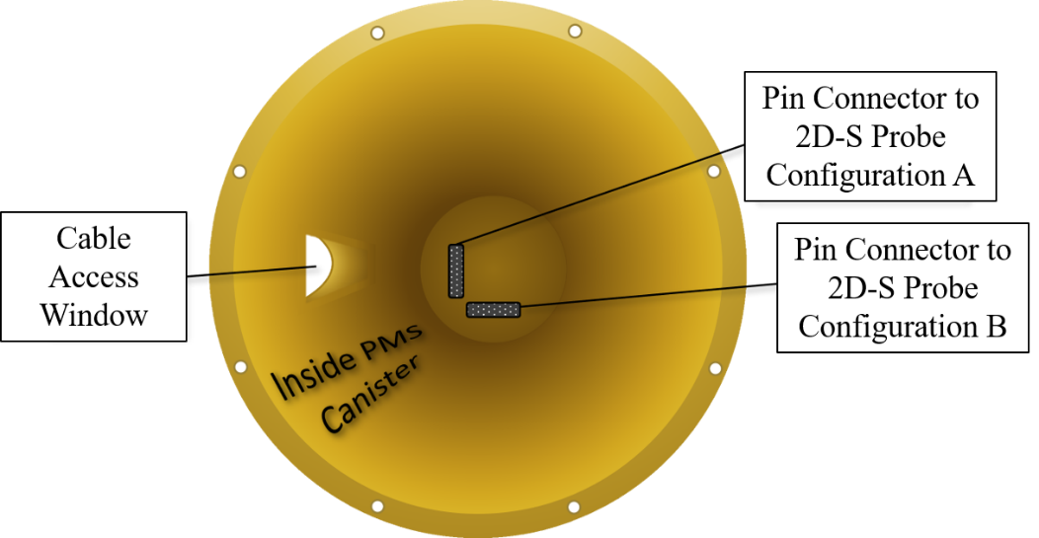
- Artistic rendering of the interior of a Particle Measuring Systems (PMS) canister includes two possible configurations for connecting the pin connecter on the Two-Dimensional Stereo Optical Array Probe (2D-S) to the pin connector on the PMS canister. Configuration A is a connection to the vertical pin connecter, while Configuration B is a connection to the horizontal pin connector.
While this provides for flexibility in how the 2D-S probe is installed, it can result in ambiguity as to the orientation of the horizontal and vertical sampling arms. The correct configuration is Configuration A, because it will result in the 2D-S Horizontal Transmitter and Horizontal Receiver arms being parallel with the ground.
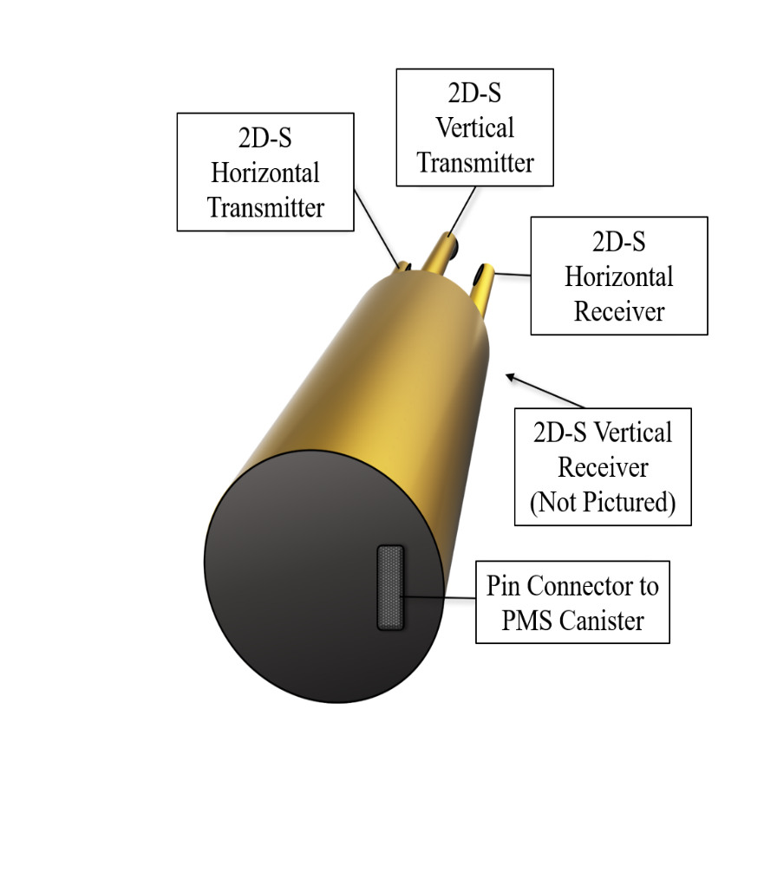
- Illustration of a simplified view of the back of a Two-Dimensional Stereo Optical Array Probe (2D-S). The canister is shown without the back end cap to illustrate where the pin connector is located. The pin connector provides the necessary connection to the Particle Measuring Systems (PMS) canister probe housing during installation. The PMS canister is connected to the aircraft wiring, which is the means that the 2D-S probe receives power and transmits data during flight. There is only one pin connector on the back of the 2D-S probe, but there are two ways inside the canister that allow probes to be oriented vertically or horizontally.
The PMS canister may be mounted on any inboard side of the starboard wing pylons or on any outboard side of the port wing pylons. The 2D-S probe should be connected in such a way that orients the horizontal probe arms with the respective laser beam parallel to the ground. The installation orientation is critical because the data stream from the 2D-S probe will label the two sampling channels by assigning a label of “H” for horizontal or “V” for vertical. However, these labels are arbitrary and may be incorrect if the 2D-S probe is not installed with the correct configuration.
When the 2D-S PMS canister is mounted on the inboard side of the outer pylon on the starboard wing, such as was the case during IMPACTS 2020, 2022, and 2023, the correct configuration is Configuration A, or the vertical pin connector. During this study, a great deal of effort was applied to clarifying and confirming which way the 2D-S probe was installed, for each year of the campaign, long after the data collection campaign had ended. Future campaigns should follow the recommendation illustrated in this appendix for installing the 2D-S probe, or similar instrumentation, on a research aircraft.
A “best practice” approach to verifying the installation configuration of the 2D-S probe involves the addition of a simple test to the standard ground test procedures that normally accompany every aircraft installation. The recommended instructions are listed below and apply to a 2D-S probe which has been fully installed on an aircraft in terms of being physically connected via the PMS canister and has power applied and data connections fully functional.
  - Recommended 2D-S Installation Configuration Ground Test
- Interrupt the vertical laser beam of the 2D-S near the transmitting arm (which should be the one on the bottom) by physically blocking the laser with a card or piece of paper, without interrupting the horizontal laser beam.
- Make note the time.
- Simulate particle encounters using a spray bottle for the uninterrupted horizontal laser beam to capture for about the span of one minute.
- Repeat Steps 1-3 but for the orthogonal laser beam, making careful note of the time.
- Document the procedure with the ground test notes, and consider making a summary of the results available within the metadata when the dataset is eventually published. This will be invaluably useful for anyone who may want to utilize 2D-S data later.
- Since it is so easy for a technician to install the 2D-S probe in either orientation, be sure to complete this process every time the 2D-S probe is installed or re-installed.
Appendix B
- System for OAP Data Analysis (SODA-2) Processing of Two-Dimensional Stereo Optical Array Probe (2D-S) Image Data
During the analysis of SODA-2 processing of 2D-S image data, quality assurance anomalies were identified in multiple instances pertaining to the issue of data buffer wrapping described previously. Specifically, analysis highlighted anomalies associated with particles spanning buffer boundaries during periods of high particle concentration and typically involving larger diameter particles. As outlined in the 2D-S Technical Manual Rev. 3.1, para. 4.2.3 (Stratton Park Engineering Company, 2011), particles can occasionally span two buffers when data buffers fill. In these instances, the particle attributes extracted from the 2D-S image data by SODA-2 matched the portion of the particle that was wrapped into the subsequent data buffer. However, the portion of these particles that were sampled at the trailing end of the preceding data buffer were omitted entirely from the 2D-S particle-by-particle file. This anomaly led to a misrepresentation of particle attributes for these specific instances.
Two examples were given previously, and this appendix provides several additional examples in which the particle-by-particle files showed discrepancies for particles at the end of a buffer. In each case, while the particle count and concentration remained accurate, the omission of proper attribute data for large buffer-spanning particles resulted in incomplete or erroneous particle descriptions. Figure 35 shows 2D-S image buffers associated with attribute data in the particle-by-particle file (Table 6) for the 07 February, 2020 flight. Combining the images and attribute data, careful examination reveals that a portion of each large diameter particle is omitted from the particle-by-particle file in every instance when the larger particle is sampled near the end of a data buffer. As these larger particles are wrapped into the subsequent buffer, the trailing portion of the particle is recorded in the next buffer; however, the part of the particle in the next buffer is not taken into consideration when calculating attributes recorded in the particle-by-particle file. Not including the full image was discussed with the SODA developer and a match was applied to the software package in the Fall of 2023 to address the processing error. The revised processing ensures that particle attributes are now accurately assigned, even for particles spanning buffer boundaries.

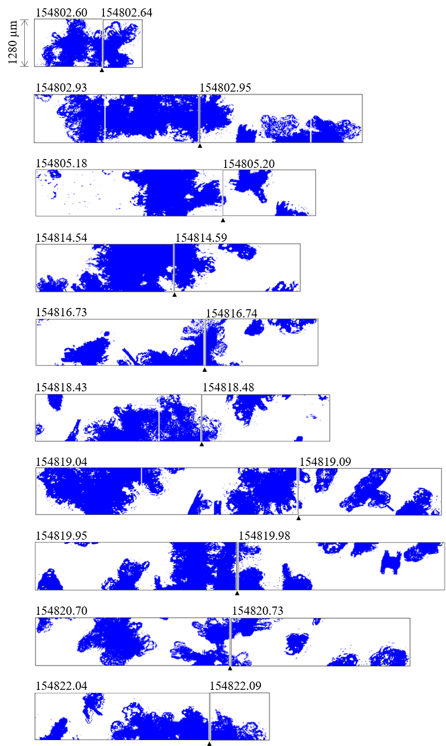
(a)
(b)
(c)
(d)
(e)
(f)
(g)
(h)
(i)
(j)
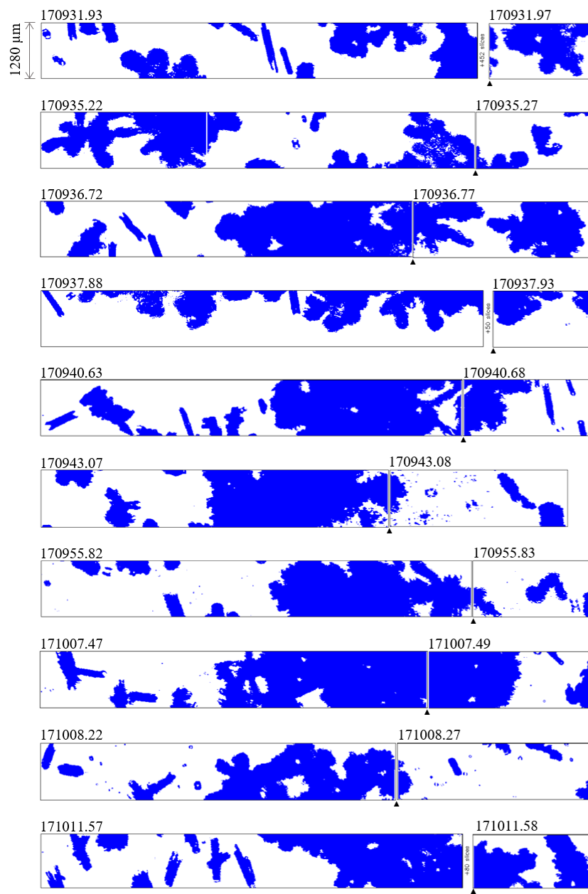
(s)
(r)
(q)
(p)
(o)
(n)
(m)
(l)
(k)
(t)
- Multiple additional examples from the Two-Dimensional Stereo Optical Array Probe (2D-S) Image Data in image buffer strip format from the 07 February, 2020 Investigation of Microphysics and Precipitation for Atlantic Coast-Threatening Snowstorms (IMPACTS) flight. The horizontal channel (a-j) and the vertical channel (k-t) are given. The start of each subsequent buffer is given to the right of each buffer to demonstrate cases where an ice crystal was sampled near the end of a data buffer and continued in the next buffer. The black triangle along the bottom of the strip denotes the transition point between buffers, and the timestamp in [HHMMSS.ss UTC] is labeled along the top of each image strip.
- Corresponding Two-Dimensional Stereo Optical Array Probe (2D-S) particle-by-particle attribute data for 07 February, 2020 Investigation of Microphysics and Precipitation for Atlantic Coast-Threatening Snowstorms (IMPACTS) flight, to the images shown in Figure 35. The time is given in [HHMMSS.ss UTC] format and a seconds-from-midnight [SSSSS.ss sfm] format. The three linear measurements given for each imaged particle include the particle diameter based on the fast circle method of processing, and an X and Y measurement, with X representing the dimension parallel to the array axis and Y representing the dimension parallel to the direction of flight. The “all in” flag is a 1 if the particle image is fully contained within the image strip and not in contact with array ends, and the flag is a 0 if the particle is only partially contained within the image strip. The inter-arrival time of each particle is shown in the last column as inter-particle time (IPT).
Ex. | Time | ID | Time | Diam. | Area Ratio | Aspect Ratio | Angle | All In | X | Buffer Time | Y | IPT
 | [UTC] |  | [sfm] | [μm] |  |  | [deg] |  | [μm] | [sec] | [μm] | [sec]
a | 15:48:02 |  | 56882.6040 | 1950 | 0.30 | 0.37 | -81.7 | 0 | 590 | 56882.6040 | 1930 | 0.013274
 |  |  | 56882.6040 | 10 | 1 | 1 | 0.0 | 1 | 10 | 56882.6040 | 10 | 0.002627
 |  |  | 56882.6040 | 20 | 0.64 | 0.5 | 90.0 | 1 | 10 | 56882.6040 | 20 | 0
 |  |  | 56882.6040 | 10 | 1 | 1 | 0.0 | 1 | 10 | 56882.6040 | 10 | 0
 |  |  | 56882.6350 | 1445 | 0.44 | 0.85 | -39.3 | 0 | 1250 | 56882.6350 | 1010 | 0.000016
 |  |  | 56882.6350 | 355 | 0.64 | 0.54 | 76.9 | 0 | 160 | 56882.6350 | 350 | 0.016164
 |  |  | 56882.6350 | 187 | 0.23 | 0.37 | 73.6 | 0 | 60 | 56882.6350 | 180 | 0.000002
 |  |  | 56882.6350 | 1059 | 0.51 | 0.67 | -40.9 | 0 | 910 | 56882.6350 | 760 | 0.000321
b | 15:48:02 |  | 56882.9320 | 10 | 1 | 1 | 0.0 | 0 | 10 | 56882.9320 | 10 | 0
 |  |  | 56882.9320 | 1585 | 0.43 | 0.58 | -83.2 | 0 | 870 | 56882.9320 | 1570 | 0.003077
 |  |  | 56882.9320 | 500 | 0.26 | 0.41 | -88.8 | 0 | 200 | 56882.9320 | 500 | 0.000003
 |  |  | 56882.9320 | 10 | 1 | 1 | 0.0 | 1 | 10 | 56882.9320 | 10 | 0.00047
 |  |  | 56882.9480 | 1321 | 0.46 | 0.89 | -28.7 | 0 | 1180 | 56882.9480 | 920 | 0.000029
 |  |  | 56882.9480 | 661 | 0.69 | 0.90 | -66.1 | 0 | 490 | 56882.9480 | 590 | 0.006159
 |  |  | 56882.9480 | 1422 | 0.49 | 0.52 | -89.2 | 0 | 730 | 56882.9480 | 1350 | 0.000456
c | 15:48:05 |  | 56885.1820 | 385 | 0.01 | 0.28 | -9.2 | 1 | 380 | 56885.1820 | 90 | 0.000001
 |  |  | 56885.1820 | 152 | 0.22 | 0.51 | 39.3 | 1 | 120 | 56885.1820 | 130 | 0.000013
 |  |  | 56885.1820 | 83 | 0.33 | 0.44 | -74.1 | 1 | 40 | 56885.1820 | 80 | 0.000001
 |  |  | 56885.1820 | 55 | 0.51 | 0.67 | -63.4 | 1 | 30 | 56885.1820 | 50 | 0
 |  |  | 56885.1820 | 20 | 0.64 | 0.50 | 90.0 | 1 | 10 | 56885.1820 | 20 | 0.000001
 |  |  | 56885.1820 | 40 | 0.48 | 0.50 | 90.0 | 1 | 20 | 56885.1820 | 40 | 0.000039
 |  |  | 56885.1820 | 153 | 0.07 | 0.45 | -24.8 | 1 | 140 | 56885.1820 | 70 | 0.000001
 |  |  | 56885.1980 | 543 | 0.06 | 0.21 | -6.5 | 1 | 540 | 56885.1980 | 100 | 0.001709
 |  |  | 56885.1980 | 1353 | 0.47 | 0.71 | 83.9 | 0 | 940 | 56885.1980 | 1270 | 0.003614
 |  |  | 56885.1980 | 973 | 0.39 | 0.46 | 82.6 | 0 | 410 | 56885.1980 | 960 | 0.006415
d | 15:48:14 |  | 56895.5410 | 2765 | 0.70 | 0.51 | -84.0 | 0 | 1280 | 56895.5410 | 2750 | 0.000017
 |  |  | 56895.5410 | 20 | 0.64 | 0.50 | 90.0 | 1 | 10 | 56895.5410 | 20 | 0.006257
 |  |  | 56895.5410 | 501 | 0.39 | 0.92 | 20.2 | 0 | 400 | 56895.5410 | 440 | 0.000003
 |  |  | 56895.5410 | 735 | 0.38 | 0.51 | -74.8 | 0 | 270 | 56895.5410 | 710 | 0.000005
 |  |  | 56895.5410 | 24 | 0.44 | 0.41 | -45.0 | 1 | 20 | 56895.5410 | 20 | 0.000001
 |  |  | 56895.5410 | 46 | 0.41 | 0.46 | -33.7 | 0 | 40 | 56895.5410 | 30 | 0
 |  |  | 56895.5880 | 680 | 0.02 | 0.12 | 0.0 | 1 | 680 | 56895.5880 | 80 | 0.016209
 |  |  | 56895.5880 | 10 | 1 | 1 | 0.0 | 1 | 10 | 56895.5880 | 10 | 0
 |  |  | 56895.5880 | 51 | 0.39 | 0.48 | 14.0 | 1 | 50 | 56895.5880 | 20 | 0
e | 15:48:16 |  | 56896.7290 | 1619 | 0.39 | 0.60 | -55.1 | 0 | 940 | 56896.7290 | 1380 | 0.006369
 |  |  | 56896.7290 | 10 | 1 | 1 | 0.0 | 1 | 10 | 56896.7290 | 10 | 0
 |  |  | 56896.7290 | 810 | 0 | 0.04 | -1.4 | 1 | 810 | 56896.7290 | 30 | 0
 |  |  | 56896.7290 | 10 | 1 | 1 | 0.0 | 1 | 10 | 56896.7290 | 10 | 0
 |  |  | 56896.7440 | 1406 | 0.29 | 0.73 | -24.5 | 0 | 1280 | 56896.7440 | 610 | 0.004571
 |  |  | 56896.7440 | 293 | 0.42 | 0.40 | 81.9 | 0 | 100 | 56896.7440 | 290 | 0.002523
 |  |  | 56896.7440 | 68 | 0.27 | 0.35 | 59.0 | 1 | 40 | 56896.7440 | 60 | 0.000001
 |  |  | 56896.7440 | 624 | 0.57 | 0.74 | -60.9 | 0 | 470 | 56896.7440 | 560 | 0.002051
f | 15:48:18 |  | 56898.4320 | 1835 | 0.46 | 0.69 | -50.1 | 0 | 1280 | 56898.4320 | 1530 | 0.00001
 |  |  | 56898.4320 | 485 | 0.20 | 0.56 | 8.5 | 1 | 480 | 56898.4320 | 240 | 0.009411
 |  |  | 56898.4320 | 10 | 1 | 1 | 0.0 | 1 | 10 | 56898.4320 | 10 | 0
 |  |  | 56898.4320 | 556 | 0.66 | 0.8 | 14.9 | 0 | 460 | 56898.4320 | 450 | 0.006411
 |  |  | 56898.4320 | 740 | 0.23 | 0.49 | -36.1 | 0 | 600 | 56898.4320 | 450 | 0.004948
 |  |  | 56898.4320 | 10 | 1 | 1 | 0.0 | 1 | 10 | 56898.4320 | 10 | 0.000168
 |  |  | 56898.4790 | 936 | 0.24 | 0.77 | 27.7 | 0 | 830 | 56898.4790 | 550 | 0.000023
 |  |  | 56898.4790 | 230 | 0.01 | 0.10 | -2.6 | 1 | 230 | 56898.4790 | 30 | 0
 |  |  | 56898.4790 | 1440 | 0.46 | 0.70 | -73.3 | 0 | 900 | 56898.4790 | 1380 | 0.003641
g | 15:48:19 |  | 56899.0410 | 1318 | 0.33 | 0.72 | -62.5 | 0 | 840 | 56899.0410 | 1170 | 0.004532
 |  |  | 56899.0410 | 20 | 0.64 | 0.50 | 90.0 | 1 | 10 | 56899.0410 | 20 | 0.000001
 |  |  | 56899.0410 | 810 | 0.42 | 0.70 | -44.7 | 0 | 690 | 56899.0410 | 690 | 0.002922
 |  |  | 56899.0410 | 426 | 0.49 | 0.75 | -27.2 | 0 | 380 | 56899.0410 | 220 | 0.005264
 |  |  | 56899.0880 | 1133 | 0.09 | 0.38 | -9.7 | 0 | 1120 | 56899.0880 | 390 | 0.003884
 |  |  | 56899.0880 | 895 | 0.43 | 0.72 | -42.7 | 0 | 690 | 56899.0880 | 650 | 0.009477
 |  |  | 56899.0880 | 1767 | 0.41 | 0.75 | -63.5 | 0 | 1210 | 56899.0880 | 1520 | 0.019782
 |  |  | 56899.0880 | 1294 | 0.49 | 0.68 | -73.3 | 0 | 750 | 56899.0880 | 1240 | 0.001524
h | 15:48:19 |  | 56899.9470 | 200 | 0.48 | 0.25 | 90.0 | 0 | 50 | 56899.9470 | 200 | 0.000002
 |  |  | 56899.9470 | 10 | 1 | 1 | 0.0 | 1 | 10 | 56899.9470 | 10 | 0.000001
 |  |  | 56899.9470 | 1491 | 0.38 | 0.62 | -62.2 | 0 | 850 | 56899.9470 | 1320 | 0.000156
 |  |  | 56899.9470 | 20 | 0.64 | 0.50 | 90.0 | 1 | 10 | 56899.9470 | 20 | 0.001164
 |  |  | 56899.9790 | 1455 | 0.31 | 0.75 | 28.5 | 0 | 1280 | 56899.9790 | 720 | 0.000018
 |  |  | 56899.9790 | 90 | 0.03 | 0.11 | 0.0 | 1 | 90 | 56899.9790 | 10 | 0
 |  |  | 56899.9790 | 201 | 0.01 | 0.10 | 6.0 | 1 | 200 | 56899.9790 | 30 | 0
 |  |  | 56899.9790 | 10 | 1 | 1 | 0.0 | 1 | 10 | 56899.9790 | 10 | 0
i | 15:48:20 |  | 56900.6970 | 1141 | 0.54 | 0.82 | -88.7 | 0 | 930 | 56900.6970 | 1040 | 0.003159
 |  |  | 56900.6970 | 593 | 0.41 | 0.77 | -50.6 | 0 | 410 | 56900.6970 | 480 | 0.000003
 |  |  | 56900.6970 | 92 | 0.70 | 0.58 | -76.0 | 0 | 40 | 56900.6970 | 90 | 0.000002
 |  |  | 56900.6970 | 70 | 0.57 | 0.29 | 90.0 | 0 | 20 | 56900.6970 | 70 | 0.000001
 |  |  | 56900.6970 | 10 | 1 | 1 | 0.0 | 1 | 10 | 56900.6970 | 10 | 0
 |  |  | 56900.6970 | 219 | 0.22 | 0.33 | 73.3 | 0 | 80 | 56900.6970 | 210 | 0.001801
 |  |  | 56900.6970 | 61 | 0.51 | 0.39 | -78.7 | 0 | 20 | 56900.6970 | 60 | 0.000001
 |  |  | 56900.6970 | 170 | 0.17 | 0.29 | 0.0 | 1 | 170 | 56900.6970 | 50 | 0.000623
 |  |  | 56900.6970 | 10 | 1 | 1 | 0.0 | 1 | 10 | 56900.6970 | 10 | 0
 |  |  | 56900.6970 | 240 | 0.39 | 0.27 | 87.5 | 0 | 60 | 56900.6970 | 240 | 0.002541
 |  |  | 56900.7290 | 1639 | 0.23 | 0.73 | -38.8 | 0 | 1280 | 56900.7290 | 1100 | 0.000928
 |  |  | 56900.7290 | 181 | 0.16 | 0.40 | -69.4 | 1 | 80 | 56900.7290 | 170 | 0.005551
 |  |  | 56900.7290 | 40 | 0.49 | 0.50 | 90.0 | 0 | 20 | 56900.7290 | 40 | 0
 |  |  | 56900.7290 | 816 | 0.47 | 0.78 | -8.8 | 1 | 810 | 56900.7290 | 690 | 0.004808
j | 15:48:22 |  | 56902.0410 | 946 | 0.38 | 0.64 | -53.3 | 0 | 620 | 56902.0410 | 780 | 0.000005
 |  |  | 56902.0410 | 331 | 0.01 | 0.10 | -3.6 | 1 | 330 | 56902.0410 | 40 | 0.000001
 |  |  | 56902.0410 | 88 | 0.45 | 0.83 | 50.2 | 0 | 70 | 56902.0410 | 70 | 0.008415
 |  |  | 56902.0410 | 149 | 0.19 | 0.44 | 30.3 | 0 | 130 | 56902.0410 | 90 | 0.000001
 |  |  | 56902.0410 | 10 | 1 | 1 | 0.0 | 1 | 10 | 56902.0410 | 10 | 0
 |  |  | 56902.0410 | 935 | 0.38 | 0.74 | -24 | 0 | 840 | 56902.0410 | 610 | 0.008359
 |  |  | 56902.0410 | 163 | 0.02 | 0.13 | -11.3 | 0 | 160 | 56902.0410 | 40 | 0.003193
 |  |  | 56902.0880 | 1627 | 0.38 | 0.57 | 71.4 | 0 | 870 | 56902.0880 | 1520 | 0.000026
 |  |  | 56902.0880 | 10 | 1 | 1 | 0.0 | 1 | 10 | 56902.0880 | 10 | 0
 |  |  | 56902.0880 | 10 | 1 | 1 | 0.0 | 1 | 10 | 56902.0880 | 10 | 0.00921
 |  |  | 56902.0880 | 32 | 0.36 | 0.45 | -26.6 | 1 | 30 | 56902.0880 | 20 | 0
k | 17:09:31 |  | 61771.9260 | 1209 | 0.16 | 0.20 | 18.0 | 0 | 1150 | 61771.9260 | 410 | 0.003296
 |  |  | 61771.9260 | 681 | 0.24 | 0.24 | 20.1 | 1 | 640 | 61771.9260 | 320 | 0.000243
 |  |  | 61771.9260 | 540 | 0.75 | 0.87 | -60.2 | 0 | 370 | 61771.9260 | 480 | 0.008648
 |  |  | 61771.9260 | 250 | 0.61 | 0.42 | 87.6 | 0 | 100 | 61771.9260 | 250 | 0.004439
 |  |  | 61771.9260 | 2299 | 0.45 | 0.41 | 86.2 | 0 | 820 | 61771.9260 | 2290 | 0.00002
 |  |  | 61771.9260 | 10 | 1 | 1 | 0.0 | 1 | 10 | 61771.9260 | 10 | 0
 |  |  | 61771.9730 | 1210 | 0.10 | 0.17 | 0.0 | 1 | 1210 | 61771.9730 | 210 | 0.00433
 |  |  | 61771.9730 | 2371 | 0.59 | 0.54 | 85.2 | 0 | 1230 | 61771.9730 | 2340 | 0.011191
 |  |  | 61771.9730 | 10 | 1 | 1 | 0.0 | 1 | 10 | 61771.9730 | 10 | 0
 |  |  | 61771.9730 | 118 | 0.42 | 0.78 | 68.2 | 1 | 70 | 61771.9730 | 110 | 0.00013
 |  |  | 61771.9730 | 195 | 0.73 | 0.62 | -80.7 | 0 | 100 | 61771.9730 | 190 | 0.003807
 |  |  | 61771.9730 | 625 | 0.39 | 0.49 | 22.0 | 1 | 600 | 61771.9730 | 330 | 0.002619
 |  |  | 61771.9730 | 923 | 0.36 | 0.43 | 61.2 | 0 | 520 | 61771.9730 | 840 | 0.011168
 |  |  | 61771.9730 | 570 | 0.45 | 0.63 | 11.3 | 0 | 540 | 61771.9730 | 370 | 0.000003
l | 17:09:35 | l-1 | 61775.2230 | 276 | 0.38 | 0.64 | 19.8 | 1 | 260 | 61775.2230 | 200 | 0.000112
 |  | l-2 | 61775.2230 | 185 | 0.53 | 0.58 | 18.4 | 1 | 180 | 61775.2230 | 130 | 0.000512
 |  | l-3 | 61775.2230 | 532 | 0.46 | 0.59 | -32.5 | 0 | 470 | 61775.2230 | 380 | 0.004521
 |  | l-4 | 61775.2230 | 1261 | 0.41 | 0.38 | -87.3 | 0 | 430 | 61775.2230 | 1260 | 0.000841
 |  | l-5 | 61775.2700 | 1260 | 0.36 | 0.41 | 87.7 | 0 | 510 | 61775.2700 | 1210 | 0.000026
 |  | l-6 | 61775.2700 | 871 | 0.48 | 0.70 | 38.9 | 1 | 740 | 61775.2700 | 730 | 0.000412
 |  |  | 61775.2700 | 1110 | 0.22 | 0.20 | 89.5 | 0 | 220 | 61775.2700 | 1110 | 0.006587
m | 17:09:36 |  | 61776.7230 | 834 | 0.23 | 0.30 | 47.0 | 1 | 670 | 61776.7230 | 640 | 0.00192
 |  |  | 61776.7230 | 615 | 0.33 | 0.44 | 30.8 | 0 | 530 | 61776.7230 | 350 | 0.005818
 |  |  | 61776.7230 | 730 | 0.65 | 0.60 | 79.3 | 0 | 410 | 61776.7230 | 720 | 0.007018
 |  |  | 61776.7230 | 171 | 0.46 | 0.41 | 90.0 | 0 | 70 | 61776.7230 | 170 | 0.003529
 |  |  | 61776.7230 | 170 | 0.35 | 0.33 | 86.4 | 0 | 50 | 61776.7230 | 170 | 0.001633
 |  |  | 61776.7700 | 1995 | 0.5 | 0.76 | -64.6 | 0 | 1280 | 61776.7700 | 1670 | 0.001801
 |  |  | 61776.7700 | 2344 | 0.7 | 0.59 | 80.4 | 0 | 1280 | 61776.7700 | 2320 | 0.003571
 |  |  | 61776.7700 | 390 | 0.41 | 0.31 | 90.0 | 0 | 120 | 61776.7700 | 390 | 0.012025
 |  |  | 61776.7700 | 401 | 0.66 | 0.49 | -87.1 | 0 | 190 | 61776.7700 | 400 | 0.000003
n | 17:09:37 |  | 61777.8790 | 242 | 0.41 | 0.73 | -82.6 | 1 | 180 | 61777.8790 | 240 | 0.00711
 |  |  | 61777.8790 | 2140 | 0.23 | 0.31 | 84.3 | 0 | 640 | 61777.8790 | 2130 | 0.000314
 |  |  | 61777.8790 | 10 | 1 | 1 | 0.0 | 1 | 10 | 61777.8790 | 10 | 0
 |  |  | 61777.8790 | 1872 | 0.47 | 0.51 | -83.8 | 0 | 900 | 61777.8790 | 1860 | 0.000014
 |  |  | 61777.8790 | 760 | 0.49 | 0.35 | -89.2 | 0 | 260 | 61777.8790 | 760 | 0.003417
 |  |  | 61777.8790 | 587 | 0.39 | 0.54 | 25.7 | 0 | 550 | 61777.8790 | 280 | 0.006646
 |  |  | 61777.9260 | 1671 | 0.5 | 0.52 | -78.0 | 0 | 790 | 61777.9260 | 1610 | 0.000435
 |  |  | 61777.9260 | 52 | 0.56 | 0.87 | 45.0 | 1 | 40 | 61777.9260 | 40 | 0.007569
 |  |  | 61777.9260 | 42 | 0.44 | 0.85 | 71.6 | 1 | 30 | 61777.9260 | 40 | 0.000001
 |  |  | 61777.9260 | 1096 | 0.67 | 0.66 | -82.2 | 0 | 640 | 61777.9260 | 1080 | 0.017617
o | 17:09:40 |  | 61780.6290 | 92 | 0.70 | 0.58 | -76.0 | 0 | 40 | 61780.6290 | 90 | 0.01069
 |  |  | 61780.6290 | 593 | 0.55 | 0.69 | 50.6 | 0 | 440 | 61780.6290 | 480 | 0.000006
 |  |  | 61780.6290 | 772 | 0.45 | 0.70 | -29.9 | 0 | 670 | 61780.6290 | 540 | 0.001699
 |  |  | 61780.6290 | 190 | 0.53 | 0.34 | -86.8 | 0 | 60 | 61780.6290 | 190 | 0.001913
 |  |  | 61780.6290 | 377 | 0.44 | 0.52 | 11.0 | 1 | 370 | 61780.6290 | 220 | 0.000538
 |  |  | 61780.6760 | 1999 | 0.51 | 0.69 | -54.0 | 0 | 1280 | 61780.6760 | 1580 | 0.00442
 |  |  | 61780.6760 | 196 | 0.54 | 0.84 | 36.3 | 0 | 170 | 61780.6760 | 120 | 0.000707
 |  |  | 61780.6760 | 973 | 0.17 | 0.20 | 12.6 | 1 | 950 | 61780.6760 | 300 | 0.008582
p | 17:09:43 |  | 61783.0670 | 120 | 0.25 | 0.19 | -84.8 | 0 | 20 | 61783.0670 | 120 | 0.007747
 |  |  | 61783.0670 | 996 | 0.53 | 0.90 | 31.6 | 0 | 890 | 61783.0670 | 850 | 0.001416
 |  |  | 61783.0670 | 393 | 0.74 | 0.54 | 81.9 | 0 | 190 | 61783.0670 | 390 | 0.00214
 |  |  | 61783.0670 | 564 | 0.36 | 0.30 | 82.7 | 0 | 140 | 61783.0670 | 560 | 0.003405
 |  |  | 61783.0820 | 1536 | 0.17 | 0.93 | 35.4 | 0 | 1280 | 61783.0820 | 1090 | 0.004885
 |  |  | 61783.0820 | 20 | 0.64 | 0.50 | 90.0 | 1 | 10 | 61783.0820 | 20 | 0.000001
 |  |  | 61783.0820 | 775 | 0.01 | 0.27 | 11.3 | 1 | 760 | 61783.0820 | 190 | 0.000001
q | 17:09:55 |  | 61795.8170 | 503 | 0.66 | 0.73 | -73.6 | 0 | 320 | 61795.8170 | 480 | 0.000272
 |  |  | 61795.8170 | 318 | 0.53 | 0.49 | 76.9 | 0 | 120 | 61795.8170 | 310 | 0.000057
 |  |  | 61795.8170 | 30 | 0.57 | 0.67 | 90.0 | 1 | 20 | 61795.8170 | 30 | 0.000175
 |  |  | 61795.8170 | 20 | 0.64 | 0.50 | 90.0 | 1 | 10 | 61795.8170 | 20 | 0.003987
 |  |  | 61795.8170 | 10 | 1 | 1 | 0.0 | 1 | 10 | 61795.8170 | 10 | 0.001401
 |  |  | 61795.8170 | 24 | 0.87 | 0.83 | -45.0 | 1 | 20 | 61795.8170 | 20 | 0.000029
 |  |  | 61795.8170 | 260 | 0.44 | 0.29 | 87.7 | 0 | 70 | 61795.8170 | 260 | 0.001169
 |  |  | 61795.8320 | 922 | 0.34 | 0.56 | 44.6 | 0 | 680 | 61795.8320 | 650 | 0.000651
 |  |  | 61795.8320 | 38 | 0.69 | 0.82 | 45.0 | 1 | 30 | 61795.8320 | 30 | 0.000222
 |  |  | 61795.8320 | 32 | 0.61 | 0.72 | -63.4 | 1 | 20 | 61795.8320 | 30 | 0.000989
r | 17:10:07 |  | 61807.0670 | 168 | 0.84 | 0.77 | 71.6 | 0 | 110 | 61807.0670 | 160 | 0.000013
 |  |  | 61807.0670 | 20 | 0.64 | 0.50 | 90.0 | 1 | 10 | 61807.0670 | 20 | 0.001662
 |  |  | 61807.0670 | 42 | 0.44 | 0.54 | 71.6 | 1 | 20 | 61807.0670 | 40 | 0.003734
 |  |  | 61807.0670 | 593 | 0.74 | 0.94 | 50.6 | 0 | 430 | 61807.0670 | 520 | 0.000802
 |  |  | 61807.0670 | 441 | 0.69 | 0.59 | -86.0 | 0 | 240 | 61807.0670 | 440 | 0.000019
 |  |  | 61807.0670 | 467 | 0.61 | 0.88 | -27.4 | 0 | 420 | 61807.0670 | 320 | 0.000183
 |  |  | 61807.0670 | 932 | 0.51 | 0.59 | 53.4 | 0 | 640 | 61807.0670 | 820 | 0.000686
 |  |  | 61807.0820 | 2642 | 0.60 | 0.51 | -86.9 | 0 | 1280 | 61807.0820 | 2570 | 0.002889
 |  |  | 61807.0820 | 24 | 0.87 | 0.83 | -45.0 | 1 | 20 | 61807.0820 | 20 | 0
 |  |  | 61807.0820 | 55 | 0.47 | 0.84 | -63.4 | 1 | 40 | 61807.0820 | 50 | 0.001953
 |  |  | 61807.0820 | 646 | 0.66 | 0.53 | -85.4 | 0 | 320 | 61807.0820 | 640 | 0.000917
s | 17:10:08 |  | 61808.2230 | 1210 | 0.30 | 0.50 | -69.0 | 0 | 630 | 61808.2230 | 1130 | 0.00022
 |  |  | 61808.2230 | 77 | 0.56 | 0.65 | 26.6 | 1 | 70 | 61808.2230 | 60 | 0.001332
 |  |  | 61808.2230 | 102 | 0.52 | 0.65 | -77.5 | 1 | 70 | 61808.2230 | 100 | 0.000715
 |  |  | 61808.2230 | 96 | 0.52 | 0.76 | 76.6 | 1 | 70 | 61808.2230 | 90 | 0.002059
 |  |  | 61808.2230 | 220 | 0.73 | 0.85 | 25.3 | 1 | 200 | 61808.2230 | 180 | 0.000147
 |  |  | 61808.2700 | 914 | 0.24 | 0.41 | 5.1 | 0 | 910 | 61808.2700 | 350 | 0.000231
 |  |  | 61808.2700 | 46 | 0.48 | 0.64 | 33.7 | 1 | 40 | 61808.2700 | 30 | 0.001332
 |  |  | 61808.2700 | 46 | 0.42 | 0.52 | 33.7 | 1 | 40 | 61808.2700 | 30 | 0.000001
 |  |  | 61808.2700 | 150 | 0.43 | 0.44 | 85.9 | 0 | 60 | 61808.2700 | 150 | 0.000012
t | 17:10:11 |  | 61811.5670 | 161 | 0.68 | 0.58 | -82.4 | 0 | 80 | 61811.5670 | 160 | 0.000681
 |  |  | 61811.5670 | 869 | 0.30 | 0.42 | -9.7 | 1 | 860 | 61811.5670 | 440 | 0.000257
 |  |  | 61811.5670 | 579 | 0.43 | 0.57 | 39.3 | 0 | 470 | 61811.5670 | 400 | 0.000325
 |  |  | 61811.5670 | 95 | 0.57 | 0.82 | 69.4 | 1 | 60 | 61811.5670 | 90 | 0.002299
 |  | t-1 | 61811.5670 | 1093 | 0.28 | 0.56 | 9.4 | 1 | 1080 | 61811.5670 | 580 | 0.000997
 |  | t-2 | 61811.5670 | 1151 | 0.21 | 0.27 | 25.4 | 0 | 1040 | 61811.5670 | 540 | 0.003118
 |  | t-3 | 61811.5820 | 1945 | 0.57 | 0.77 | 58.5 | 0 | 1150 | 61811.5820 | 1660 | 0.000428
 |  | t-4 | 61811.5820 | 2030 | 0.48 | 0.59 | 52.8 | 0 | 1280 | 61811.5820 | 1680 | 0.00116
 |  |  | 61811.5820 | 2703 | 0.36 | 0.48 | 62.1 | 0 | 1280 | 61811.5820 | 2440 | 0.000949
 |  |  | 61811.5820 | 24 | 0.66 | 0.62 | -45.0 | 1 | 20 | 61811.5820 | 20 | 0.000619

