Biological Particles (Bacteria and Fungi) in Thunderstorms

1Harrison P. Rademacher, 1David J. Delene, 2Karin Ardon-Dryer, and 3Michael San Francisco, 1Department of Atmospheric Sciences, University of North Dakota, 2Department of Geosciences Atmospheric Science Group, Texas Tech University, 3Department of Biological Sciences, Texas Tech University

# Abstract

### Aerosol particles play an important role in cloud formation, affect cloud lifetime, and precipitation formation processes. Ice nuclei particle concentrations greatly influence precipitation development in clouds. Biological particles (bacterial and fungi) are important atmospheric ice nuclei particles; however, few measurements of the biological particles in the upper troposphere have been performed. A research project (CapeEx19) in Titusville, FL during summer 2019, with the North Dakota Citation Research Aircraft provided the opportunity to obtain upper tropospheric measurements of particles in and around thunderstorms to assess the presence of biological particles. Filter samples were collected from 9.14 km (30,000 ft) to 12.19 km (40,000 ft) MSL while flying in and around cirrus cloud anvils. Each sample was kept in a sealed container until DNA sequencing was performed. Identification of fungi and bacterial species was done using ribosomal internal transcribed spacer sequence ITS for fungi and 16S ribosomal RNA-encoding DNA for bacteria. Species identification enables us to determine the atmospheric source by relating the species found in the thunderstorm anvils to their locations on the Earth’s surface.

# 1. Introduction

Aerosol particles can range from a variety of natural and man made materials, including mineral dust, sea salt, volcanic dust, and other particles which are produced by chemical and physical reactions of trace gases, and of primary biological particles. The most important characteristics of aerosol particles are their size distribution and chemical composition (Figure 1). The fine particles include the Aitken nuclei range, which have condensation and coagulation of primary particles and chain aggregates, and the accumulation range, forming the particles into droplets via homogeneous nucleation or condensation growth of nuclei (Whitby, 1977). Finally, there are coarse particles which are the mechanically generated aerosol range, as wind-blown dust and emissions fall to the ground via sedimentation. By examining these two characteristics, the aerosol’s chemical, microphysical, and optical properties can be found (Whitby, 1977). Atmospheric particles have several sources and sinks. They have an important role in cloud formation and precipitation processes by serving as cloud condensation nuclei and Ice Nuclei Particles (INP) (Matthias-Maser et al., 2000). Often times, these primary biological particles act as INP at temperatures colder than -10 °C; however, they can sometimes activate at temperatures as warm as -4 °C (Matthias-Maser et al., 2000). A large number of observational studies confirmed the substantial presence of bacteria in the atmosphere (Hu et al., 2018).

### 

### 

#### Figure 1: Idealized schematic of the distribution of particle surface area of an atmospheric aerosol (Whitby, 1977).

It is common knowledge that water can exist in all three major phases, solid, liquid, and gas in the Earth’s atmosphere. Ice crystals have a potential immersion mode with different concentrations found as a function of temperature for a range of atmospheric aerosol species (Figure 2). These immersions were calculated using concentrations of different aerosol particle types, from mineral dust, volcanic ash, and bacteria. For bacteria, it is assumed that 1% of the total number of airborne bacteria are active INP, and they are found to be the most active at warmer freezing temperatures (Murray et al., 2012). Consequently, atmospheric waters can efficiently transport bacteria via lifting from various surfaces and mix vertically (Hu et al., 2018). Some examples of vertical mixing processes include thunderstorms, dust storms, volcanic ash, and human activity (DasSarma, 2018). Once in the air, the submicron size of bacteria gives them long residence time on the order of several days (Hu et al., 2018). The bacteria particles can be detected for many more days after the transport into the air is complete. Over ${10^{21}}^{}$ cells are annually carried into the atmosphere, leading to considerable transport and dispersal around the globe. Despite extreme conditions in the atmosphere, a small fraction of the cells carried up into the atmosphere (<0.1%) survive (DasSarma, 2018). Health impacts of atmospheric bacteria have also been studied, and it has been found that diseases and airborne illnesses can be carried into the atmosphere via these airborne biogenic particles (Burrows et al., 2009). There are also seasonal variations in the bacteria and PM concentrations, and local events such as dust storms can contribute to the bacteria isolates (Harbizadeh, 2019).

Most studies that focus on collecting bacteria were done near the surface upto the lower portions of the troposphere (~25,000 ft) (Burrows et al., 2009). They include identifying bacteria types, and their consequential impacts to cloud nucleation and/or climate. Some airborne studies look at biological particles in the atmosphere via aircraft sampling. A study on cirrus clouds via NASA research aircraft found only a few types of bacteria and fungal spores as ice crystal residual (Cziczo et al., 2013). The most common and most capable type of biogenic INP is pseudomonas syringae, derived from decaying vegetation, and capable of nucleating in temperatures as warm as -2 °C (Bauer et al., 2003). The impacts include aid in heterogeneous freezing of cloud droplets, which can improve the role of cloud glaciation and precipitation (Bauer et. al., 2003). Bacteria do not need to be alive to aid in producing freezing nuclei, they can be alive or dead to aid in the process of ice nucleation, and can also be dead or alive when collecting samples for DNA sequencing (Matthias-Maser et al., 2000). Overall, collecting biological aerosols in the atmosphere is historically challenging, as it requires careful handling from air to ground to prevent contamination. There is a need for mid-tropospheric and higher altitude testing for the presence of bacteria (Triado-Margarit et al., 2019). Sampling platforms such as balloons and aircraft sampling platforms have been used to try to collect and study these biogenic particles (Burrows et al., 2009).

### 

#### Figure 2: Potential immersion mode ice nuclei concentrations as a function of temperature for a range of atmospheric aerosol species. Calculations performed using concentrations of different aerosol types (Murray et. al., 2012).

To help determine if bacteria and Fungi exist in the upper troposphere and the lower stratosphere, samples were collected during the CapeEx19 field campaign in the summer of 2019 above Titusville, FL. The goal was to obtain interstitial aerosol measurements on the North Dakota Citation Research Aircraft, and to determine if biogenic particles exist in the upper portion of thunderstorm clouds. Instrumentation devices for use on the aircraft were studied for their flow rates, collecting systems, and application for use on aircraft, such as the Aerodyne Aerosol Mass Spectrometer (AMS), the Desert Research Institute Linear-Jet Impactor (DRI), the Axial Cyclone Cloud Water Collector (AC3), the Brechtel Counterflow Virtual Impactor (CVI), and the Axial Cyclone 3 (AC3). The Condensation Particle Counter (CPC) was used to collect aerosol samples on the Citation Research Aircraft. Additionally, the Citation Research Aircraft carried several clouds physics probes (PHIPS, CAPS, CIP, PIP, CDP) to obtain images and counts particles during flight. The data collected was analyzed for any possible connections to prior research experiments, in addition to identifying potential impacts of biogenic particles in the moist tropical air of Florida.

# 2. Methodology

a. Sampling Preparation

The first step in preparing the experiment for flight testing includes preparing and designing the instrument rack platform for collecting the aerosol particle samples (Figure 3). At first the filter holder was placed on the rack, located in the middle side rack below the CPC plate, which is accessible to flight engineers during research flights. The sampling rack includes the filter holder itself, and two air pumps which are connected through ¼” swagelok tubes. Inbound air is forced into the CPC inlet tube (1” diameter) by the forward motion of the aircraft (Figure 3). The first pump draws CPC inlet tube air past the filter and out the aircraft. This design keeps good airflow throughout flight testing and meets design requirements from other experiments done.

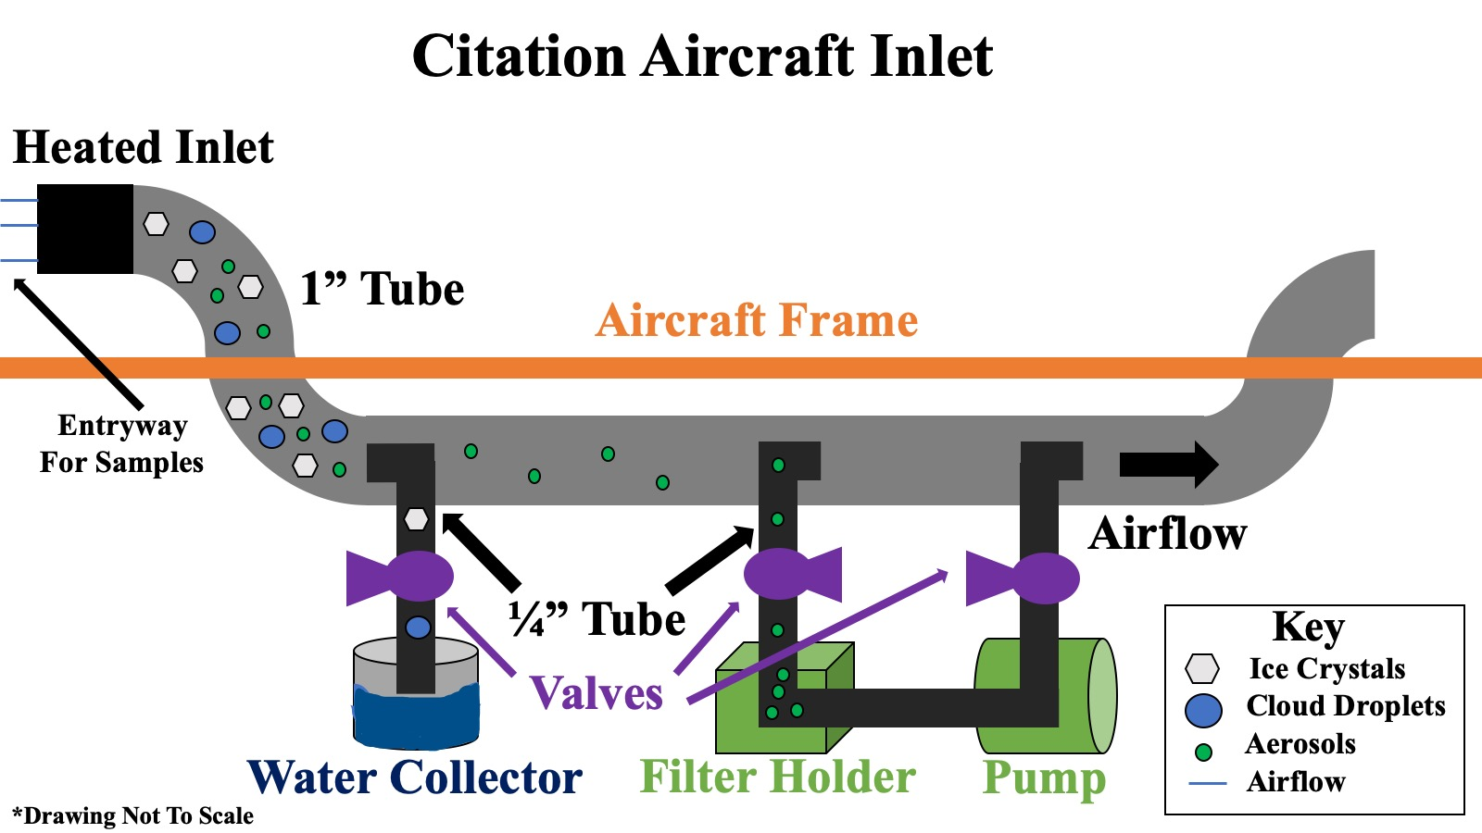

#### Figure 3: Citation’s CPC inlet design The original design included a water collecting jar, which was omitted due to technical problems with pressure leaks that could cause explosive decompression from pressure changes. Also, limited space inside the aircraft made it difficult to mount the jar to the inlet.

## The Citation Research Aircraft samples at 160 knots indicated airspeed (~90 m/s). Air moves across the sampling filter when the filter stop valves is opened. The streamlines of the flow in front of the inlet should not be distorted so particles with sufficient inertia would not follow them, which prevents losses or overloading of particles in the flow into the inlet (Kramer & Schutz, 1993). The CPC inlet is only able to collect small particle at 100 % efficiency due to turbulence issues. Aerosols with a radius of 0.05-1.5 µm will be able to be collected by the CPC inlet onto the filters (Capes, et. al. 2008).

b. Filter Construction and Aircraft Procedure

Several 37 mm tissuquartz filters with small pores were used in the CapeEx19 campaign. The filters and filter jar containers were prepared in the lab by sterilizing and autoclaving them separately (121 °C or 394 K for 45 min.) Then, each filter was evaluated for damage control and placed in a clean sterile jar as a preparation for the flight.

On board the airplane, the filter holder was cleaned with 98% pure ethanol between each sample. Once cleaned, the filter was placed with clean tweezers inside the holders, making sure the filter was oriented correctly. The second holder closes the unit and sealed it from contaminants. A label with the filter ID number was placed onto the top of the filter holder, to keep track of each filter sample time. After each measurement, the filter was taken from the filter holder and placed in the same filter container, which was then wrapped in parafilm, to protect from outside contamination. A total of 15 filters were built for sampling in Florida.

c. Flight Testing

The flights for CapeEx19 were based out of Space Coast Regional Airport (KTIX) in Titusville, FL. Testing was conducted during a two week period from July 21st through August 3rd, 2019. On board the aircraft were a variety of different probes, such as a PIP, CDP, and CIP for measuring the size of droplets (Figure 4). A typical day on the field project began with a weather briefing, followed by tech work on the aircraft. Once storms developed, the plane was dispatched to fly from the mobile command radar (MCR) on project. The aircraft flew for up to 3 hours most days during the campaign.

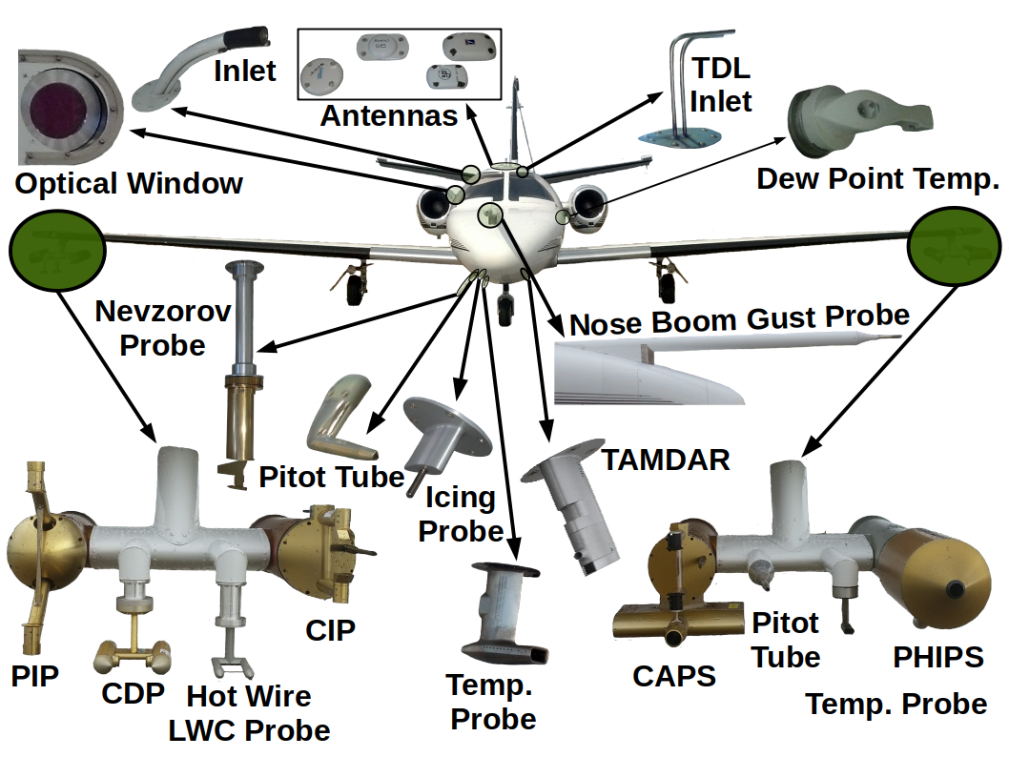

Figure 4: Complete diagram of instruments used on CapeEx19. The CPC inlet is labeled as “heated inlet,” and is located behind the right door of the airplane

Before each flight, a filter was placed in the filter holder. The filter spacer holder inside the filter holder (the spacer holder is to prevent contaminants from entering around the holder space). The stickers from the container are then placed onto the side of the filter holder to determine which one is being sampled. Once the plane was airborne, the flight engineers opened the valves and turned on the pumps to collect a filter sample. The exact time at which the valve was opened was recorded. Each test ran for approximately 1-2 hours depending on the type of event.

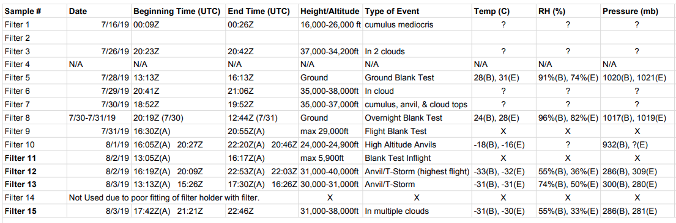

Figure 5: Table of filter measurements conducted during CapeEx19. Times that the filter are placed onto the aircraft and removed are recorded, along with times the filter were being sampled. Height/altitude, type of event, range of temperatures, relative humidity, and pressure were also recorded. Missing data is labeled with an “X”.

Since the experiment was to look at biological particles in the upper troposphere and lower stratosphere, the valves and pumps only were turned on if the plane was greater than 30,000 ft and the plane was sampling in and around a cloud. Most events consisted of the tops of cumulonimbus clouds and anvils, which had strong updrafts, therefore increasing the odds that the biogenic particles traveled to higher altitudes. If the plane did not reach 30,000 ft, the valves and pumps were kept off, and the filter was tested as a blank, to see if there was any residual contaminants found in the inlet or tubes.

Once the plane landed, the sampled filter was immediately offloaded from the aircraft’s filter holder, sterilized with parafilm, and placed into a cool fridge. The filters were then sent to the Texas Tech lab for DNA sequencing. In the lab, filters were placed in an incubation to maintain low RH and to make sure no contamination will occur.

d. Post Flight DNA Sequencing

Four filters were selected for DNA sequencing based on their exposure times, and supporting data recorded from other equipment on board the airplane. The filters were first prepared for DNA sequencing. In the lab a clean environment was created using a Bunsen burner. Sterilized tweezers and scissors were used to cut the filter into half. Half of the filter was placed back in the filter container and another half was cut into small pieces and placed in a 2 ml RNA free tube. Each tube was prefilled with 1 ml of sterilized double distilled water using a sterilized pipette. Each piece of filter needed to be completely submerged in the water for the sequencing to work. The tubes were then placed in an ultrasonic bath for 60 min to remove the particles from the filter into the water. The tubes were then stored in a -80 °C freezer until sequencing. The portion of filter left in the container will be used for microscopic analysis, to analyze the concentration of bacteria samples located on the filters.

**REFERENCES**

Bauer, H., H. Giebel, R. Hitzenberger, A. Kasper-Giebel, G. Reischl, F. Zibuschka, and H. Puxbaum, 2003: Airborne bacteria as cloud condensation nuclei. *Journal of Geophysical Research*, **108**, D21, 4658, doi:10.1029/2003JD003545

Burrows, S. M., W. Elbert, M.G. Lawrence, and U. Poschl, 2009: Bacteria in the global atmosphere - Part 1: Review and synthesis of literature data for different ecosystems. *Atmos. Chem. Phys*., **9**, 9263-9280, https://doi.org/10.5194/acp-9-9263-2009.

Capes, G., B. Johnson, G. McFiggans, P.I. Williams, J. Haywood, and H. Coe, 2008: Aging of biomass burning aerosols over West Africa Aircraft measurements of chemical composition, microphysical properties, and emission ratios. *Journal of Geophysical Research*, **113**, D00C15, doi:10.1029/2008JD009835.

Crosbie, E., and Coauthors, 2018: Development and Characterization of a High- Efficiency, Aircraft-Based Axial Cyclone Cloud Water Collector. *Atmospheric Measurement Techniques,* **11***,* 5025-5048, doi:<https://doi.org/10.5194/amt-11-5025-2018>.

Cziczo, D.J., and Coauthors, 2013: Clarifying the Dominant Sources and Mechanisms of Cirrus Cloud Formation. *Sciencexpress*, **340**, 1320-1324, doi: 10.1126/science.1234145

DasSarma, P., and S. DasSarma, 2018: Survival of microbes in Earth’s stratosphere. *Current Opinion in Microbiology*, **43**, 24-30, https://doi.org/10.1016/j.mib.2017.11.002.

Glantz, P., K.J. Noone, and S.R. Osborne, 2003: [Comparisons of Airborne CVI and FSSP Measurements of Cloud Droplet Number Concentrations in Marine Stratocumulus Clouds.](https://journals.ametsoc.org/doi/abs/10.1175/1520-0426%282003%29020%3C0133%3ACOACAF%3E2.0.CO%3B2) *J. Atmos. Oceanic Technol.,* **20**, 133–142, [https://doi.org/10.1175/1520-0426(2003)020<0133:COACAF>2.0.CO;2](https://doi.org/10.1175/1520-0426(2003)020%3C0133:COACAF%3E2.0.CO;2).

Harbizadeh, A., and Coauthors, 2019: Indoor and outdoor airborne bacteria air quality in day-care centers (DCCs) in greater Ahvaz, Iran. *Atmospheric Environmen*t, **216**, 116927, <https://doi.org/10.1016/j.atmosenv.2019.116927>

Hu, W., H. Niu, K. Murata, Z. Wu, M. Hu, T. Kojima, and D. Zhang, 2018: Bacteria in atmospheric waters: Detection, characteristics and implications. *Atmospheric Environment*, **179**, 201-221, https://doi.org/10.1016/j.atmosenv.2018.02.026.

Matthias-Maser, S., B. Bogs, and R. Jaenicke, 2000: The size distribution of primary biological aerosol particles in cloud water on the mountain Kleiner Feldberg/Taunus (FRG). *Atmospheric Research*, **54,** 1-13, https://doi.org/10.1016/S0169-8095(00)00039-9.

Murray, B.J., D. O’Sullivan, J.D. Atkinson, and M.E. Webb, 2012: Ice nucleation by particles immersed in supercooled cloud droplets. *Chem. Soc. Rev.*, **41**, 6519-6554, doi:10.1039/c2cs35200a.

Straub, D. J., & Collett, J. L. (2004): An Axial-Flow Cyclone for Aircraft-Based Cloud Water Sampling. *Journal of Atmospheric and Oceanic\ Technology,* **21,** 1825-1839. doi:10.1175/jtech-1670.1.

Triado-Margarit, X., J. Caliz, I. Reche, and E. O. Casamayor, 2019: High similarity in bacterial bioaerosol compositions between the free troposphere and atmospheric depositions collected at high-elevation mountains. *Atmospheric Environment*, **203**, 79-86, https://doi.org/10.1016/j.atmosenv.2019.01.038.

Whitby, K. T, 1977: The physical characteristics of sulfur aerosols. *Atmospheric Environment*, **12**, 135-159, https://doi.org/10.1016/0004-6981(78)90196-8.

**APPENDIX I: Annotated Bibliography**

**Bahreini, R., J.L. Jimenez, J. Wang, R. C. Flagan, J. H. Seinfeld, J. T. Jayne, and D. R. Worsnop, 2003: Aircraft-based aerosol size and composition measurements during ACE-Asia using an Aerodyne aerosol mass spectrometer. *Journal of Geophysical Research*, 108, D23,** [**https://doi.org/10.1029/2002JD003226**](https://doi.org/10.1029/2002JD003226)**.**

The Aerosol Characterization Experiment-Asia (ACE-Asia) field campaign used CIRPAS Twin Otter aircraft to measure the size-resolved chemical composition of submicron aerosols in the outflow from eastern Asia. The Aerosols were collected using an Aerodyne Aerosol Mass Spectrometer (AMS). AMS measured distinct layers (boundary to ~3700 m) of submicron aerosols composed of sulfate, ammonium, and organics. Sulfate and organics of up to 10 ug m^-3 and 13 ug m^-3 were measured in pollution layers. AMS is capable of measuring physical and chemical properties of Asian aerosol, and can provide radiation measurements. It cannot detect refractory aerosol components (mineral dust, black carbon, sea salt). Pressure-dependent size calibration was determined from lab experiments. Concentrations of some materials (non sea salt sulfate and ammonium) show concentrations are higher in winter and spring but lower in summer.

**Bauer, H., H. Giebel, R. Hitzenberger, A. Kasper-Giebel, G. Reischl, F. Zibuschka, and H. Puxbaum, 2003: Airborne bacteria as cloud condensation nuclei. *Journal of Geophysical Research*, 108, D21, 4658, doi:10.1029/2003JD003545.**

This paper talks about airborne bacteria as CCN, which is not as widely known as the IN. A study showed that Erwinia carotovora carotocora and E. carotovora atroseptica) were slightly CCN active (~25-30% of the bacteria activated at supersaturations > 1%). Some airborne minerals may be carriers to transport bacteria into the cloud droplets. Furthermore, if bacteria act as CCN and subsequently could act as heterogeneous freezing nuclei, their role in cloud glaciation may be non-negligible. An experiment conducted at Mount Rax focused on quantifying the role of organic material in cloud processes. From the experiment, two bacterial isolated were cultivated from aerosol samples, and three isolates from cloud water cultures were randomly selected to be identified. Preparations of bacteria suspensions and measurement of the activation properties were conducted. The concentrations were found to be low, particularly in aerosol samples, due to growing season. However, the cultivable bacteria between 0.07 and 0.11% were found to be CCN activate at those activations.

**Burrows, S. M., W. Elbert, M.G. Lawrence, and U. Poschl, 2009: Bacteria in the global atmosphere - Part 1: Review and synthesis of literature data for different ecosystems. *Atmos. Chem. Phys*., 9, 9263-9280, https://doi.org/10.5194/acp-9-9263-2009.**

This paper discusses and reviews different bacterial studies done in the atmosphere. Due to their size, bacteria have a long atmospheric residence time (several days). They are transported by wind over long distances. Measurements of mean concentrations in ambient air are at least 1x10^4 cells/m^3 over land. Concentrations over sea are lower by a factor of 100-1000. The presence of bacteria in the air can impact cloud formation by acting as ice nuclei and cloud condensation nuclei and development, with implications for the global distribution of clouds and precipitation. They also can metabolize, which can change the chemistry of a cloud. Bacteria enter the atmosphere as aerosol particles from all surfaces on land (soil, plant, water). They are carried upward by air currents, and remain there for days until removed by precipitation or direct deposition onto surfaces. Bacteria found in cloudwater must metabolize with nutrients available in cloud droplets at ambient cloud temperatures. They can even metabolize and reproduce when incubated in a lab. Most airborne bacteria are non-culturable even when viable. The sampling efficiency and culturability of viable bacteria depend strongly on the bacteria strain, experimental and environmental factors, such as the growth medium used. Bacteria in marine air are positively correlated with chlorophyll concentrations.

**Capes, G., B. Johnson, G. McFiggans, P.I. Williams, J. Haywood, and H. Coe, 2008: Aging of biomass burning aerosols over West Africa Aircraft measurements of chemical composition, microphysical properties, and emission ratios. *Journal of Geophysical Research*, 113, D00C15, doi:10.1029/2008JD009835.**

This paper discusses the physical and chemical characteristics of biomass burning aerosol over West Africa using data from a UK Facility for Airborne Atmospheric Measurements aircraft. Biomass burning aerosols have an important effect on the Earth’s radiation budget through scattering and absorption of solar radiation and usually act to cool the climate. Warming can result, depending on the amount of absorption that occurs. Filter measurements show that the composition of biomass burning aerosols are carbonaceous particles dominate. The measurements were made via a Passive Cavity Aerosol Spectrometer Probe 100X (PCASP), which is an optical particle counter, measuring aerosols of radii between 0.05 - 1.5 um. The Aerodyne Research Inc. Quadrupole Aerosol Mass Spectrometer (Q-AMS) was used to provide near real time mass loadings and size-resolved chemical composition of the non refractory components of submicron aerosols. The instrument samples particles into a vacuum through an aerodynamic lens, which focuses the particles at a heated vapor temperature, and volatile. Organic aerosol mass and CO were found to be linearly correlated.

**Crosbie, E., and Coauthors, 2018: Development and Characterization of a High- Efficiency, Aircraft-Based Axial Cyclone Cloud Water Collector. Atmospheric Measurement Techniques, 11, 5025-5048, doi:https://doi.org/10.5194/amt-11-5025-2018.**

The Axial Cyclone Cloud Water Collector (AC3) is a probe that uses inertial separation to remove cloud droplets from the airstream, which are subsequently collected and stored for offline analysis. It uses an axial cyclone design to achieve this. The size range is for droplets greater than 10 micrometers. A deployment on NASA HC-130 aircraft shows a reliable method of collecting cloud water samples, which would be later analyzed for chemical concentrations. The system is capable of collecting cloud liquid water which ties into being able to quantify the abundance of chemical species within a cloud. A helical flow centrifugally separates the larger particles and droplets from the air stream into the inlet of the AC3. The goal of this design is to maximize the volume of collected cloud water to allow the possibility of high temporal resolution sampling, and online analytical techniques used to process the data.

**Cziczo, D.J., and Coauthors, 2013: Clarifying the Dominant Sources and Mechanisms of Cirrus Cloud Formation. *Sciencexpress*, 340, 1320-1324, doi: 10.1126/science.1234145**

A flight campaign onboard two NASA platforms studies the formation of cirrus clouds. The study focuses on the availability of ice nuclei to begin condensation of atmospheric water vapor, finding that only a small fraction of atmospheric aerosols are efficient ice nuclei. However it is still not known what the critical ingredients are to make up those particles. It was found that mineral dust and metallic particles are the dominant source of residual particles, sulfate/organic particles are underrepresented and elemental carbon and biological material absent. Heterogeneous freezing was also found to be the dominant formation mechanism of these clouds.

**DasSarma, P., and S. DasSarma, 2018: Survival of microbes in Earth’s stratosphere. *Current Opinion in Microbiology*, 43, 24-30, https://doi.org/10.1016/j.mib.2017.11.002.**

This paper discusses the survivability of microbes in Earth’s stratosphere. Microorganisms of terrestrial origin enter the stratosphere by vertical movement of air from the troposphere as a result of thunderstorms, dust storms, volcanic action, and human activity. 10^21 cells are transported annually into the atmosphere, leading to dispersal around the globe, with a small fraction surviving (<0.1%). Some species such as extremophilic archaea and pathogenic bacteria have survived residency in the stratosphere for short periods of time. The troposphere contains less than a billionth the number of cells found in the oceans, soils, and subsurface. The stratosphere is a difficult place for cells to live because temp, oxygen, and humidity levels plummet. Above the ozone layer, cells are subject to lethal amounts of UV and cosmic radiation. Bacteria data on the balloons going up to 41 km were collected using impactor devices used on high altitude aircraft. Atmospheric residence time can be from days to years for the bacteria, depending on local weather events and patterns. Viability after UV exposure is 0.001%. Survivability of microorganisms can cause considerable consequences for health and agriculture. Infectious diseases and allergens of the 10^4 cells/m^3 can be spread. Global warming and climate change also have ties into the consequences of microorganisms in the air.

**DeFelice, T.P., and V.K. Saxena, 1990: Mechanisms for the Operation of three cloudwater collectors: comparison of mountain-top results. *Atmospheric Research*, 25, 277-292, https://doi.org/10.1016/0169-8095(90)90015-5.**

This paper compares three cloudwater collections on mountain tops, oftentimes staying immersed in clouds, testing their physical components. The physical mechanisms can affect the chemistry of the sampled water. The Desert Research Institute Linear-Jet Impactor (DRI), the Daube California Institute of Technology Active-String Collector (Caltech), and the Non-Rotating Passive Atmospheric Science Research Center string collector (ASRC). The DRI yields the least, and the ASC yields the most under the same sampling environments. The DRI preferentially collects cloud droplets by bringing them toward a central nucleus upon which they accumulate and subsequently deposit into its sampling bottle; the mechanism being analogous to diffusional-condensation growth of activated cloud condensation nuclei at cloud base. The amount of water collected depends on the rate at which droplets are brought into the DRI towards the nucleus, affected by wind speed. Caltech and ASRC transfer cloudwater into their sampling bottles analogously to the collision-coalescence process in precip initiation. Water collection does not depend on wind speed. Collision-coalescence is where the smaller droplets bead into larger ones, then fall into the collector by gravity.

**Delene, D., K. Hibert, M. Poellot, and N. brackin, 2019: The North Dakota Citation Research Aircraft Measurement Platform. *SAE International*, 1, 1-13, https://doi.org/10.4271/2019-01-1990.**

This paper is a simple overview of the history of the former UND (now WMI) citation research jet, and its research platforms, capabilities and research history. For the project, the anti-ice sampling inlets for cabin-based gas and aerosol sampling are used. A CPC can be used with a heated inlet to collect aerosol samples needed for bacteria analysis.

**Garcia, E. B., and Coauthors, 2019: Microbial diversity of individual raindrops collected from simulated and natural precipitation events. *Atmospheric Environment*, 209, 102-111, https://doi.org/10.1016/j.atmosenv.2019.04.023.**

This study focuses on filling in knowledge gaps on the abiotic and biotic components of rain drops with the Liquid Nitrogen Apparatus for Isolating Raindrops system (LNAIR). Through the bergeron process, biotic and abiotic aerosol particles can nucleate the crystallization of supercooled water in clouds. The best biological ice nucleators are bacteria and fungi. The LNAIR is developed based on the flow cytometry (atmospheric scavenging) and a study by the Yue group where fungal aerosols were released at the onset of a precipitation event, and most important, Guttalgor’s research with the SRE and NRE. The LNAIR determines size distribution and microbial diversity of individual raindrops collected during simulated and natural rain events, by using an apparatus capable of isolating individual raindrops for microbial analysis. Liquid nitrogen was used to immediately freeze the drops, and settled to the base of the colander. They were collected and plated after sample collection to prevent contamination. In all the LNAIR proved to be a success with 73% of initial drops recovered.

**Glantz, P., K.J. Noone, and S.R. Osborne, 2003:** [**Comparisons of Airborne CVI and FSSP Measurements of Cloud Droplet Number Concentrations in Marine Stratocumulus Clouds.**](https://journals.ametsoc.org/doi/abs/10.1175/1520-0426%282003%29020%3C0133%3ACOACAF%3E2.0.CO%3B2) ***J. Atmos. Oceanic Technol.,* 20, 133–142,** [**https://doi.org/10.1175/1520-0426(2003)020<0133:COACAF>2.0.CO;2**](https://doi.org/10.1175/1520-0426(2003)020%3C0133:COACAF%3E2.0.CO;2)**.**

The Brechtel Counterflow Virtual Impactor is a probe that is used to measure the cloud droplet number concentrations, and has been deployed on two different aircraft for marine testing. More specific, the sampling of cloud droplets and ice crystals are sampled larger than given in size by inertially separating them from ambient air into a particle-free, dry airstream. It has a controllable cut size ranging from 7-15 micrometers, which is considerably smaller than the AC3 probe, but similar to the CSU in range. The cut size range of the CVI is determined by the geometry of the probe and the aircraft’s true airspeed. Decreasing the area of the probe inlet allows for smaller droplets to be collected, however decreasing the cross sectional area decreases the ambient flow rate. This is considered to be a disadvantage due to the short sampling time periods. Inside the CVI, droplets or ice crystals evaporate with the heat. This leaves behind residual aerosol particles, which can be characterized and analyzed both micro-physically and chemically. The CVI has also been tested in ground-based cloud and fog environments.

**Harbizadeh, A., and Coauthors, 2019: Indoor and outdoor airborne bacteria air quality in day-care centers (DCCs) in greater Ahvaz, Iran. *Atmospheric Environment*, 216, 116927,** [**https://doi.org/10.1016/j.atmosenv.2019.116927**](https://doi.org/10.1016/j.atmosenv.2019.116927)

This paper looks at air pollution as a major cause of environmental health problems, and looks at the sensitivity to children exposed to sensitive environmental conditions in daycares. Six daycares in Iran were compared for regional and seasonal variations of airborne bacteria and PM concentrations. This region is susceptible to high levels of pollution due to high traffic regions. The bacteria was found to be culturable, and a positive correlation was found between concentrations of airborne bacteria in indoor air samples in winter seasons and in high traffic and residential regions.

**Hu, W., H. Niu, K. Murata, Z. Wu, M. Hu, T. Kojima, and D. Zhang, 2018: Bacteria in atmospheric waters: Detection, characteristics and implications. Atmospheric Environment, 179, 201-221, https://doi.org/10.1016/j.atmosenv.2018.02.026.**

Bacteria and other atmospheric micro-organisms are said to be active participants in atmospheric physical and chemical processes, including IN and CCN. This means that there is potential impacts on Earth’s ecosystems, global climate and public health. The submicron size of bacteria enables the a long residence time of the order of several days in the atmosphere, while atmospheric waters can be an efficient means of transportation and dissemination for bacteria, lifted via various surfaces by vertical mixing. Atmospheric waters can be a habitat for viable microorganisms can live, reproduce, and degrade various organics. The status of atmospheric bacteria (dead or alive) can indicate activities of bacteria in cloud and precipitation processes, and the potential effect on public health and ecosystems. Cell detection technologies include culture-based methods, single particle analysis, and fluorescence enumeration of stained bacterial cells. Detection also includes morphology, studying chemical composition by using instruments such as transmission/scanning electron microscopes w/x-ray detectors, and aerosol time of flight mass spectrometry. In most studies, bacteria were identified by 16S rRNA sequencing.

**Joly, M., E. Attard, M. Sancelme, L. Deguillaume, C. Guilbaud, C.E. Morris, P. Amato, and A.M. Delort, 2013: Ice nucleation activity of bacteria isolated from cloud water. Atmospheric Environment, 70, 392-400, https://doi.org/10.1016/j.atmosenv.2013.01.027.**

This paper summarizes the known IN activity of Bacteria in cloud water. Ice nucleation activity for bacteria is conferred by a single gene, which is coding for a membrane protein that acts as a template for the arrangement of water molecules in crystals. The most efficient bacteria are said to be the Gamma-Proteobacteria affiliated to the genera Pseudomonas, Pantoea, Erwinia, and Xanthomonas, capable of catalyzing freezing of supercooled water at a temperature as warm as -2 degrees celsius. P. syringae has been reported in vegetation and precipitation concentrations from ~10^2 to ~10^5 L^-1 in freshwater environments. Bacteria may be most prominent in ice nucleation in supercooled liquid water at mid latitudes. One third of ice crystals sampled in Wyoming contained a solid residue with a biological signature. Concentration of ice nuclei at a temperature can be calculated by CIN = [IN (N total) - IN (N liquid)]T/V x (1/Df). The model by Hoose shows that the proportion of INA cells increases with decreasing temperature, reaching 2.4% at -4 C, and 4.3% at -6 C. Cells must be integrated into cloud droplets to precipitate.

**Kramer, M., and L. Schutz, 1994: On the collection efficiency of a rotating ARM collector and its applicability to cloud- and fogwater sampling. *Journal of Aerosol Science*, 25, 137-148, https://doi.org/10.1016/0021-8502(94)90186-4.**

The RAC is an impactor class of water measurements for ground use, designed and operated to sample cloud or fog droplets. It is based on the concept of inertial impaction. They are known to be applicable to sample aerosols, and particles or droplets larger than 5 um radius without the problems typical for impactors that require an inlet, like jet impactors. However they are criticized for only gradually increasing the collection efficiency for smaller particles or with regard to their mechanical stability. When the RAC samples both cloud and fog water, they are both mixed and flown in together. The collection efficiency of widestream impactors is less steep than jet impactors, thus causing por size cut. However for large particles, collection efficiency of widestream impactors predominates over the jet impactors. Most of the droplet mass is sampled, and some loss will occur. The working principle of the RAC is that particles within the free air stream are sucked in an inlet by means of a pump and subsequently to the filter, where they are separated from the flow. Aspiration is important, the inlet must face the wind (isoaxial sampling) and the velocity in the inlet must be equal to the velocity in the free stream (isokinetic sampling).

**Marrie, T.J., and J.W. Costerton, 1984: Scanning and Transmission Electron Microscopy of In Situ Bacterial Colonization of Intravenous and Intraarterial Catheters. *Journal of Clinical Microbiology*, 19, 687-693, doi:0095-1137/84/050687-07$02.00/**

This paper covers the scanning and transmission of bacterial samples microbiologically and morphologically. The study recovers bacteria yeasts on over half of the catheters examined. Some of the scans showed surface irregularities. The microscope recovered several species found in the samples, ranging from 0.8 micron to 1 micron to 4.3 microns. The methodology of a microscope analysis is important for visually seeing bacteria samples captured during sampling.

**Matthias-Maser, S., B. Bogs, and R. Jaenicke, 2000: The size distribution of primary biological aerosol particles in cloud water on the mountain Kleiner Feldberg/Taunus (FRG). *Atmospheric Research*, 54, 1-13, https://doi.org/10.1016/S0169-8095(00)00039-9.**

The field campaign FELDEX 95 collected cloud water samples, and analyzed insoluble particles by single particle analysis to determine the content of primary biological aerosol particles (PBAP). The study found that 25% of the total insoluble particles are biological ones. The CCN and IN processes are dependent on the size distribution and chemical composition of aerosol particles. PBAP include mineral dust, sea salt, volcanic dust, soot, particles, produced by physical reactions of trace gases. Viruses, bacteria, spores, pollen, and insect parts cause diseases or allergic reactions in humans, animals, and plants. PBAP have freezing capabilities down to temperatures of -4 C, which can induce cloud formation processes. Even dead bacteria may be active in producing freezing nuclei. Pollen can contribute to condensation processes, because they are hygroscopic. The study tested the rotating arm collector (RAC), an isokinetic cloud probing system (ICPS) and a round jet impactor. Identification of PBAP was performed using an unselective protein die. Concentration of samples (caused by spores) increased with time. The content of biological particles in cloud water lies over three orders of magnitude higher than in rain water.

**Murray, B.J., D. O’Sullivan, J.D. Atkinson, and M.E. Webb, 2012: Ice nucleation by particles immersed in supercooled cloud droplets. *Chem. Soc. Rev.*, 41, 6519-6554, doi:10.1039/c2cs35200a.**

This journal discusses the formation of ice particles in the Earth’s atmosphere, which strongly affects climate, and properties of clouds. Citing insufficient knowledge on the impact of atmospheric ice formation in the Intergovernmental Panel on Climate Change, the quantitative knowledge of ice nucleation by particles immersed within supercooled water droplets is reviewed. Minerals, dust, and biological species were reviewed. It was found that ice nucleation below -15 °C is dominated by soot and mineral dust, and that the only materials above this temperature known to nucleate are biological. A useful plot from this reading comparing these minerals and their potential ice nuclei over temperature was used in reference.

**Pace, L., L. Boccacci, M. Casilli, and S. Fattorini, 2019: Temporal variations in the diversity of airborne fungal spores in a Mediterranean high altitude site. *Atmospheric Environment,* 210, 166-170, https://doi.org/10.1016/j.atmosenv.2019.04.059.**

This paper focuses primarily on fungal spore concentrations at high altitudes using cross-correlation analysis to test between daily variation in meteorological factors and the concentration. Relative humidity acts positively on airborne fungal concentration. A study was conducted at high altitudes at Gran Sasso Massif, Italy (2117 m in elevation). They correlated daily spore abundance and diversity with main meteorological variables by using cross-correlation analysis, a statistical timing measurement, measuring the movement and proximity of alignment between two different information sets of time series. An increase of airborne spore concentrations was found after rain events, citing leafs and moist soil. However, rain can also remove fungal spores via washout. Air sampling was conducted with a 7-day recording Hirst-designed volumetric air sampler, which samples the atmospheric concentration of fungal spores, pollen grains, and other biological particles as a function of time via morphological identification. The machine outputs a tape of the data, and was cut into 48 mm long segments for each daily sample. The research project found that there were low concentrations of fungal spores at high altitudes, which can help human health. It was also discovered that with a certain lag, correlations are highest between atmospheric parameters and spore diversity with a brief spore discharge when it is raining, and a dry turnover.

**Straub, D.J., & Collett, J.L. (2004): An Axial-Flow Cyclone for Aircraft-Based Cloud Water Sampling. *Journal of Atmospheric and Oceanic\ Technology,* 21, 1825-1839. doi:10.1175/jtech-1670.1.**

The Colorado State University/National Center for Airborne Research (CSU-NCAR) Airborne Cloud Water Collector was developed to provide samples of cloud liquid water for chemical analysis. Similar to the AC3, it also uses an axial cyclone to collect the cloud liquid water, making use of centrifugal separation in an axial-flow cyclone which removes cloud drops from the air stream inside the cyclone. The range however is limited, as it can only collect up to 50 micrometers in size. One design advantage of the CSU-NCAR collector is that it features an automated sample storage system which can store up to seven independent samples during a single research flight. This is housed in a Particle Measurement System (PMS) canister to permit the collector to be used on various range of research aircraft without needing to modify the collector extensively.

**Szyrmer, W., and Z Isztar, 1997: Biogenic and Anthropogenic Sources of Ice-Forming Nuclei: A Review. *Bulletin of the American Meteorological Society.* 78, 209-209, doi: 10.1175/1520-0477(1997)078<0209:BAASOI>2.0.CO;2.**

This paper reviews possible sources of ice forming nuclei coming from biogenic material, living or dead, and also human activities being identified as prolific sources of particles on which ice crystals can be generated. It also discusses that some anthropogenic effluents deactivate nuclei naturally in the atmosphere. Liquid water is known to be less stable at temperatures below the freezing point at normal values of pressure. Furthermore, transformation of vapor or water into ice has to be preceded by a nucleation process. Nucleation is aided by the presence of foreign particles or surfaces. Homogeneous nucleation only occurs for extreme saturations, and is probable at temperatures below -40 degrees celsius. This can be observed in high clouds, and in parts of biological systems. Clay minerals are said to contribute to the contributor to AIN population. In IN counting systems, it must nucleate in order to be detected and counted. Since liquid water is essential to the structure and functioning of living cells, the freezing of cell solution is typically lethal for any organism. The most important atmospheric organisms are Pseudomonas Syringae and Erwinia herbicola. The bacterial ice-nucleation activity is conferred by a single gene, in which deleting the gene abolishes the ice-nucleation activity.

**Triado-Margarit, X., J. Caliz, I. Reche, and E.O. Casamayor, 2019: High similarity in bacterial bioaerosol compositions between the free troposphere and atmospheric depositions collected at high-elevation mountains. *Atmospheric Environment*, 203, 79-86, https://doi.org/10.1016/j.atmosenv.2019.01.038.**

This paper bacteria measurements via mountain observations. Bioaerosols can be injected above the boundary layer at typical heights from 500 m to 2 km before being washed out by rain and snow or dry deposition. Bacteria are typically co-transported embedded within organic detritus and/or soil particles that provide UV shielding and humidity that may increase their viability and dispersal ranges. All airborne measurement platforms (plane, balloon, etc.) yield limited microbial biomass that require extensive controls and careful sterilization procedures. 0.2 um polycarbonate filters of 47 mm size were used for DNA filtration, and extraction was done using the UltraClean Plant DNA kit. The study in this paper discards chloroplasts, mitochondrias, and other non targeted species. Their results yielded dry and wet depositions in the Sierra Nevada that were barely separated. In all, tropospheric communities are expected to be less complex than those on the surface of Earth. Naturally deposited aerosols were observed with little influence of ground contamination.

**Walters, P.T., M.J. Moore, and A.H. Webb, 1983: A separator for obtaining samples of cloud water. *Atmospheric Environment,* 17, 1083-1091, https://doi.org/10.1016/0004-6981(83)90331-1.**

This study focuses on SO2 emissions from payer stations on the formation of acid rain, by sampling cloud water and using a small axial flow cyclone for separating the liquid water from the cloud. The sampling was done by aircraft, utilizing the Lockheed Hercules of the Meteorological Research Flight, and a Handley Page Jetstream operated by the Cranfield Institute of Technology. The Hercules carried an air sampling duct where the separator was installed. A fixed annular row of turning vanes is introduced into the duct to convert the ram pressure developed by the airspeed at the intake into a rapidly swirling vortex. Water suspended as fine droplets is driven onto the wall by a centrifugal action to be extracted through a circumferential slot. Ram pressure was calculated via the acceleration of the flow over the fuselage. This increases airspeed relative to the sampling intake. The water sample flow rate was 1.5 g/min to provide 0.5 g/min for continuous pH monitoring in flight. Following separation, the cloud water is driven by the shear action of the swirled flow in filaments that spiral along the wall of the separator chamber.

**Whitby, K. T, 1977: The physical characteristics of sulfur aerosols. *Atmospheric Environment*, 12, 135-159,** [**https://doi.org/10.1016/0004-6981(78)90196-8**](https://doi.org/10.1016/0004-6981(78)90196-8)**.**

This paper reviews the physical characteristics of sulfur-containing aerosols, with respect to the size distribution of physical distributions, sulfur distributions, distribution modal characteristics, nuclei formation rates, aerosol growth characteristics, and in situ measurements. An idealized model of physical size distributions was used to explain the surface areas expected with the different aerosol particles. This helps to illustrate the different sizes and concentrations of aerosol samples, applied to the sulfur example.

**Yli-Ojanperä, J., H. Sakurai, K. Lida, and J. Makela, 2012: Comparison of Three Particle Number Concentration Calibration Standards Through Calibration of a Single CPC in a Wide Particle Size Range. *Aerosol Science and Technology*, 46, 1163-1173, https://doi.org/10.1080/02786826.2012.701023.**

This paper talks about a set of experiments that compares three particle number concentration standards (NCSs) by calibrating the same condensation particle counter (CPC) unit. NCS was compared to AIST of Japan, SCAR of Finland, and IAG of AIST. The CPC in this experiment has a laminar flow type and is alcohol based. The nominal flow rate is 1 L/min, and no sheath flow is used. It was operated only on a single particle counting mode, and measures concentrations up to 10^4 particles/cm. The nominal cut-off size for the CPC is 10 nm. A CPC efficiency equation is given. The standards ranged from 10 nm to 11 um. The CPC was discovered to be applicable to measuring total number concentration for particles below 2.5 um aside the PM2.5 filter-based mass measurement.