# Facilities, Instruments, and Equipment

## University of North Dakota (UND), Department of Atmospheric Sciences

The Atmospheric Sciences Department is within the John D. Odegard School of Aerospace Sciences at the University of North Dakota (UND). The department offers Bachelor of Science, Master and Ph.D. degrees with recent year enrollments of 60-70 undergraduate and 35-40 graduate students. The University of North Dakota provides office space, power, clerical support, and meeting room facilities for the investigator, graduate students and undergraduate researchers. The Department works closely with several companies, including Weather Modification International (WMI) who operates the North Dakota Citation Research Aircraft for conducting cloud physics, aerosols and instrumentation testing research. WMI collaborated with UND to conduct the CapeEx19 file project to obtain in-situ measurements of cirrus cloud anvils during the summer of 2019. This project is one example of the Department’s corporate collaboration, which includes sharing of instruments, equipment and other resources. The Department owns several aircraft instruments; include a Cloud Droplet Probe (CDP), King Hot Wire probe, Two-dimensional Stereo cloud probe (2D-S), two High-Volume Precipitation Spectrometer (HVPS3), Passive Cavity Aerosol Spectrometer Probe (PCASP), Tunable Laser Hygrometer (TDL), and aircraft Data Acquisition Systems (M300). Additionally, instrumentation is available to department faculty and students through the Department’s close connections with government, university, and corporate laboratories.

## Equipment

The MetTrailer (Figure 1) is an 8 ft wide by 10 ft long enclosed trailer with a 9 ft above the ground roof that is equipped with a telescoping mast. The mast has two horizontal bars, one at 6 meters and the other at 12 meters. The roof itself has instruments at 4 meters. The 12-meter bar is equipped with a R.M. Young 81000 3 Axis Sonic Anemometer and a Vaisala HMP45C temperature & humidity probe (with a 10 plate radiation shield). A junction box is also attached to the 12-meter bar and is responsible for connecting the wires coming from the instruments to the main wire that leads into the trailer to a data logger. The MetTrailer includes also a visibility sensor (Campbell Young Barometric Pressure Transducer, model CS125) and four cameras (two amazon Web Service Deeplens cameras, all-sky camera and web camera). An aerosol inlet enables measurements with instruments, such as a Cloud Condensation Nuclei (CCN) counter and Condensation Particle Counter (CPC), at the MetTrailer.

The University of North Dakota (UND) has a Graw radiosonde system and a mini-sonde balloon system (windsond.com) for obtaining temperature, relative humidity, and wind measurements. Additionally, the Department has worked with WMI to utilize their weatherized Unmanned Aircraft System (UAS) for atmospheric measurements since the platform has a Federal Aviation Administration (FAA) waiver to conduct flights in heavy fog. Instruments, such as the InterMet IMET-XQ2 and a mini-visibility sensor (Sten Lofving Optical Sensor, MiniOFS) are able to be deployed on the UAS platform.

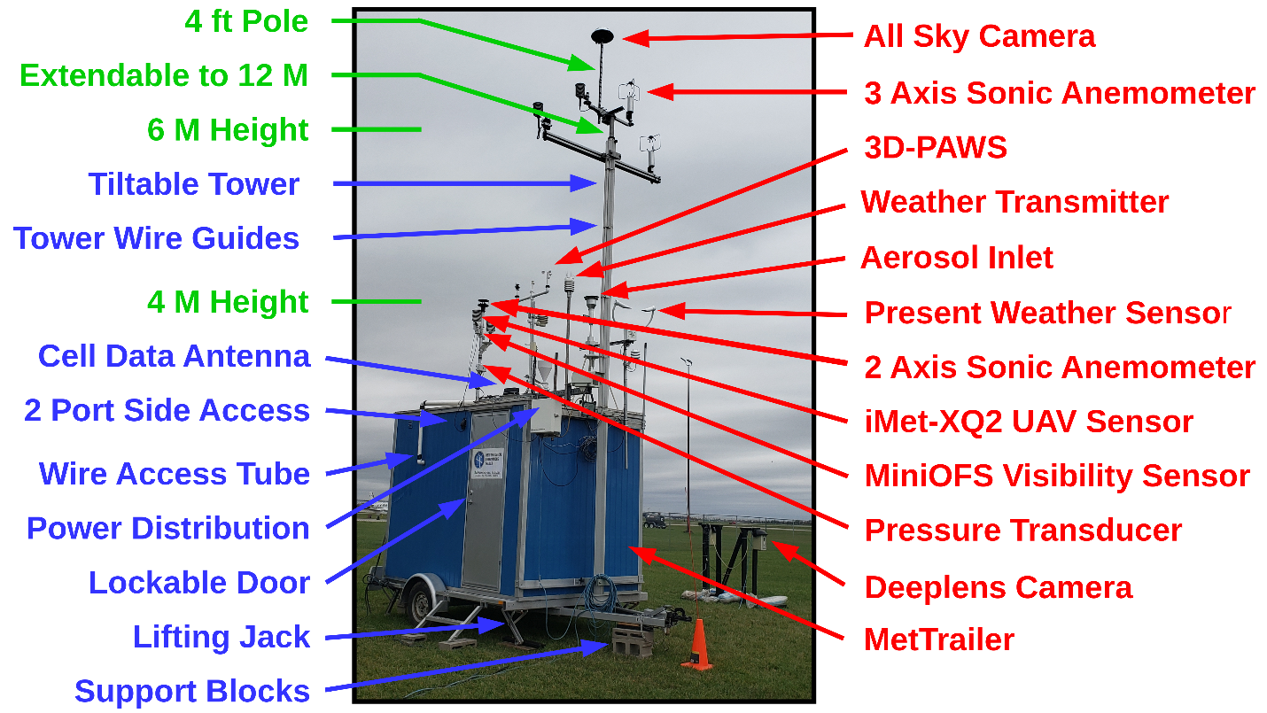

Figure 1: Image showing the Meteorological Observation Trailer (MetTrailer) with cameras and labels of instruments for measurement of atmospheric state parameters and visibility.

## Computer and Software Facilities

The Department works closely with the Scientific Computing Center to maintain workstation and Linux servers. The Department has dictated computer servers for storage and processing of both aircraft and radar data. The Airborne Data Processing and Analysis (ADPAA) is an open-source software package developed at UND that will be used to process and visualize project data. ADPAA can process data acquired from many data acquisition systems. For example, ADPAA has an extensive tool set for processing data recorded by the Droplet Measurement Technologies (DMT) Cloud Condensation Nuclei (CCN) counter. Additionally, ADPAA includes several python programs for acquiring and archiving RS232/RS422 data streams. ADPAA produces time-series data files in a documented American Standard Code for Information Interchange (ASCII) format that includes a meta-data header that fully describes included parameters and enables ADPAA scripts to convert files to several other formats such as the International Consortium for Atmospheric Research on Transport and Transformation (ICARTT) data format. The ADPAA software provides utilities for conducting quality control checks of aircraft instruments before, during and after field projects and quality assurance utilities so instrumentation experts can review measurements by inserting missing value codes to create “clean” data set. The ADPAA repository has been hosted at Source forge since 2007 and is available under the open-source GNU General Public License, version 3.