Science Plan

Saudi Arabia Spring 2024 Field Project:

Citation Research Aircraft Microphysical Observations of Developing Precipitation Systems

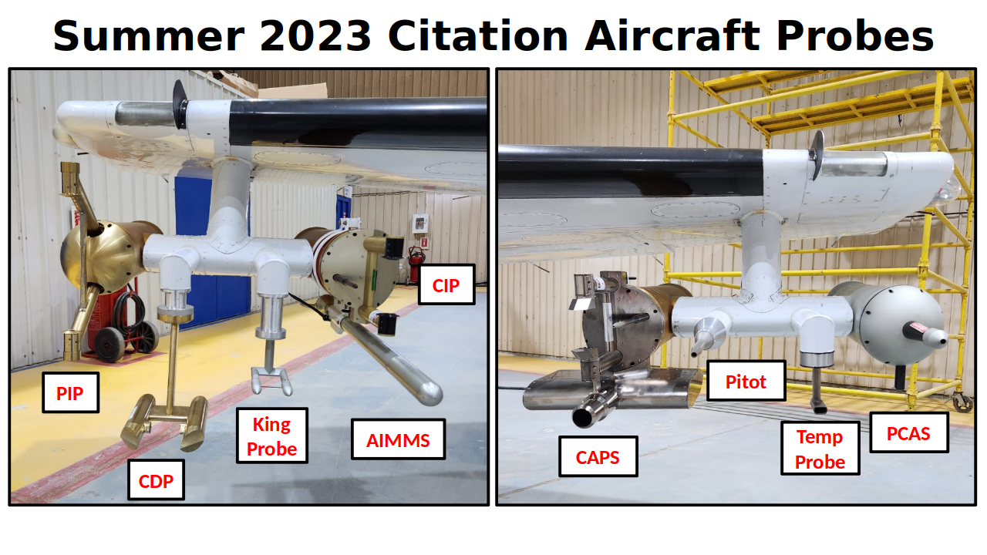

Prepared by:

University of North Dakota

and

Weather Modification International

Updated: 11 January 2024

# Introduction

The University of North Dakota (UND) and Weather Modification International (WMI) are conducting a field research project to obtain aircraft observations contemporaneous with the operational cloud seeding program in Saudi Arabia (Figure 1). UND and WMI are part of the research team proposing a comprehensive, 5-year research program. This Research Initiative assesses the effectiveness of the current cloud seeding program in achieving increases in precipitation and examines the technology, equipment, and seeding methods needed to achieve optimal results. The current Cloud Seeding Operational Program is conducted under contract with the National Center for Meteorology (NCM) in the Kingdom of Saudi Arabia (the Kingdom). The Cloud Seeding Operational Program spans five years and is an important initiative of the Middle East Green Initiative and the Saudi Green Initiative designed to increase rainfall in the Kingdom of Saudi Arabia. The original intent was to conduct the Research Initiative contemporaneous with the Cloud Seeding Program; however, the Research Initiative has been delayed. Conducting research and operational projects at the same time enables sharing of resources, which reduces the overall time and cost requirements. Additionally, obtaining the field project observations now enables the creation of a data set for use by the Research Initiative team to conduct scientific analysis at the start of the program.

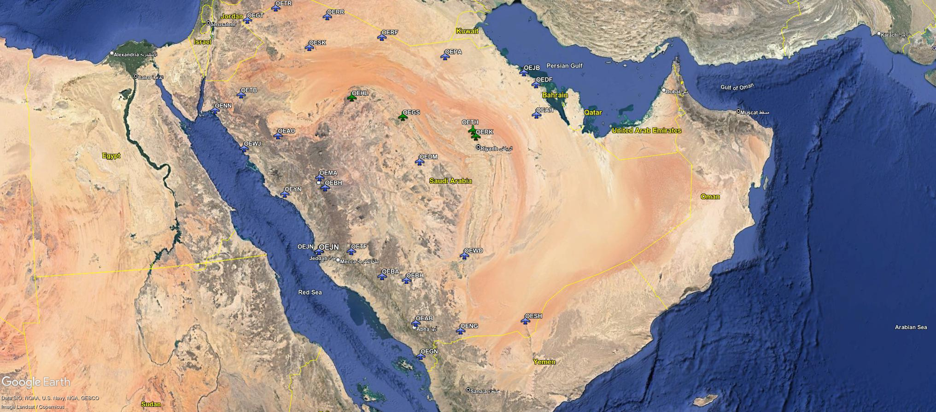

Figure 1: Image showing Saudi Arabia, with national borders given by solid yellow line. The project is based out of the OETH airport and focuses on measurements near Riyadh; however, clouds in the south-west region are targeted when clouds near Riyadh are not available.

To support the scientific analysis of weather modification methods used by the operational cloud seeding program, the spring 2024 intensive operation period (IOP3) is being conducted to obtain cloud microphysical measurements. It is important to measure cloud properties to enable an understanding of the region’s precipitation formation process. Understanding the main precipitation formation processes is a necessary step for understanding how changes produced by cloud seeding conducted by the Cloud Seeding Operational Program modify precipitation amounts. Understanding the details of how precipitation formation processes are changed by cloud seeding in the region is important for developing a long-term, effective, operational cloud seeding program in the Kingdom.

Cloud seeding introduces ice nuclei that activate at warmer temperatures than naturally occurring ice nuclei. The glaciogenic particles released by cloud seeding converts small water droplets to larger ice particles, which results in precipitation development by an ice phase process. Without such an ice nucleus, liquid water droplets would remain liquid within the super cooled cloud. Therefore, the existence of liquid water at temperatures below 0 °C indicates the lack of ice nuclei active at the temperature of the cloud. Since we know that liquid water droplets would not be converted to the solid state without an ice nucleus until homogeneous freezing at approximately -40 °C, the occurrence of frozen hydrometeors within the updraft of convective clouds indicates that there are ice nuclei present. Furthermore, determining the temperature at which frozen hydrometeors occur within the updrafts provides the activation temperature of the ice nuclei. Additionally, measuring the cloud droplet concentration within the updraft enables determination of the cloud condensation nuclei (CCN) concentration of the air parcel that created the cloud without the complexity of deploying a well calibrated CCN counter (Delene and Deshler 2000). Therefore, the sampling of the updraft cores of developing cumulus clouds provides a robust assessment of two of the most important aerosol properties; namely, the cloud base CCN concentration (Delene et al. 2011) and the activation temperature of ice nuclei. More importantly, cloud microphysical measurements over the full particle size range of both liquid and ice phase hydrometeors at different altitudes provide observations at important times during the precipitation development process. Hence, cloud core observations at different altitudes provide both aerosol property information and cloud process information. Therefore, the plan for conducting scientific observations to assess the operational cloud seeding program focuses on cloud microphysical measurements within the cores of developing cumulus clouds.

To obtain the required observations, the best available cloud microphysical instrumentation should be deployed on a research aircraft able to conduct cloud core sampling of developing cumulus clouds. The field project uses the North Dakota Citation Research Aircraft (Delene et al. 2019), which has state-of-the-art instrumentation and uses robust data processing and analysis software (Delene 2011). The field project observations will enable the objective of understanding the precipitation development in Saudi Arabia and modification made by cloud seeding to be obtained by providing a high-quality airborne data set that can be analyzed by conducting case studies of aircraft flights and for the development of cloud microphysical statistics for model development and evaluation. Specifically, the cloud observations enable precipitation formation processes to be evaluated and provide key cloud and aerosol parameter statistics.

# Cloud Microphysics Observations of Convective Cores

The North Dakota Citation Research Aircraft carries microphysical instrumentation for measuring all cloud and precipitation particles, which range from small cloud droplets all the way up through hailstones. Vertical wind, temperature, and humidity are recorded to fully document the sampled clouds and the environment. During the research deployment, clouds that meet the operational requirements of the seeding program are selected for sampling. Such clouds may be organized in linear forms, isolated, or appear in clusters. The clouds of interest for seeding are those having updrafts, supercooled liquid water, and a lack of natural ice. Clouds without updrafts are no longer growing, and those containing significant ice have already produced it naturally, making seeding unnecessary.

Both unseeded and seeded clouds are sampled. The Cloud Seeding Operational Program should be conducted as if the IOP3 was not being conducted; however, the research team works closely with the operational team. The research team attends the daily weather briefing to obtain weather information, review previous operations, and discuss current research plans. During flights, the research aircraft receives the cloud seeding aircraft position and provides the research aircraft position to the operational team. Additionally, team members communicate plans using VHF radio. When cloud development is forecast to be likely, the Citation Research Aircraft is launched with sufficient lead time to enable sampling of the initial development phase of the clouds. Ideally, it is desirable to penetrate the target cloud at or near seeding altitude prior to seeding, thus obtaining “natural” characteristics of the cloud before seeding operations begin. A team that includes WMI, UND, and Saudi Arabian personnel meets daily to discuss research plans. The onboard flight scientist, with input from the team, may adjust the cloud to target and sampling levels as conditions evolve during a research flight.

Sampling of convective clouds in Saudi Arabia starts with sampling at the -10 °C level since this is typically the level targeted by glaciogenic seeding (Figure 3). If the cloud does not extend to the -10 °C level, sampling is started 500 ft below cloud top. Each cloud sample ideally begins at the prescribed altitude of the -10 °C level; however, if seeding aircraft operations prevent sampling of the -10 °C altitude level, the cloud sample starts 2,000 ft above the cloud seeding aircraft’s operational level. Upon entering the cloud, the aircraft is flown at a constant altitude to avoid accumulation of ice on the underside of the aircraft and to optimize the vertical wind measurement. Cloud passes may be conducted once, or several times, at a sampling level depending on how fast the cloud is maturing. Each sampling level is followed by an ascent and turns conducted out-of-cloud, and repeated until the top of the cloud is reached. Obtaining out-of-cloud measurements is important since it provides a baseline for adjustment of hot-wire probe measurements (Delene et al. 2019). Ideally, the aircraft sampling ascends with the vertical development of the cloud. Figure 3 illustrates the standard flight profile used for sampling the convective clouds. Ideally, the -10 °C, -15 °C, -20 °C, and -25 °C levels are sampled. Sampling may not be conducted at all these levels initially since the cloud may not have matured sufficiently to extend to the colder temperatures. In this case, sampling is continued at the current sampling level until the cloud has matured to enable sampling at a higher altitude. Some clouds may not mature enough to enable sampling at all temperature levels. The Citation Research Aircraft has the performance to effectively conduct cloud sampling at all desired cloud levels.

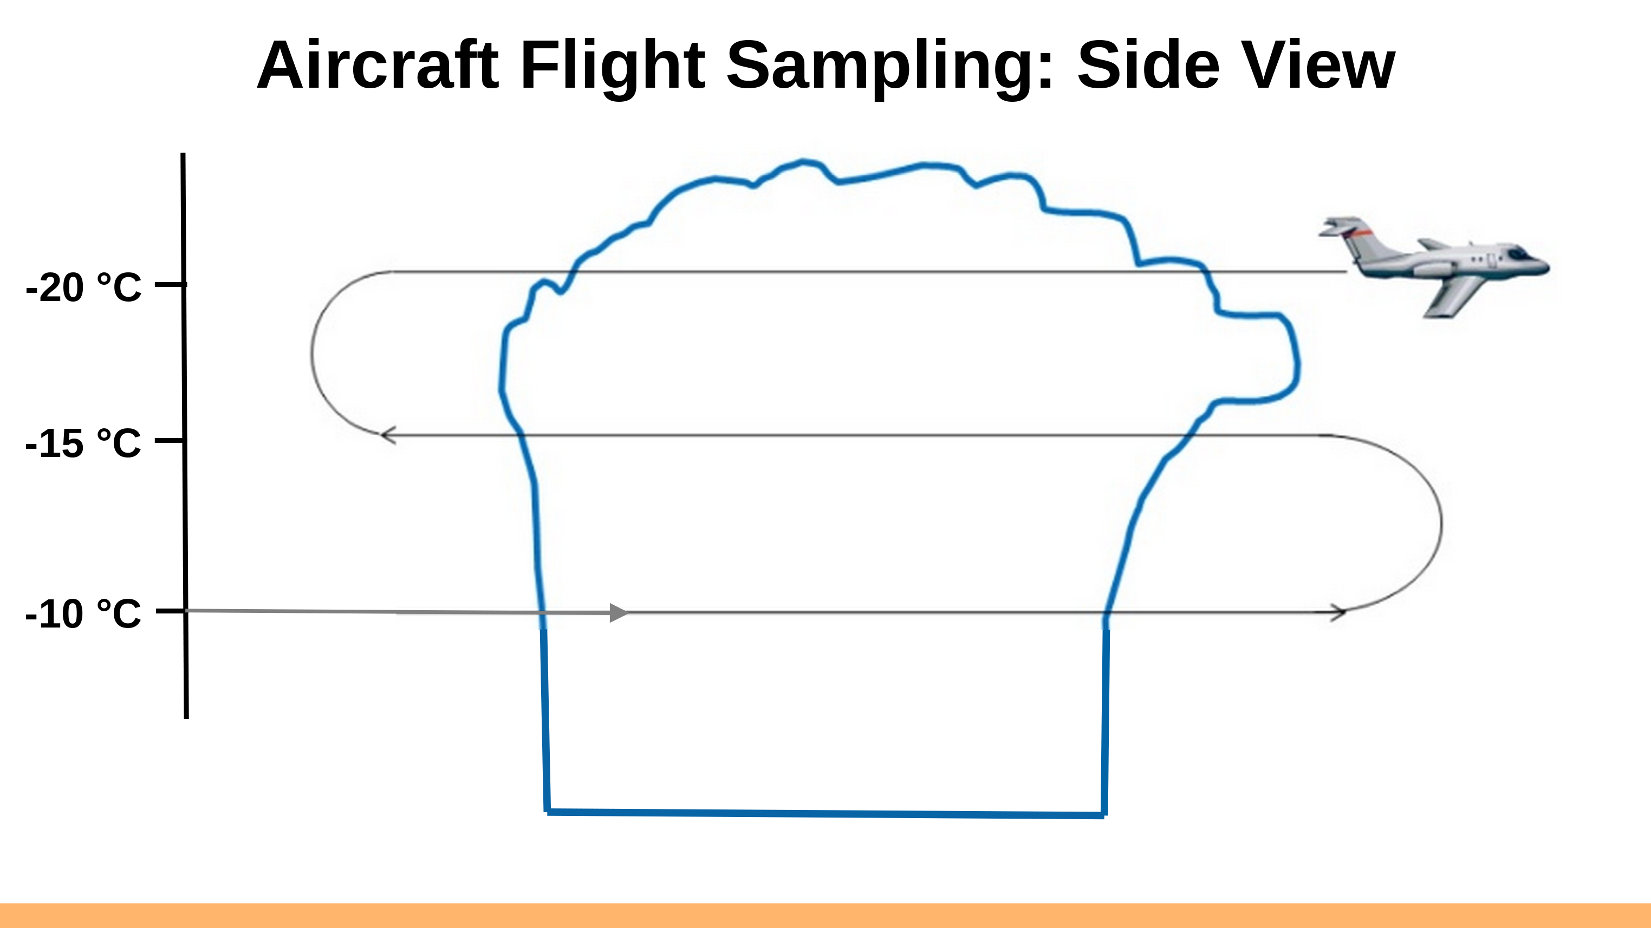 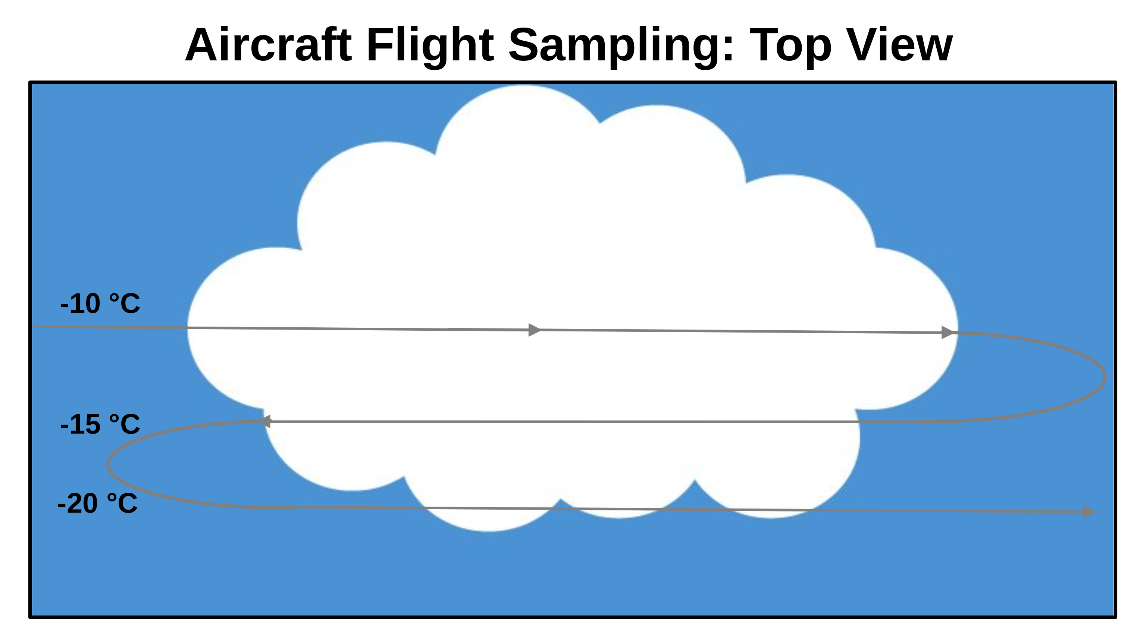

Figure 2: Diagrams illustrating how a cloud suitable is sampled by the research aircraft. A series of passes, initially out of cloud, and then in-cloud is conducted at different altitudes that correspond to temperature levels (left panel). Each flight level may not be over the same ground location if the cloud is tilted due to wind shear (right panel). Note that the flight profile is for both unseeded (natural) clouds and seeded clouds.

Sampling at the -10 °C, -15 °C, and -20 °C levels allows for the determination of how much super cooled liquid water exists, the extent to which the super cooled liquid water increases with decreasing temperature, and the existence of mixed water and ice particles within the cloud. Specifically, the change of cloud droplet size (for example, effective radius) with height enables determination of the occurrence, or the non-occurrence, of the collision and coalescence process (Figure 3). The lack of the collision and coalescence process in clouds with a significant vertical extent indicates that precipitation is slow to develop and seeding with ice nuclei should result in a more efficient precipitation development process.

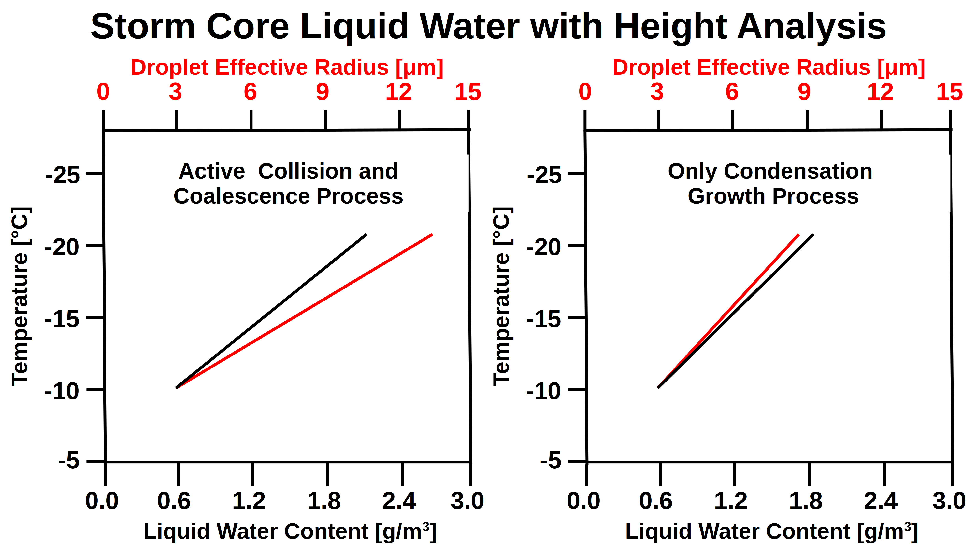

Figure 3: Image illustrating the analysis to be applied to aircraft cloud core measurements to determine the processes occurring.

The -25 °C level is where naturally occurring ice nuclei are likely to produce a cloud containing only ice; however, ice may be observed at lower levels. The amount and altitude of ice in unseeded clouds provide information on the activation temperature of naturally occurring ice nuclei. Details of the ice observed, such as the presence or not of an aggregation mode in the ice particle spectrum, enable determination of the occurrence, or not, of aggregation (Figure 4). Additionally, the amount of aggregation and type of aggregation illustrate important information about the process occurring within the cloud. The lack of high concentration of ice crystals and large ice crystal aggregates indicates that precipitation is slow to develop and seeding with ice nuclei should result in a more efficient precipitation development process.

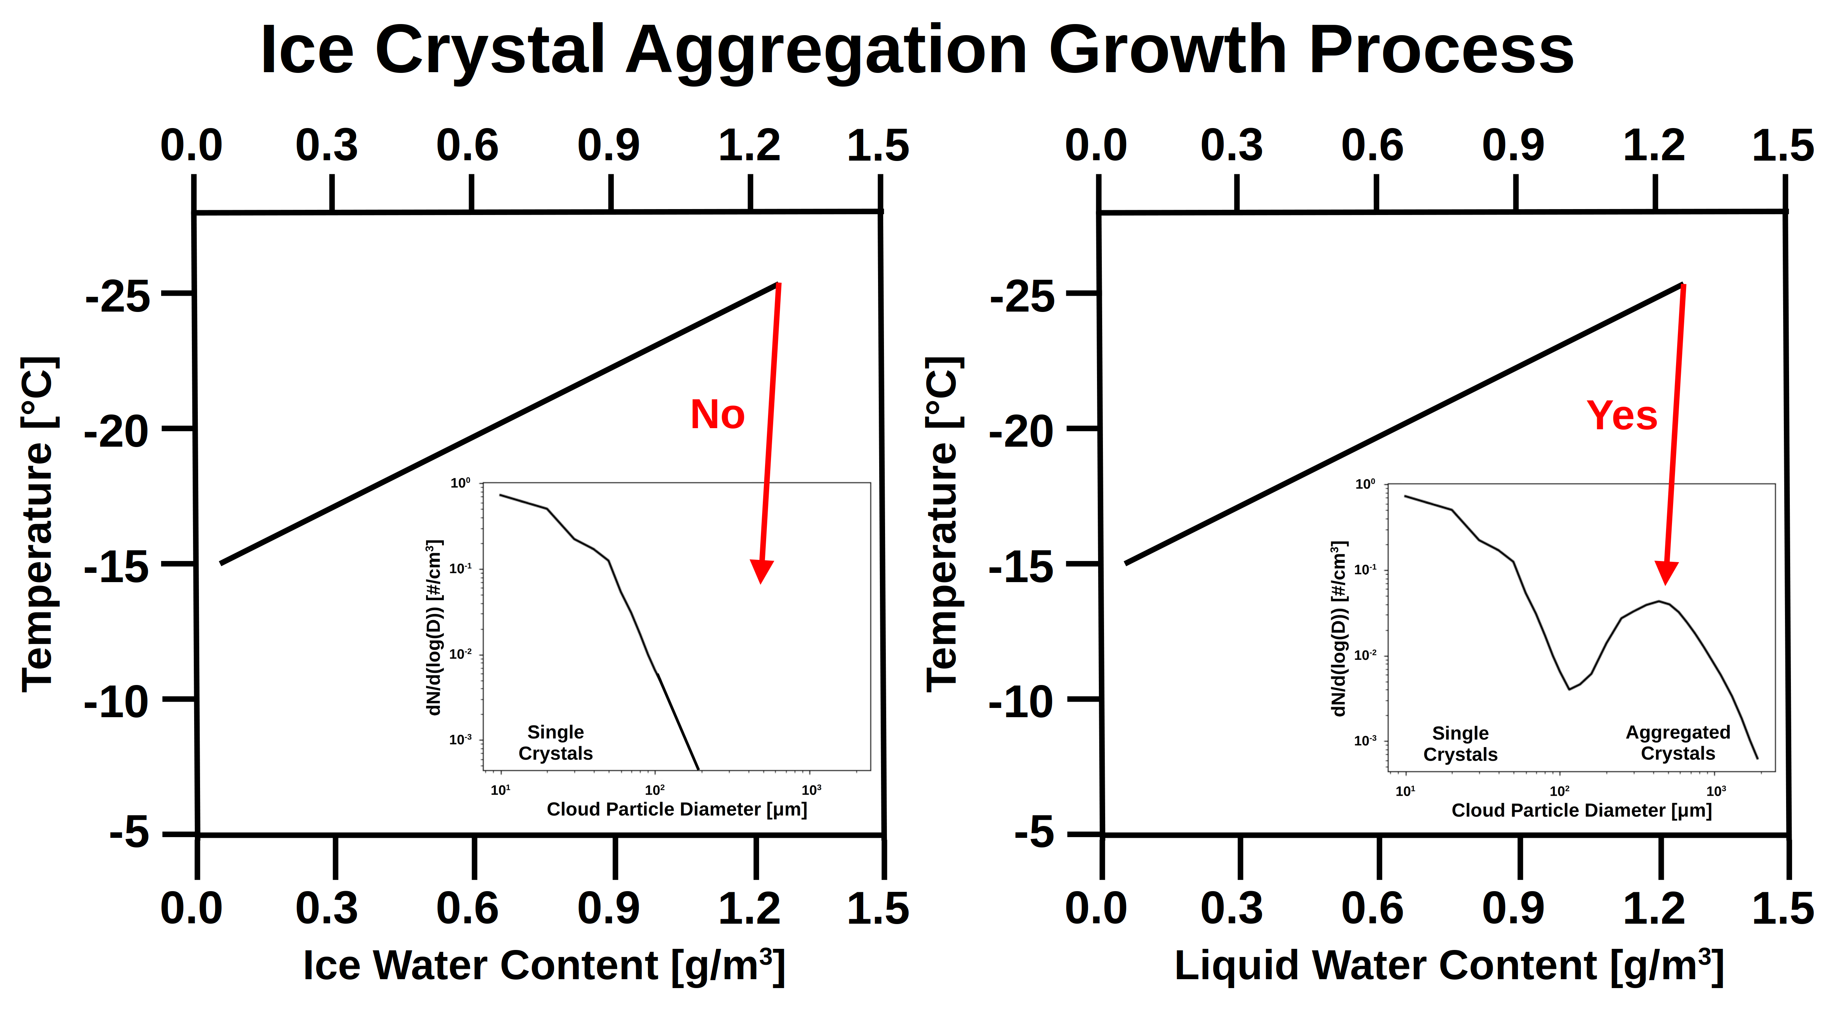

Figure 4: Image illustrating the analysis to be applied to aircraft cloud ice phase measurements to determine the processes occurring.

# Conclusions

The cloud microphysics data set created enables analysis that could be published in several individual scientific papers. A paper describing the scientific plan for conducting the 2023 operations would form a good base for these analysis papers. Therefore, it is planned that publications would start with a scientific objective paper that describes the methodology of obtaining the data set. Such a paper would describe the research plan, the reason for conducting the field project, the methodologies for obtaining measurements, and the objectives for analysis of the collected data. The developed science plan for each field project is a start on such a paper. Additionally, conference presentations at the annual meeting of the American Meteorological Society allows for obtaining feedback on the research and is an initial start of an analysis paper, which utilizes the created data set.

# References

Delene, D. J., 2011: Airborne data processing and analysis software package. *Earth Sci. Inform.*, **4**, 29–44, https://doi.org/10.1007/s12145-010-0061-4.

Delene, D. J., and T. Deshler, 2000: Calibration of a Photometric Cloud Condensation Nucleus Counter Designed for Deployment on a Balloon Package. *J. Atmospheric Ocean. Technol.*, **17**, 459–467, https://doi.org/10.1175/1520-0426(2000)017<0459:COAPCC>2.0.CO;2.

Delene, D. J., C. Grainger, P. Kucera, D. Langerud, M. Ham, R. Mitchell, and C. Kruse, 2011: The Second Polarimetric Cloud Analysis and Seeding Test. *J. Weather Modif.*, **43**, 14–28.

——, K. Hibert, M. Poellot, and N. Brackin, 2019: The North Dakota Citation Research Aircraft Measurement Platform. *SAE Tech. Pap. 2019-01-1990*, https://doi.org/doi: 10.4271/2019-01-1990., 63–71.