NASA IMPACTS Probe Maintenance and Cleaning

Modification History
Written by Kendra Sand
2020/01/16: Updated by Kendra Sand
2022/09/01: Updated by David Delene

Probe Maintenance and Cleaning Summary
Acronym | Purging | Duration | Purge Tools Needed | Required Cleaning Supplies
2DS | Yes | 5 min disassemble  10 min purging  5 min reassemble | Regular Driver | Methanol, Kimwipes, Q-tips
CDP | No |  | N/A | Q-tips, 91% Isopropyl Alcohol, White Vinegar, Distilled Water
Hawkeye  (FCDP, 2DS, 2DS, CPI) | Yes | 15 min disassemble  25 min purging  5 min reassemble | Regular Driver, 3/32 Allen Wrench, Magnet (Optional) | Methanol, Q-tips, Cleaning Wand, Snips
HVPS3-A | Yes | 5 min disassemble  10 min purging  5 min reassemble |  | Methanol, Kimwipes, Q-tips
HVPS3-B | Yes | 5 min disassemble  10 min purging  5 min reassemble |  | Methanol, Kimwipes, Q-tips
King | No |  | N/A | N/A
Nevzorov | No |  | N/A | N/A
PHIPS | No |  | N/A | N/A
RICE | No |  | N/A | Isopropyl Alcohol, Kimwipes, Extended Ladder
Pitot Static | No |  | N/A | N/A
Pitot Dynamic | No |  | N/A | N/A

Probe Cleaning Procedure

HVPS3-A, HVPS3-B, and 2D-S
1. Soak a regular Q-tip in methanol (green bottle).
2. Cover the Q-tip with a Kimwipe.
3. Swipe the Kimwipe covered, methanol-soaked Q-tip over the top OAP window only once.
4. Swipe the Kimwipe covered, methanol-soaked Q-tip over the bottom OAP window only once.
Notes:
- Clean OAP windows in order, top to bottom.
- Use the cleaning wand to reach the eight OAP windows in the Hawkeye.
- Methanol-soaked Q-tips may be reused, but use each Kimwipe only once.

Hawkeye (Hawkeye FCDP, Hawkeye 2D-S, Hawkeye CPI)
1. Cut a regular Q-tip in half.
2. Insert Q-tip halves into each end of the cleaning wand, be careful not to touch the Q-tip heads.
3. Apply a few drops of methanol (green bottle) to each Q-tip.
4. Swipe the Q-tip over each of the 8 optical windows, working from top to bottom.
5. Repeat steps 1-4 until all 8 windows have been satisfactorily cleaned.
6. Insert a dry Q-tip into the cleaning wand and use to dab any excess drops.

CDP
1. Soak a black Q-tip in isopropyl alcohol (yellow bottle).
2. Wipe the isopropyl soaked Q-tip over the top CDP window.
3. Wipe the isopropyl soaked Q-tip over the bottom CDP window.
4. Repeat steps 1-3 using white vinegar.
5. Repeat steps 1-3 using distilled water (pink spray bottle).
Notes:
- A Kimwipe may be used in conjunction with the Q-tips, if needed.
- The top window should have a blue tint (this is the receiving window).
- Bottom window should be completely clear and appear invisible (transmitting window).

Rosemount Icing Probe
1. Extend a ladder up to the Rosemount probe location.
2. Apply some isopropyl to a couple Kimwipes.
3. Climb up the ladder with the isopropyl-dampened Kimwipes.
4. Carefully wipe the surface of the Rosemount probe.
Notes:
Conduct one day prior to flight, if possible.

King Probe
- No cleaning required.
- Visually inspect the hotwire for protruding ends along the coiled wire
  - If wire is broken requires replacement.
- Be careful, the probe is very delicate

WCM
- No cleaning required
- Visually inspect each sensor for damaged or missing parts.
- If damaged, the entire sensor head requires replacement with our spare sensor head.

Probe Purging Procedure
Conduct one day prior to flight, if possible.
1. All hermetic PMS cans need to be purged occasionally, preferably the day prior to a flight.
2. Remove tail cone (end cap).
3. Have purge gas ready.
4. Release valve caps as purge gas is applied.
5. Purge for 10-20 minutes, alternating valves halfway through.
6. Once complete, seal with valve caps to finger tight.
7. Reattach the tail cone.
8. Notify a maintenance crew member so the probes can be checked for airworthiness.

Figures
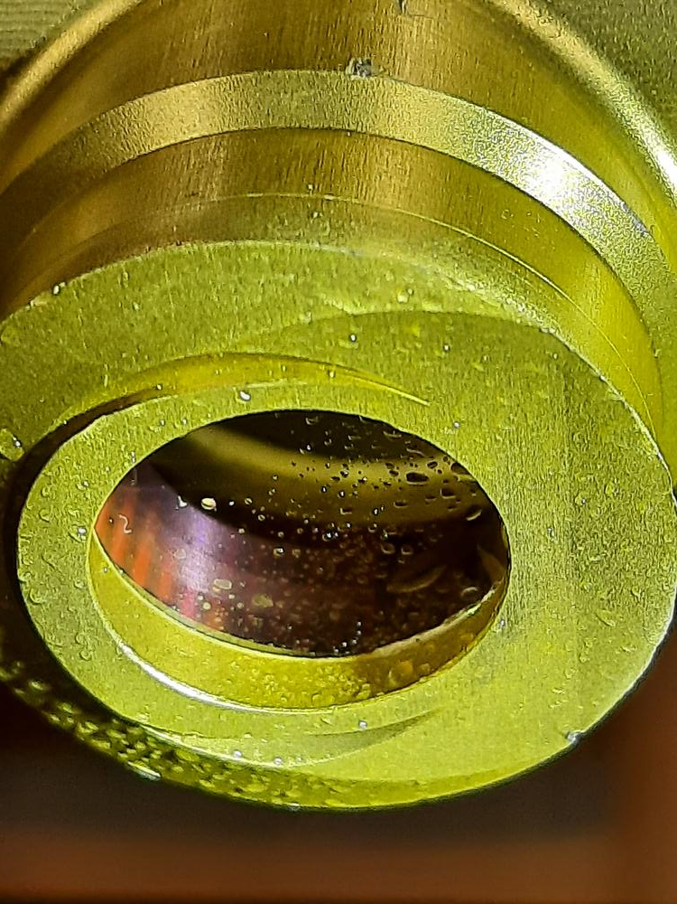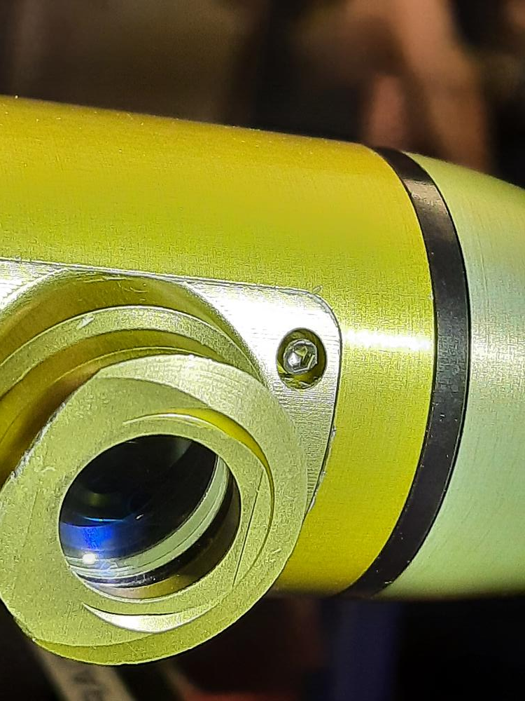
Figure 1: Image (left) illustrating a dirty windows and an image (right) illustrating a clean window on the Cloud Droplet Probe (CDP).

