Improving Education using Open Hardware, Software, and Course Material in a Hands-on, Project-based Learning Environment

David Delene1, Marwa Majdi2, Fred Remer3, Woei Hung4, Paul Kucera5, Laura Munski6

1Research Professor, Department of Atmospheric Sciences

2Postdoctoral Researcher, Department of Atmospheric Sciences

3Associate Professor, Department of Atmospheric Sciences

4Professor, Department of Education, Health & Behavior Studies

5Faculty Member, National Center for Atmospheric Research

6Executive Director, Dakota Science Center

Integrated approaches to teaching and providing a learning environment are key to producing students knowledgeable and skilled in science, technology, engineering and math (STEM). However, education in STEM encounters several barriers to improving teaching and nowadays face many challenges with declining enrollments and reduced funding, while at the same time graduates have increased global competition. Hence, educational institutions have to improve the quality of education with less funding. While improving STEM education has many challenges, technological advances offer solutions that were not available in the past. Three- dimensional (3D) printers have been developed that significantly reduce the cost of constructing complex equipment. The availability of 3D printing technology and inexpensive sensors has enabled the development of open hardware projects that prove educators the ability to create tools and instrumentation at a fraction of the cost of commercial counterparts.

The [3D-Printed Automatic Weather Station](https://sites.google.com/ucar.edu/3dpaws/home) (3D-PAWS) is an existing open hardware project created by the University Corporation for Atmospheric Research (UCAR) and the US National Weather Service International Activities Office (NWS IAO) in an effort to fill observational gaps in remote, sparsely observed regions. The 3D-PAWS project has enabled building weather stations capable of high-quality measurements which are comparable to expensive commercial instruments. However, the major advantage of the 3D-PAWS weather stations is the opportunity provided to educators to enhance student learning since it is an open system where the hardware, manuals, and software are freely available.

The Department of Atmospheric Sciences at the University of North Dakota has experience with using the 3D-PAWS system in both education and research applications. In 2018 the Atmospheric Science Department purchased equipment for building the 3D-PAWS, which enabled graduate students in Dr. David Delene’s Measurement Systems class to print 3D-PAWS components and conducted a lab where the 3D-PAWS rain gauge was calibrated. During the summer of 2019, UND collaborated with an Australian private company “Bee Innovative” in a research project aiming at increasing the sunflower oil yield and quality in North Dakota by maximizing honey bee pollination. To support the project, UND built and deployed four 3D-PAWS weather stations near Bismarck to monitor micro-climate by collecting temperature, pressure, wind direction, wind speed, and precipitation data to enable effective placement of bee hives and thus maximize pollination. During the Fall of 2020, two 3D-PAWS weather stations were mounted on the roof of Clifford Hall and one on a mobile meteorological trailer to collect meteorological data as part of a fog research project (Figure 1).

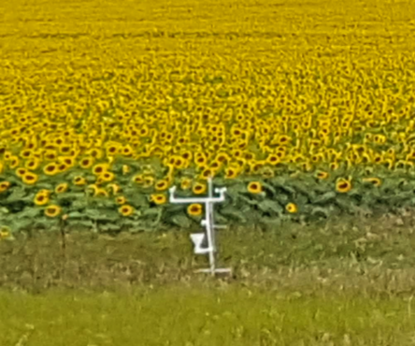 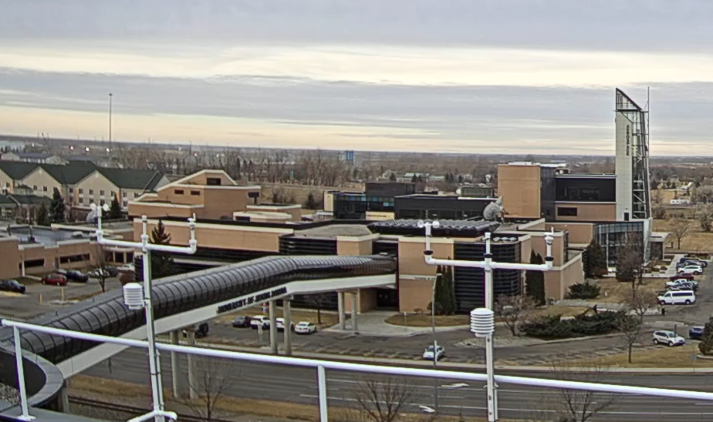 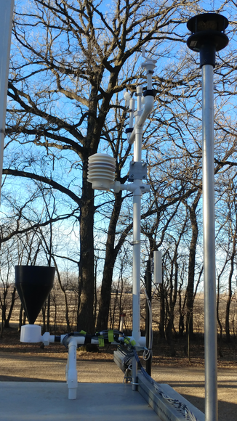

Figure 1: Images showing 3D-Printed Automatic Weather Station (3D-PAWS) on a sunflower field in Bismarck (left), on top of Clifford Hall (middle), and on top of the Met Trailer (right). Links to real-time data from Clifford Hall and Met Trailer 3D-PAWS sensors are available on [Dr. Delene's Meteorological Observational web page](http://aerosol.atmos.und.edu/Observations.html).

Our project aims to improve undergraduate student’s understanding of observational sciences by making instruments, conducting measurements, testing instrument performance, calibrating sensors, and comparing measurements. Therefore, it is crucial to create an educational gateway where instructors have resources to enable students to effectively learn problem-solving instead of simply doing the minimum required for assignments. The project will develop course syllabus and student projects that use the 3D-PAWS to add practical experience to the theory provided by text book material. Students will conduct experiments using the 3D-PAWS, and advanced student will develop additional open hardware and software. For example, the 3D-PAWS rain gauge could be enhanced to enable the collection of rainwater for mercury sampling.

The ultimate project’s objective is to enhance STEM education at the undergraduate college level using 3D-PAWS weather stations. This project will implement a holistic approach to STEM learning by providing tested resources to instructors from different universities so they can effectively incorporate problems based learning into classes. This project will focus on developing all the essential and tested materials (slides, videos, manuals, equipment, software, etc.) provided to professors in an easily accessible manner to focus their time interacting with the students instead of developing and testing instructional material.

The project uses several committed testers in evaluate developed material. These testers are critical to ensure the use of the developed material and in determining what types of developed materials can be integrated into their classes. A team of 3-5 dedicated testers from different universities provide the core development team feedback on what is practical and evaluate developed materials. For example, we are developing a pressure calibration lab involving the 3D-PAWS pressure sensor after discussing with collaborator Fred Remer on what material can easily be incorporated into his undergraduate Instrumentation Class during the Spring 2021 semester. Additionally to constructing a 3D-PAWS with a pressure calibration setup, we plan to construct 10 to 15 3D-PAWS systems with different other components for potential testers from other universities. The calibration setup of these different sensors as well as inputs on how to incorporate the 3D-PAWS system into classes will be documented.